TECHNICAL DESCRIPTION (PART B)

COVER PAGE
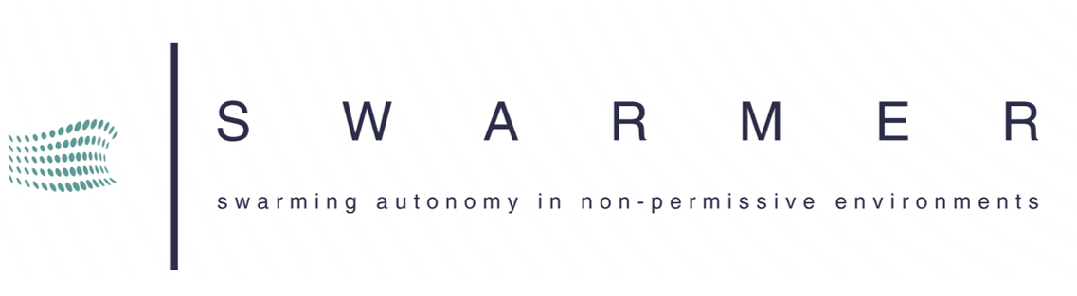
Part B of the Application Form must be downloaded from the Portal Submission System, completed and then assembled and uploaded as a single password protected encrypted ZIP archive (see section 11 of the Call document) in the system. Page 1 with the grey IMPORTANT NOTICE box should be deleted before uploading.
Note: Please read carefully the conditions set out in the Call document (for open calls: published on the Portal). Pay particular attention to the award criteria; they explain how the application will be evaluated.

PROJECT
Project name: | Swarming Autonomy in non-peRMissive EnviRonments
Project acronym: | SWARMER
Coordinator contact: | Aggelos VASSILEIOU, IKNOWHOW

TYPE OF PROJECT
Type of project  (article 10(2) EDF Regulation) | New defence product or technology ¨  Upgrade of existing defence product ¨
Types of activities (article 10(3) EDF Regulation)  Information provided here must be consistent with Section 8.2 and with the detailed budget table.  Not all types of activities are allowed in all calls. Consult the Call document for details. | Generating knowledge (a) ¨  Integrating knowledge (b) ¨  Studies (c) ¨  Design (d) ¨  Prototyping (e) ¨  Testing (f) ¨  Qualification (g) ¨  Certification (h) ¨  Increasing efficiency (i) ¨

TABLE OF CONTENTS
TECHNICAL DESCRIPTION (PART B) 1
COVER PAGE 1
PROJECT SUMMARY 3
1. EXCELLENCE AND POTENTIAL OF DISRUPTION 5
1.1 Overall concept 5
1.2 Objectives — Scope and types of activities — Functional requirements — Expected impact 23
1.3 Advantage and potential of disruption 27
2. INNOVATION AND TECHNOLOGICAL DEVELOPMENT 28
2.1 Innovation potential 28
2.2 Complementarity with previous and ongoing R&D activities 30
2.3 Potential for spin-offs 33
3. COMPETITIVENESS 34
3.1 Competitive advantage 34
3.2 Potential to accelerate growth 35
3.3 Intellectual property strategy 39
4. EDTIB AUTONOMY 40
4.1 EDTIB autonomy 40
4.2 Security of supply 41
4.3 Member State defence capability priorities 42
5. CREATION OF NEW CROSS-BORDER COOPERATION 43
5.1 New cross-border cooperation 43
5.2 Planned future cross-border cooperation 44
5.3 Cross-border cooperation by SMEs and mid-caps 45
6. LIFECYCLE EFFICIENCY (n/a for Research Actions and Lump Sum Grants for Research Actions) 46
6.1 Improved lifecycle efficiency 46
7. MEMBER STATE COOPERATION (n/a for Research Actions and Lump Sum Grants for Research Actions) 46
7.1 Member State cooperation 46
8. IMPLEMENTATION 47
8.1 Work plan 47
8.2 Work packages, activities, resources and timing 50
Work Package 1 51
Work Package 2 54
Work Package 3 56
Work Package 4 58
Work Package 5 60
Work Package 6 62
Work Package 7 64
Work Package 8 66
Work Package 9 68
Work Package 10 70
Work Package 11 73
Work Package 12 75
Work Package 13 77
Work Package 14 80
Timetable 83
8.3 Consortium set-up 86
8.4 Consortium management and decision-making 87
8.5 Project management, quality assurance and monitoring and evaluation strategy 89
8.6 Cost effectiveness and financial management 89
8.7 Risk management 90
8.8 Communication, dissemination and visibility 91
9. OTHER 93
9.1 Ethics 93
9.2 Security 93
10. DECLARATIONS 95
ANNEXES 98

#@APP-FORM-EDF@#
#@PRJ-SUM-PS@# [This document is tagged. Do not delete the tags; they are needed for the processing.]

PROJECT SUMMARY
Project summary
Please provide an executive summary in order to provide the evaluators with an overview of the main aspects of your project.
Do NOT limit yourself to the abstract provided in Part A (SEP Submission System screens).

GOAL
The evolution of unmanned aerial systems (UAS) is vital for future defence operations, especially as conflict zones increasingly disrupt traditional navigation technologies like GNSS. Adversaries now use advanced jamming and spoofing techniques, leaving forces vulnerable if dependent on GNSS for navigation and coordination. UAS must evolve to operate autonomously in denied environments, executing complex tasks like reconnaissance and coordinated attacks. The SWARMER project addresses these needs by developing a drone swarm capable of independent navigation in GNSS-denied settings, integrating multi-sensor systems and intelligent fusion techniques. This solution ensures drones can adapt to dynamic conditions and cooperate in swarming formations, enhancing defence capabilities, aligning with the EU's 2023 Capability Development Priorities for Ground Combat, Military Mobility, Infrastructure Protection, and Airborne Command. Τhe Ministries of Defence of Greece, Poland, Cyprus and Ireland support the SWARMER proposal, as its expected outcomes align with their operational interests and will benefit their goals and objectives through the acquisition of valuable knowledge.

CURRENT STATE OF AFFAIRS
“'Drones' have been instrumental in providing new capabilities for European defence and have demonstrated significant growth as a consumer leisure product” ● “The extensive deployment of drones revolutionises the acceleration of military control cycles” ● “UAS play a crucial role in military conflicts and intelligence-gathering missions, having been used extensively in dual-used type of applications. As a result, UAS are considered a great example of dual-use technology and capability, being recognized as key elements in military and civil missions” ● Αugust 2024: “Ukraine has been stepping up its long-range strikes inside Russia over the past few months, launching scores of drones simultaneously at strategic targets several times a week” ● March 2024: “The war in Ukraine has been characterised by drone deployment of unprecedented scale, with thousands of unmanned aerial vehicles (UAVs) used to track enemy forces, guide artillery and bomb targets”.
The aforementioned quotes are just a small example from a vast pool of articles, news and commentaries regarding the significance of drones within the conflict theatre over the last 10 years. It is thus evident that drones, i.e. the Unmanned Aerial Systems (UAS), are rapidly transforming the landscape of modern warfare, playing a crucial role in surveillance, reconnaissance, intelligence gathering, and tactical strikes. As demonstrated in recent conflicts such as the war in Ukraine, drones are becoming indispensable for military operations. However, existing UAV systems are often reliant on GNSS (Global Navigation Satellite Systems) for navigation, leaving them vulnerable to jamming, spoofing, and other electronic warfare tactics employed by adversaries. In such environments, GNSS-dependent drones suffer severe disruptions, reducing their effectiveness in key operations such as ISR (Intelligence, Surveillance, and Reconnaissance).
A recent analysis from the Institute for the Study of War (2024) highlights how the Ukraine conflict is reshaping warfare, particularly through extensive drone use. This marks the first major conflict with large-scale air and missile defence against drones, wide deployment of reconnaissance and strikes UAVs, and rapid advancements in electronic warfare and counter-drone measures. The study emphasizes Ukraine's need to develop drone swarm capabilities to move beyond positional warfare, as most drones currently operate independently rather than in coordinated swarms. While Western literature has anticipated drone swarms for overwhelming defences, Ukraine's decentralized approach allows individual drones to identify and attack targets autonomously, though this slows the kill-chain and limits engagement. This model may be a precursor to future tactics, merging independently operated drones with proven coordination methods. The study also underscores the importance of autonomous systems, noting challenges with full autonomy, particularly in preventing friendly fire, which can be mitigated by “last-mile autonomy,” where human operators guide systems into target zones before autonomous operation begins. into autonomous target-seeking mode, operating independently without further communication.
Of course, insights drawn from the Ukrainian War can be applied globally as drones’ technology is now accessible to all players despite their level of technological and financial advancement. Drones are a key component that can provide asymmetric advantage to Armed Forces of any state in to counteract the mass of the opponent.

MARKET OPPORTUNITIES
Despite these vulnerabilities, the global military drone market continues to grow at a rapid pace. Drones are now seen as essential tools for force multiplication, providing new capabilities to enhance situational awareness and execute precision strikes with minimal risk to human operators. However, to stay ahead of adversaries, modern defence forces need drone systems capable of operating autonomously in environments where traditional navigation systems are compromised.
The military drone market is poised to experience growth, advancing from USD 13.0 billion in 2023 to reach USD 18.2 billion by 2028, with a Compound Annual Growth Rate (CAGR) of 7.0% during the period from 2023 to 2028. Military drones, whether operated autonomously, remotely, or through a combination of both, are equipped with sensors, electronic receivers, transmitters, and offensive weaponry. These drones play a vital role in reconnaissance, both in strategic and combat zones, by designating targets for precision-guided munitions or deploying them directly. Initially developed as remotely piloted vehicles (RPVs) during World War II for target practice, drones have evolved significantly. Today, they are used by major military powers and even militias for battlefield surveillance, extending the observation range and accuracy of ground and naval forces. The increasing reliance on drones in both strategic and tactical operations has driven their growth.

OVERVIEW OF THE SWARMER PROJECT
The SWARMER project offers a comprehensive solution with an increased level of autonomy, by developing an effective holistic platform of swarming and navigation to target positions when GNSS availability is contested or lost and more generally in non-permissive environments. These drone swarms will be capable of navigating in GNSS-denied environments through intelligent information fusion, integrating LIDAR, electro-optical (E/O) sensors, and inertial navigation systems (INS). In addition, utilizing AI and machine learning (ML) techniques, the drones will make real-time decisions, dynamically adjust to changing mission parameters, and collaborate seamlessly in swarm formations, while having a low SWaP-C (Size, Weight, Power and Costs).
SWARMER’s innovation platform may be broken down into the following pillars that will allow for autonomous drone flights in GNSS and Communications denied environments (Figure 1).
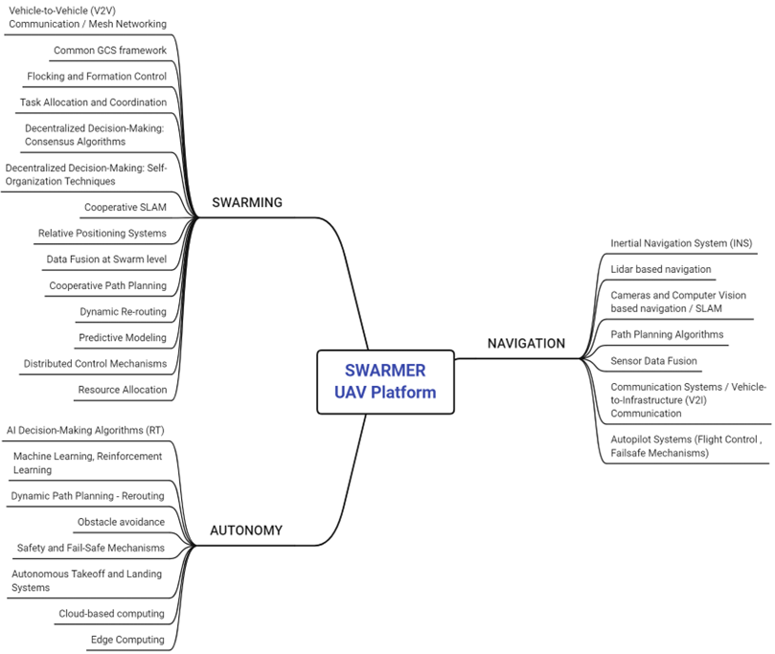
Figure 1: SWARMER Diagram
Navigation: The drones swarms will navigate autonomously in real-time utilizing advanced edge computing and cloud-based computing solutions to process sensor data. This allows them to operate effectively even when GNSS signals are unavailable or disrupted.
Autonomy: The drones swarms will adapt to complex and dynamic environments, overcoming obstacles and responding to threats autonomously using AI and ML-based decision-making algorithms. The system’s resilience will be enhanced by redundancy and decentralized control mechanisms within the swarm, ensuring reliable operation in the face of adversary interference.
Swarming: The drones swarms will collaborate through Vehicle-to-Vehicle (V2V) and Vehicle-to-Infrastructure (V2I) communication systems, allowing for coordinated task execution and robust swarm behaviors. These systems will enable the drones to communicate, share sensor data, and dynamically allocate tasks among themselves, ensuring that the mission is completed even in the event of individual drone failures.
SWARMER CONSORTIUM
- IKNOWHOW SA (IKH) - SME - Greece – Coordinator – Technical Provider
- DEUTSCHES ZENTRUM FUR LUFT - UND RAUMFAHRT EV (DLR) - RTO – Germany - Technical Manager – Technical Provider
- APPLIED INTELLIGENCE ANALYTICS LIMITED (AIA) – SME – Ireland- Technical Provider
- ETHNIKO KENTRO EREVNAS KAI TECHNOLOGIKIS ANAPTYXIS (CERTH) – RTO – Greece - Technical Provider
- ETRA INVESTIGACION Y DESARROLLO SA (ETRA) – Industry – Spain - Technical Provider
- SIGNALGENERIX LIMITED (SG) – SME – Cyprus - Technical Provider
- STOWARZYSZENIE POLSKA PLATFORMA BEZPIECZENSTWA WEWNETRZNEGO (PPHS) – RTO – Poland - Project Management
- ICARUS SWARMS (ICARUS) – SME – France - Technical Provider
- THALES SA (TRT) – Industry – France – Technical Provider
An analysis of SWARMER partners’ capabilities and expertise that will be brought to the project may be found on the “Consortium Set-up” at Section 8.3.
#§PRJ-SUM-PS§# #@REL-EVA-RE@# #@PRJ-OBJ-PO@# #@CON-MET-CM@#

1. EXCELLENCE AND POTENTIAL OF DISRUPTION

1.1 Overall concept
Overall concept
Describe the overall concept, demonstrating its excellence and explain the proposed approach for the solution, including main ideas, technologies and methodology, demonstrating its soundness.

PROBLEM IDENTIFICATION
Deploying Unmanned Aerial Systems (UAS) in non-permissive environments presents several critical challenges, especially in the context of conflict zones where operational conditions are highly unpredictable, and adversarial forces actively work to disrupt missions. In these environments, UAS must operate in areas where their functionality is hindered by external threats such as enemy interference, hostile territory, and adverse environmental factors. These challenges significantly complicate mission execution, as drones are required to perform complex tasks in conditions that are far from ideal. Difficulties like ensuring that UAS can maintain reliable navigation and communication in environments where external support systems, like satellites or communication networks, are unreliable or deliberately disrupted or there is the risk of detection and interception by adversaries which is heightened in conflict zones, require UAS to operate stealthily and with greater resilience to threats. Weather conditions and terrain obstacles also add to the complexity, as drones must adapt to rapidly changing conditions that can affect flight stability and mission performance. Unmanned Aerial Systems (UAS) face critical challenges in GNSS-denied or contested environments due to their dependence on GNSS for navigation, positioning, and mission execution. When adversaries disrupt these signals through jamming or spoofing, a drone’s ability to navigate accurately is compromised, leading to potential mission failure and loss of situational awareness. This vulnerability is particularly concerning in military settings, where disruptions in navigation can leave drones stranded or ineffective, exposing them to interception or damage. A further challenge is the limited autonomous decision-making and swarm coordination capabilities in current UAS systems. Heavy reliance on human input for mission planning and real-time decision-making constrains scalability and adaptability in complex environments. Without the ability to autonomously allocate tasks or adjust to new conditions, drones operating in swarms risk inefficiencies, as they may overlap in coverage or fail to respond dynamically to unexpected changes in mission parameters. Navigating unpredictable environments also poses a significant obstacle. Drones are frequently deployed in areas with dynamic weather, shifting terrain, or unexpected obstacles. Many current systems rely on pre-programmed routes or basic obstacle-avoidance algorithms, which often struggle when conditions change suddenly. This inability to adapt in real time increases the risk of collisions or veering off course, which can undermine mission success in critical scenarios such as search-and-rescue or surveillance. Limitations in existing communication systems for drone swarms present an additional bottleneck. Most drones operate under centralized control, where a single hub manages task allocation and communication, creating vulnerabilities. If the central hub is compromised, the entire swarm may become inoperable. This centralized model limits the swarm’s responsiveness and adaptability in high-risk environments, as individual drones lack the autonomy to continue their mission if central control is lost. High SWaP-C (Size, Weight, Power, and Cost) constraints further hinder the performance and scalability of UAS. Advanced sensors, powerful processing units, and communication systems increase the drone’s weight and energy consumption, reducing flight endurance. This is particularly problematic for missions requiring long-duration operations in remote areas. Additionally, the high cost of sophisticated components limits scalability, making it challenging to deploy large swarms in a cost-effective manner. These challenges demand highly adaptive, secure, and robust UAS to ensure mission success in hostile environments. To solve this, the SWARMER project integrates advanced technologies like Inertial Navigation Systems (INS), Simultaneous Localization and Mapping (SLAM), multi-sensor fusion and AI and ML techniques to ensure that drones can navigate autonomously in hostile territories at both swarm and single-done formation

SWARMER CONCEPT
The SWARMER project aims to design an advanced autonomous drone operations system by implementing state of the art technologies on a) advanced sensors fusion for navigation and autonomy b) intelligent navigation payload for real-time on-board processing of information as well as c) swarm intelligence and decentralized decision-making algorithms for while maintaining the system’s size, weight, power, and cost at the lowest feasible level. The system will be by-design appropriate for defence operations able to perform under GNSS and communications denied environments.
The SWARMER Concept illustration Figure 2 presents a comprehensive overview of the project's technological framework for both single-drone flight and swarm-drone flight operations.

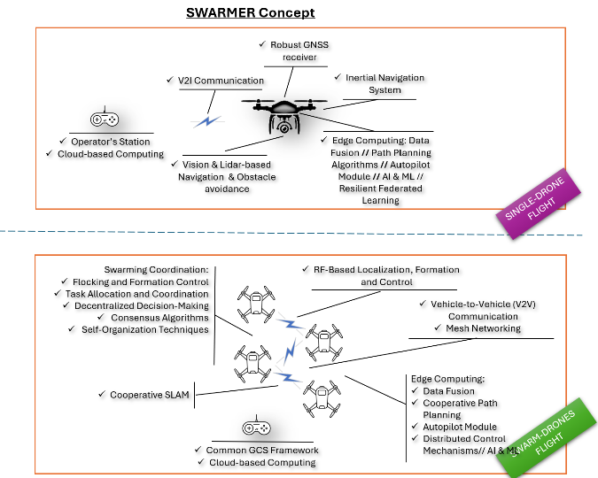
In the single-drone flight, the concept highlights key components such as a robust GNSS receiver and inertial navigation system (INS) to ensure accurate positioning, even in the absence of GNSS signals. The drone utilizes vision and LIDAR-based navigation for obstacle detection and avoidance, ensuring autonomous operation in complex environments. V2I (Vehicle-to-Infrastructure) communication allows the drone to interact with ground-based infrastructure, when available, enhancing its coordination capabilities. Additionally, edge computing is employed to handle onboard data processing, including data fusion, path planning, and AI/ML-driven autopilot functionalities. These systems may additionally be supported by cloud-based computing, providing additional computational resources and real-time control.
Figure 2: SWARMER Concept
In the swarm-drones flight, the concept focuses on enabling multiple drones to operate as a coordinated unit. Key features include swarming coordination, with capabilities like flocking and formation control, task allocation, and decentralized decision-making through consensus algorithms and self-organization techniques. The swarm utilizes RF-based localization and V2V (Vehicle-to-Vehicle) communication to maintain accurate positioning and real-time data sharing among drones. The mesh networking capability enhances communication within the swarm, enabling seamless coordination. Cooperative SLAM (Simultaneous Localization and Mapping) allows the drones to collaboratively map their environment and localize themselves. The Common Ground Control System (GCS) framework supports overall swarm management, with cloud-based computing assisting in decision-making processes. Similar to the single-drone operation, edge computing enables real-time data fusion, cooperative path planning, and AI/ML-driven decision-making across the swarm. This concept demonstrates SWARMER's focus on autonomy, coordination, and decentralized control, utilizing advanced technologies like AI and edge computing to enhance both individual and collective drone operations.
Figure 3 illustrates the SWARMER Architecture, showcasing how various components of the autonomous drone system interact with its cloud-based control station. The architecture is divided into two key sections: the drone platform and the control station, with multiple layers within each.
In the drone platform section, the sensors layer includes several key technologies such as Ultra-Wideband (UWB) for precise positioning, a robust GNSS module for geolocation, and an Inertial Navigation System (INS) for accurate positioning in GNSS-denied environments. Additional sensors include LIDAR for mapping and obstacle detection, along with UAV video streams (RGB and thermal cameras) for capturing environmental data. The processing layer of the drone fuses the sensor inputs using a Data Ingestion & Fusion Engine, which integrates data from various sources, including the SLAM (Simultaneous Localization and Mapping) module. This provides a coherent understanding of the environment, enhancing situational awareness. Above this, the control layer manages real-time decision-making and flight control. The Autopilot system controls the drone’s flight based on mission goals, while Real-Time Path Planning calculates optimal routes. The Navigation system ensures that the drone follows these planned routes, while an AI Module handles complex decision-making in dynamic situations. The Decision Support System (DSS) assists in mission-critical decisions, and Edge Computing enables real-time data processing on the drone, reducing the need to rely on cloud computing for immediate actions. In the control station section, the sources layer gathers external data, such as the location of assets and path planning configurations, to provide real-time mission planning. The processing layer at the control station also integrates data through its own Data Ingestion & Fusion Engine, creating a complete picture of the mission environment. The system is supported by cloud-based computing, which enhances computational capabilities for complex tasks like data analysis and long-term mission monitoring, both for the drone and control station. Overall, the SWARMER Architecture ensures a seamless integration of sensor data fusion, real-time control, and cloud-based support, enabling autonomous operation and mission adaptability in complex environments, even in areas where GNSS signals are unavailable or disrupted.
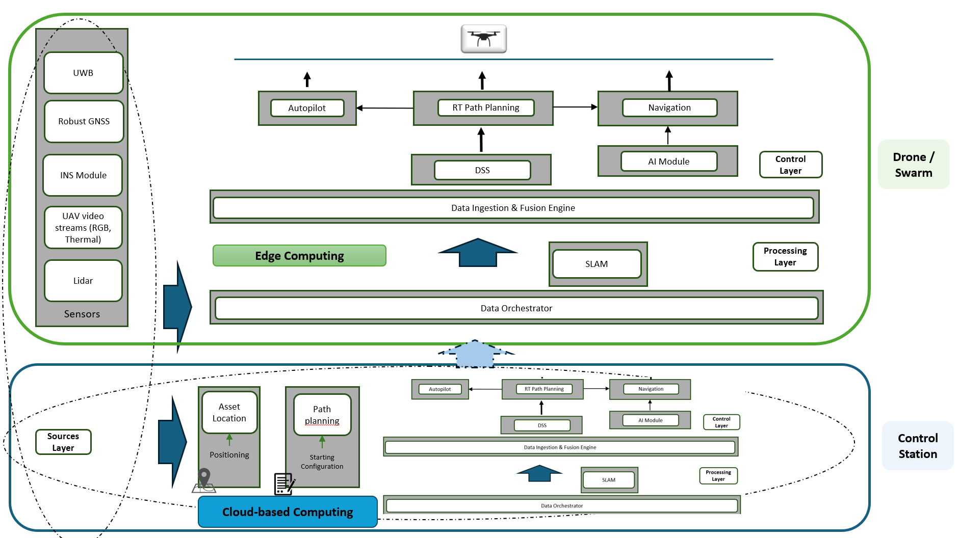
Figure 3: SWARMER Architecture

Centralised – Decentralised – Distributed configurations
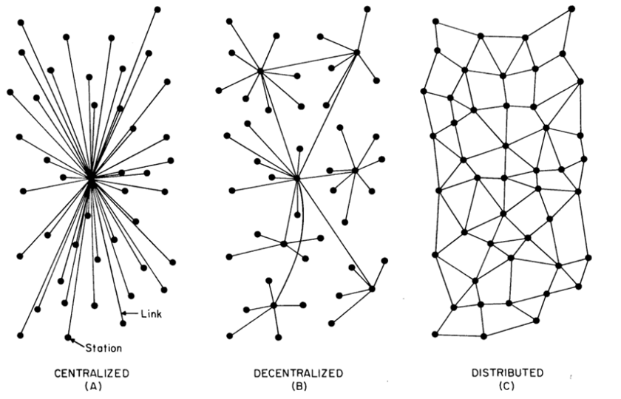
Another aspect that will be studied as well within the frame of the SWARMER project, considering always the requirements coming from the Challenge Organising Consortium, is the applicability of the different decision-making and processing configurations of the Centrallised, De-centralised and Distributed approaches - Figure 4. These configurations are well established theories in multi-agent systems, swarm intelligence, and autonomous robotics.,,, In a centralised swarming configuration, a single central unit or "leader" manages the actions of all drones in the swarm, making decisions and issuing commands. This model simplifies decision-making, as one entity coordinates the swarm, ensuring uniform behavior and easy monitoring. However, the central controller is a single point of failure—if compromised, the entire swarm may be rendered ineffective, making it fragile in hostile environments. Additionally, centralized systems may face communication bottlenecks as all data flows through the leader, potentially causing delays.
Figure 4: Swarming Configurations
A decentralized configuration allows multiple drones within the swarm to make decisions independently based on local information, coordinating with nearby drones. This model improves resilience and adaptability, as there is no single point of failure; if one drone is lost, the others can still function. Decentralized systems respond more flexibly to environmental changes, but coordination without a central entity is complex and requires advanced algorithms to align individual actions with swarm goals. This approach may demand more processing power and communication bandwidth. In a distributed configuration, each drone is fully autonomous and responsible for its own actions, with minimal communication. Distributed swarms are highly scalable and resilient, as each drone operates independently, reducing the risk of widespread disruption. Redundancy ensures that individual drone failures have little effect on the mission. However, without continuous communication, complex tasks requiring precise coordination can suffer, leading to delays or inconsistencies in behavior. Additionally, the lack of central oversight may result in inefficient resource allocation during large-scale missions.

SWARMER TECHNOLOGIES
Νavigation
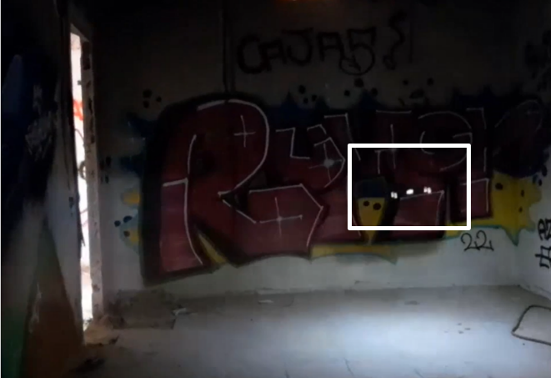
LIDAR-Based Navigation: LiDAR sensors can be mounted on drones in different ways: rotating to scan the entire scene or fixed for specific areas. Data is processed by a microcontroller, using algorithms to identify objects and obstacles in the environment. RGB cameras have limitations like reliance on visible light and a limited field of view, affecting performance in low-light, shadows, glare, and fog. They also require more computational power. LiDAR overcomes these by operating in any lighting, having a wider field of view, and measuring distances and sizes more accurately. Moreover, LiDAR-based obstacle navigation enhances drone safety by avoiding collisions, maintaining safe altitude and distance, enabling accurate landings, and following paths or targets while adapting to environmental changes. Mini-LIDARs (Time of Flight LIDAR) in combination with pre-defined thresholds and rules are implemented operational currently by ETRA for obstacle avoidance in indoor and outdoor environments. Vectorial algorithms are used to calculate magnitude and direction depending on the obstacle position, providing the necessary input to allow the drone making flight decisions. In the Figure 5, ETRA’s AKILA e-micro UAS is showcased navigating in indoor environment with low lightning and field of view.
Figure 5: AKILA e-micro UAS is showcased navigating in indoor environment with low lightning and field of view
ETRA’s approach for the development and implementation of LIDAR-based obstacle avoidance algorithms will aim to guarantee flight safety and efficiency under different swarming configurations. Research and development of Vector Field Histogram (VFH) algorithms leveraging 3D measurements will take place. The 3D LIDAR-based VFH algorithm will be expanded to use measurements from various drones involved in the swarm, with the objective to maximise environment coverage with the minimal resources. Architectures for decentralised obstacle avoidance are optimised for edge deployment, preparing the ground for scaling-up drone swarm strategies and formation. Furthermore, specific obstacle configuration of the environment will be addressed, both indoor and outdoor, which may pose a challenge for LIDAR-based navigation. In SWARMER, ETRA will optimise perception and avoidance by sharing the outputs of a swarm-based VFH algorithm to perform autonomous adaptations on the drone flight path while holding the planned swarm configuration.
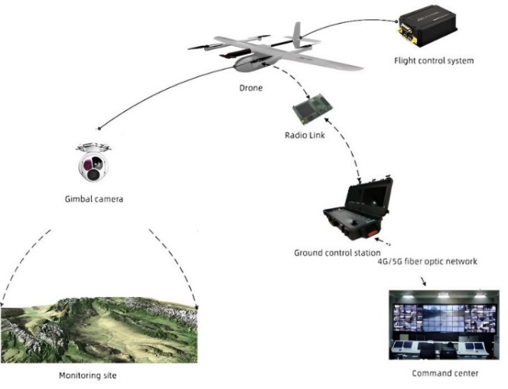
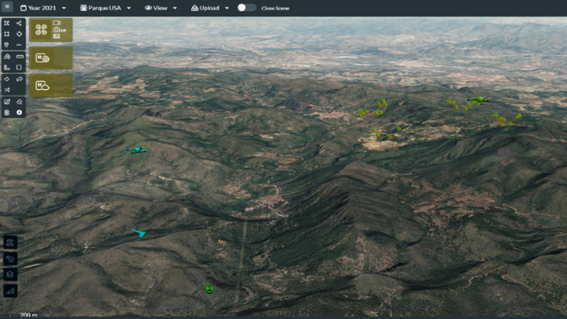
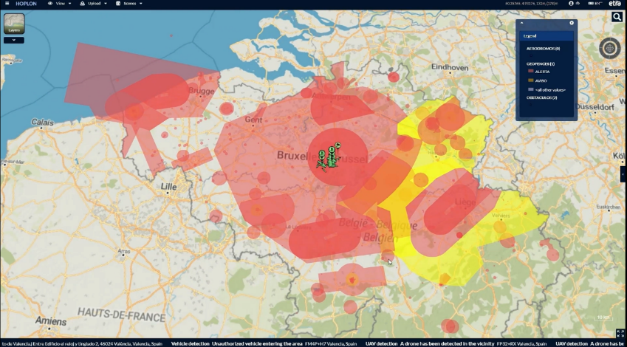
Mission Management User Interface And Interoperability Layers: Mission Management Systems (M2S) have gone in the recent years through a transition from platform-based and rule-based to distributed and intelligent. As M2S inherently process in real-time a large number of various data types, exploiting the underlying data through efficient user interfaces and interoperability layers is of the outmost importance. Through the past 5 years, a flexible and modular mission management platform (Figure 6) has been developed by ETRA, which can be deployed on the cloud or on-site based on user requirements. The platform has been developed through several EU-funded projects such as LETSCROWD¹, ASSISTANCE², SAURON³ at an early stage, later PRAETORIAN⁴, PERIVALLON⁵ , POP-ART⁶. A picture of ETRA’s M2S is included below:
Figure 6: ETRA's Mission management user interface
Computer vision: Computer vision comprises a pivotal domain within artificial intelligence empowering robotic systems to acquire, process, and interpret visual data from their surroundings among others. Such technology leverages advanced algorithms from the Machine and Deep learning research community to emulate human visual perception, enabling robotic platforms to perceive its operational areas and to perform tasks such as object detection, scene reconstruction, localization etc. Specifically, within the objectives of the robotics research domain, computer vision facilitates autonomous navigation, precise manipulation, and adaptive interaction with dynamic surroundings. By integrating sophisticated image processing techniques and machine learning models, computer vision targets to improve the cognitive capabilities of robots, driving significant advancements in automation and intelligent system design.
Figure 7: Common architecture for RPAS surveillance operations.
Towards delivering and integrating innovative and cognitive capabilities in each SWARMER prototype, supervised AI techniques will be designed considering essential system parameters such as overall performance (detection accuracy and computational resources), power consumption, autonomy etc. An optronics system comprises the most common payload and sensory system for surveillance operations and execute ISTAR operations from RPAS systems. The integration of novel AI techniques prerequisites the (near) real-time consumption of the acquired data following end-to-end architectures (Figure 7). Based on the adopted architectural approach, the AI-based detection models, either they operate on a server side (Command & Control) or on-board of an aerial vehicle through an embedded platform, supervised models will consume the available information to estimate the existence of specific targets with a metric of the confidence level and a potential estimation of the target’s location. The latter will be available to a unified prototype in order for other components to consume the produced information and either to extract additional knowledge or update accordingly the operator.
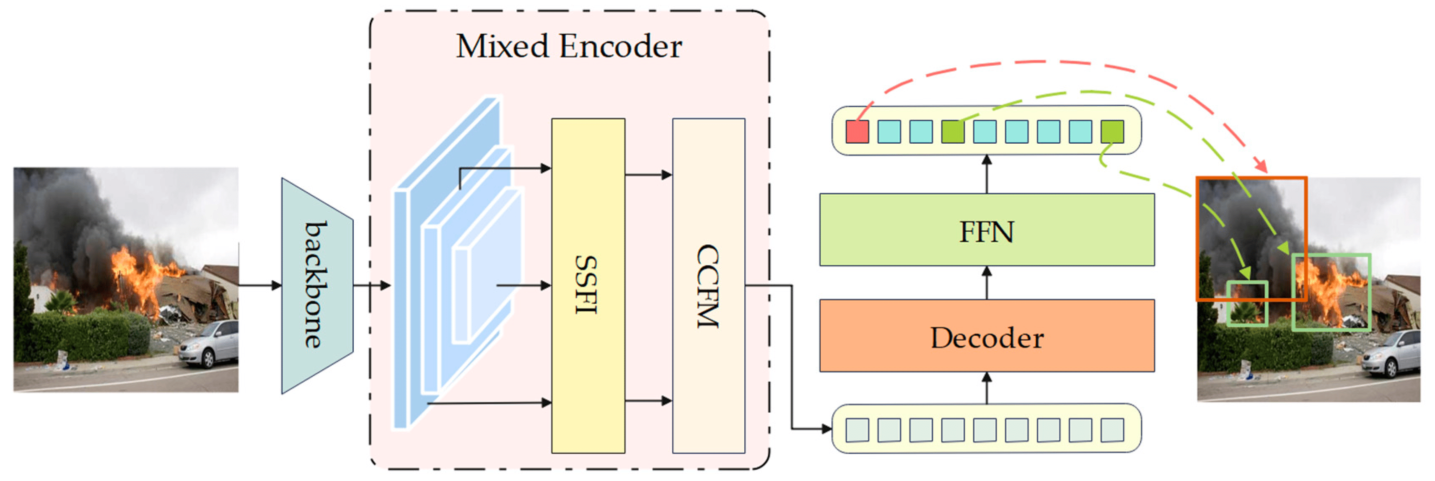
Such a versatile and flexible architecture permits an integration approach of plug-n-play rationale though, with minor adaptations that are relevant with the technical specifications of the payload. Hence, the researched models will consume frames acquired as part of visual streams from the RPAS systems. Such models will rely on deep learning architectures to identify the requested objects nonetheless essential parameters will be under serious consideration to contribute to autonomous navigation such as low available resources, improved overall performance and low power consumption. Modified YOLO architecture, entitles as YOLOv7-sea, was applied for such operations focused on maritime operations. Similar basis model, namely YOLOv5, was also adopted for the detection of small size objects or from a considerable distance rendering the latter as potential candidate for RPAS surveillance operations. More advanced architectures were also proposed where attention mechanisms are adopted nonetheless, at the expense of time complexity. Though, such technologies have been significantly improved to support also real time operations, an essential parameter for robotics and the defence sector, categorized as Vision Transformers. Such models were also utilized as back-bone layers of more complex structures towards improving the detection capabilities (Figure 8). Apart the visual detectors and towards taking advantage of the collective intelligence, the system will also incorporate capabilities for optimal mapping operations and advanced localizations for each swarming member. Without the necessity of upgrading the RPAS system with a dedicated sensory system, collective monocular SLAM has been extensively researched by the robotics community. Numerous approaches have been proposed and validated either at a resource allocation level or sensor layer e.g. LiDAR. All aforementioned models will comprise the research basis that within the scope of SWARMER, will be extended targeting to improve the detection accuracy and reduce the overall complexity.
Figure 8: Vision Transformers as multi-object detector.
Vision Transformers (ViTs) have revolutionized the entire computer vision domain by leveraging the self-attention mechanism, permitting the caption of global interactions within an image and video stream frames. Unlike traditional Convolutional Neural Networks (CNNs), which rely on local receptive fields, ViTs process the entire caption as a sequence of patches, enabling them to model long-range dependencies more effectively and efficiently. This feature renders ViTs particularly well-suited for tasks that require comprehension of complex spatial relationships, such as object detection, particularly in dynamic and challenging environments. Utilizing such architectures as visual object detectors, the objective is to identify and locate objects within the projection plane. In summary, ViTs approach the objective by dividing the image into a patch grid, each of which is linearly embedded into a fixed-size vector (Figure 9). These vectors are then processed through multiple layers of self-attention and feed-forward networks, allowing the model to learn hierarchical representations of the image. The final output is a set of predictions for each patch, which are then aggregated to form the final detection results. This approach contrasts with CNN-based detectors, which typically use a hierarchical feature pyramid to detect objects at different scales.
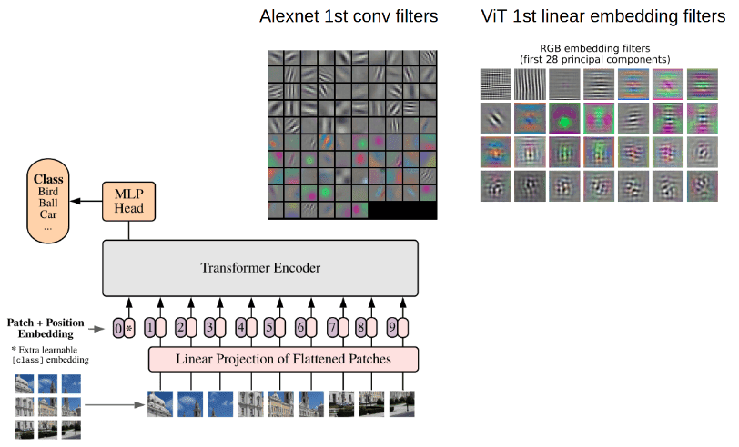
From their initial introduction, ViTs have attracted considerable interest from the research community proposing various alternatives and upgrades that significantly improve the overall performance. In particular, ViTs require the extensive use of large datasets for the training and validation process though, data availability comprises a significant limitation specifically in military applications due to security constraints. To surpass this limitation, pre-trained and/or fine-tuned models were proposed that rely on open vocabularies and frugality principles (RO-ViT). A similar rational of utilizing pre-trained models with specific computer vision updates was also proposed towards increasing the detection accuracy nonetheless at the expense of the significantly increased complexity. The latter was also an essential parameter jeopardizing the insertion of such technologies in defence systems as time and accuracy are of paramount importance. Alternatives targeting to improve processing time were also proposed.
Figure 9. Preliminary ViT architecture
Towards a robust, computer vision-based navigation system, the studied ViT models will contribute to both optimizing the operator’s situation awareness through automated ISTAR operations and adapting each SWARMER member navigation outcome. Each individual member will locally adjust its locomotion so as to avoid potential objects and/or optimize its objective e.g., wider coverage. Following the SWARMER Challenge timeline, all necessary activities will be dedicated for each development iteration/phase to deliver fully functional services. During the first period of the project’s execution, the collected user requirements will be thoroughly assessed to define communication protocols and the technical specifications needed for the acquisition of the visual streams. In addition, ISTAR related information will be identified so that the collection of the required datasets can be initiated as well as the technical requirements for the execution of each model (embedded and/or server). Each development circle will be initiated with the user requirement assessment, proper adaptations of the computer vision model, laboratory validation tests and performance evaluation under real operational conditions. Hence, during Phase 1, a feasibility study will be performed within the scope of assessing the initial user requirements. Design phase of the models will follow while their lab validation will comprise the base of producing knowledge. Each Phase will be concluded with the Integration phase where every model will be altered to comprise a component of one unified system.

Autonomy
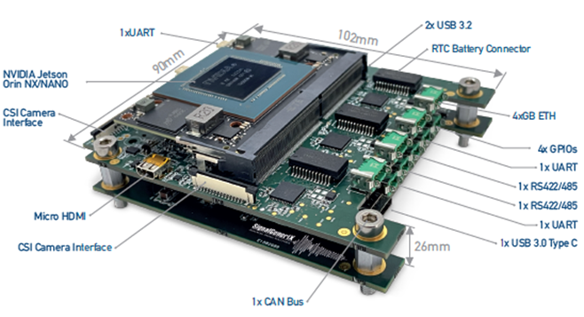
Intelligent Navigation Payload – Edge Computing: The technological brick for the SWARMER proposal brought by SignalGeneriX is the design and development of the edge AI computer for small drones during the missions that aims to run computational burden algorithms for swarming capabilities, autonomous navigation and obstacle avoidance in GNSS denied environment. It is therefore necessary to develop an airborne and cost-effective AI-board with strict SWaP constraints so as to enhanced autonomy and decision making for successful mission execution. The UAVs are equipped with ISR sensors eg. Camera, LiDAR in order to detect, recognize, classify and track targets in near-real time using AI algorithms which cause considerable computation burden. In addition, the AI computer capabilities aim to execute algorithms with enormous data from the aforementioned sensors required in advanced data fusion techniques. The AI board aims to provide sufficient resources in order to effectively cooperate with the communication sub-systems and run complex algorithms with minimum power consumption ending a successful mission execution while controlling sensors that are necessary for autonomous navigation eg. SLAM, computer vision. Moreover, the AI-board will be tailored to meet the SWaP constraints so as a lightweight, low volume is implemented tailored to the requirements of the SWARMER. A recent prototype AI prototype board (Figure 10) that SG has designed and developed for the LOTUS EDIDP project is depicted below. The board will be tailored to the SWARMER project to exhibit high levels of autonomy, particularly in navigations and swarming capabilities making the UAS capable for navigation in non-permissive environments through the integration and testing for advanced multisensory systems, intelligent information fusion techniques achieving effectiveness and robust performance even in the most challenging environments. A miniaturized AI edge computing board is expected to be developed from Signalgenerix by the end of the SWARMER able to interface various sensors with large data amount (eg. LiDAR, Camera), run computational burden algorithms (eg. SLAM) and meet the strict SWaP limitations of an airborne platform integrated to the UAS that are used in the SWARMER project. The AI edge computing board will be tailored to the needs of the project but during the design stage the adaptability and interoperability will be considered so as to make sure that the board will be able to be integrated with other systems in the future. The Edge AI computer in the SWARMER UAS represents a sophisticated technological integration designed to perform complex, mission-critical tasks autonomously. Below are the main technological bricks underpinning its development and successful operation:
Figure 10: AI prototype board with relevant interfaces
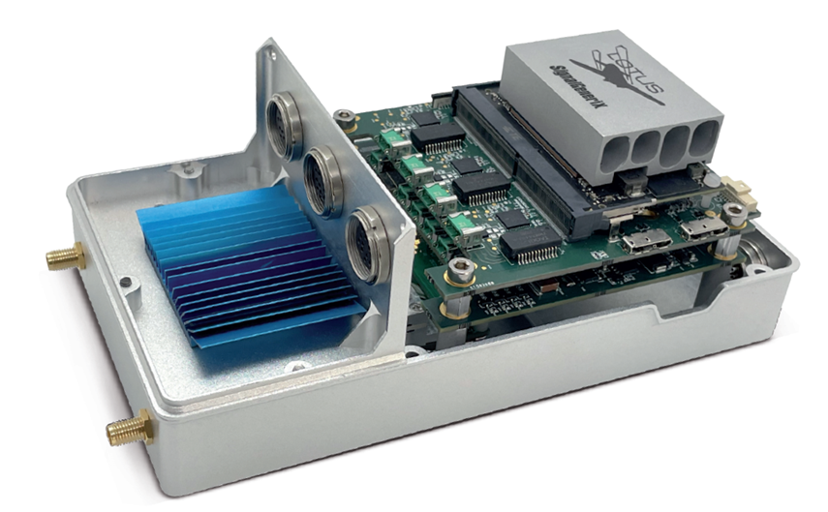
The SWARMER's central processing and mission execution are powered by an Edge AI computer, serving as the primary processing unit for mission-critical algorithms and task execution in centralized, decentralized, and distributed configurations for swarming or standalone missions. Equipped with NVIDIA Jetson Orin NX and Nano modules, it supports AI, machine learning, and edge computing, enabling high-performance, real-time autonomy for complex mission objectives without human intervention. This computer’s data processing capabilities manage and analyze information from various sensors to support obstacle avoidance, SLAM (Simultaneous Localization and Mapping), and ISR (Intelligence, Surveillance, and Reconnaissance), essential for precise navigation, mapping, and mission adaptability. It integrates seamlessly with the autopilot and sensors, connecting with components like LiDAR and cameras to enhance situational awareness and decision-making. With up to 100 TOPS GPU performance, the Jetson Orin modules enable real-time object recognition, environmental adaptation, and autonomous path adjustments, creating a detailed operational environment map. Operating within a 7W to 25W power range, it optimizes battery life while maintaining computational performance, crucial for extended missions. Its flexible cooling options—fan-based or passive—allow it to operate effectively in diverse environments, while its modular, scalable design enables customization for evolving mission requirements (Figure 11). This architecture makes the Edge AI computer vital to SWARMER’s autonomous mission execution and real-time adaptability, ensuring SWARMER's effectiveness in UAS swarming operations.
Figure 11: Edge AI computer Integration flexibility
Data Fusion: Multi-sensor data fusion (MSDF) is essential for enhancing perception in drone swarms, particularly in GNSS-denied environments. By integrating data from cameras, LiDAR, RADAR, and other sensors, MSDF improves decision-making, situational awareness, and swarm coordination. AIA has developed capabilities across three fusion Figure 12.
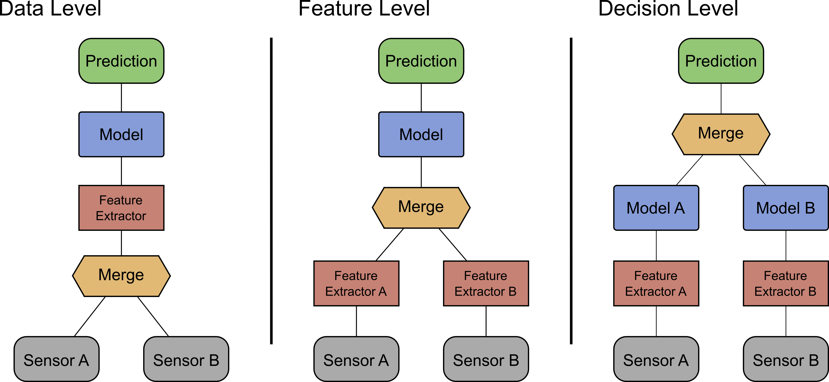
Figure 12: Data Fusion Levels
Data-Level Fusion combines raw sensor data, like LiDAR and video feeds, to create a comprehensive dataset for mapping terrain and obstacles. This approach involves preprocessing for calibration and noise reduction, normalizing data to enable effective merging, and using the fused dataset for subsequent analysis. Feature-Level Fusion extracts specific features, like shape or texture, from each sensor’s data. For example, object recognition may merge shape data from cameras with depth data from LiDAR. This results in a combined feature set that enhances object detection and is then fed into AI models or neural networks for complex tasks. Decision-Level Fusion merges independent decisions from each drone, such as identifying objects or locations. Each drone processes its data and makes decisions individually, which are then combined—often through voting systems—for a unified swarm response. MSDF can be managed through centralized or decentralized fusion. In centralized fusion, data flows to a single processing unit, increasing computational power but risking single points of failure. Decentralized fusion distributes processing across drones, improving robustness but facing challenges like limited resources and fragmented views. AIA will test both fusion configurations to find optimal setups for resilience and autonomy, particularly focusing on adaptive algorithms to handle drone dropouts effectively. Here the authors demonstrated an improvement by proposing a variational Bayesian adaptive Kalman filter. In this reportthe authors present an adaptive weighting algorithm which is applied to the raw data before a linear Kalman filter where the weights are decided based on the confidence in measurements provided by the respective sensors. One limitation of the mentioned algorithms is that they were applied for single drones, not a swarm. Distributed Kalman Filters (DKF) have been suggested to extend the Kalman Filter for use in drone swarms. DKFs allow drones to share these state estimates with others in the swarm, combining them to provide a more accurate collective estimate. Here authors used a DKF to fuse inertial information and optimised position estimation to modify the navigation states. As an alternative to variations of the Kalman Filter, the use of The Information Consensus Filter was proposed as a common state estimator data level fusion. While these methods extend to drone swarms, they were utilising GPS data in the fusion process and were never adapted to GNSS denied environments. With this limitation in mind the authors proposed a hybrid solution consisting of an adaptive Kalman Filter and a neural network. Results were promising when testing in a simulated GNSS denied environment, but the solution was never tested with a real-life drone warm subjected to various environmental conditions. Additionally, the method was not tested or adjusted to accommodate for drone dropout. AIA will develop a solution to the problem of Raw Data Fusion which is capable of operating in challenging environments with various constraints and under dynamic swarm conditions. Feature and Decision Fusion: Recent methods proposed for data fusion in UAV swarms at the feature and decision levels aim to enhance collaborative sensing and decision-making. Feature-level fusion extracts features from the raw sensor data (e.g., images, sensor readings), using several approaches including traditional techniques (Optical flow, histogram of gradients) and deep learning based techniques (convolutional neural networks (CNNs) and autoencoders) to create a unified representation. This helps in improving object detection, localization, and mapping accuracy. Decision-level fusion, on the other hand, aggregates decisions made independently by each UAV through consensus algorithms, voting schemes, or evidential belief reasoning techniques. These approaches ensure robust and efficient group decisions, even in dynamic and uncertain environments. Combining both levels of data fusion optimises swarm performance.
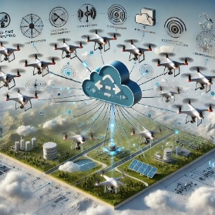
Cloud Computing Cloud-based computing can offer several advantages to autonomous drones or swarms of drones by offloading heavy computational tasks, providing real-time data processing, and enhancing coordination capabilities. While drones often have limited onboard processing power, leveraging cloud resources enables them to perform more complex tasks and improves the overall efficiency of their operations. Below are the key benefits of cloud-based computing for autonomous drones and drone swarms (Figure 13): Enhanced Data Processing and Storage: Offload large datasets and conduct complex analyses remotely, freeing up drone resources for other tasks ● Real-Time Collaboration and Swarm Coordination: Improve coordination among drones in a swarm using cloud-based communication, enabling dynamic task allocation and real-time collaboration ● Advanced Ai and Machine Learning: Leverage powerful AI models for decision-making and pattern recognition, enabling more effective autonomy and adaptation to changing conditions ● Scalability For Large Drone Fleets: Manage large numbers of drones more effectively through elastic cloud resources that can scale up or down based on mission demands ● Big Data Analysis And Predictive Insights: Analyze large volumes of sensor data to extract insights and patterns, helping drones to predict and react to evolving threats ● Reduced Onboard Processing Requirements: Extend drone flight time and reduce the cost of drone components by offloading computationally intensive tasks to the cloud ● Centralized Mission Control and Remote Updates: Remotely control, monitor, and update drones in the field via cloud-based systems, enabling real-time mission adjustments and software updates ● Global Connectivity and Distributed Operations: Enable cross-region drone coordination and seamless data sharing via cloud, enhancing collaboration for large-scale operations ● Secure Data Storage and Cybersecurity: Protect sensitive mission data using encryption and other cloud-based security protocols to ensure data integrity ● Remote Data Access for Multi-Operator Teams: Facilitate collaboration between multiple teams and operators by providing shared access to real-time mission data via cloud systems.
Figure 13: Cloud-computing concept in SWARMER
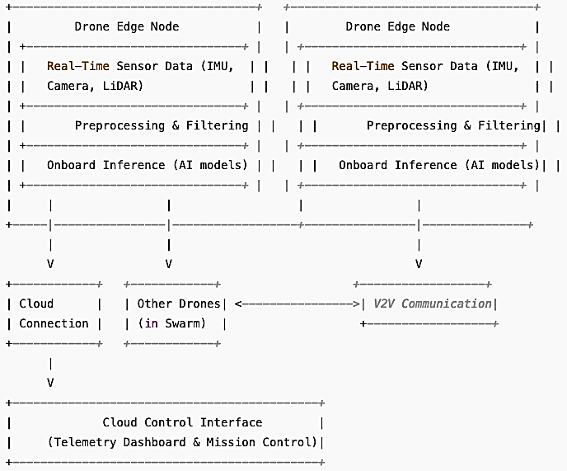
IKH’s technological contribution to the project leverages the power of cloud platforms to enhance the computational capabilities of autonomous drones and drone swarms. By integrating cloud services, we enable real-time processing, coordination, and decision-making for drones, optimizing their performance in complex and dynamic environments. The core components of the proposed technology stack are designed to facilitate efficient task distribution, high-availability, real-time analytics, and seamless communication between drones and the cloud. This architecture ensures that autonomous drones can rely on external cloud resources for demanding computational tasks like optimized path planning, swarm coordination, and data analytics.
Key Components
Cloud Infrastructure: The cloud platform provides scalable storage, computational power, and machine learning models that drones can access on-demand. This infrastructure includes:
- Data Storage: A scalable, distributed storage solution for sensor data, imagery, and operational logs.
Figure 14: HL Architecture of Cloud-Computing
- Compute Resources: Virtual machines (VMs) or containers (e.g. via Kubernetes) to run complex algorithms (e.g., environmental mapping, etc.).
Edge Computing Node (on drones): Each drone is equipped with an edge computing module that provides a local processing layer. The edge device will perform preliminary compression to minimize latency in communication with the cloud. This component includes:
- Task Offloading Logic: The capability to dynamically decide which tasks to process locally and which to offload to the cloud depending on current latency and resource availability.
Telemetry & Control Dashboard: Operators can interact with the drones via a cloud-based interface. This dashboard provides real-time telemetry from the drones, a live map of their positions, and mission status.
- Real-time Visualization: Cloud-hosted visual analytics tools to display the drone’s flight path, environmental data, and mission-critical KPIs.
- Mission Control: The interface allows users to update mission objectives, change drone flight parameters, and issue commands to individual drones or the entire swarm.

Figure 14 shows a high-level architecture diagram illustrating the interaction between drones, the cloud, and the edge processing components. Our approach combines cloud computing and edge processing to create a scalable, low-latency, and efficient system for managing autonomous drones and swarms. The cloud-based architecture supports scalability by offloading resource-intensive tasks like object recognition and mission planning, enabling the system to handle a larger number of drones. Edge computing on drones reduces latency for mission-critical decisions, such as obstacle avoidance and real-time tracking, while real-time analytics optimize drone tasks and trajectories, enhancing overall mission efficiency. By leveraging both cloud and edge resources, this system is designed to support robust and responsive swarm operations
Autopilot Expert System: Every UAS mission is complex, requiring precise synchronization of interdependent elements. The autopilot plays a critical role, as the core of the avionics, coordinating all subsystems, making a resilient and reliable system essential for handling challenging flight situations. They typically consist of hardware and software components that work together to provide flight control and automation capabilities. ETRA has developed flight control systems for single drones and for drone swarms, operating both centralised and decentralised. The proprietary autopilot expert system provides robust positioning, speed and orientation of the drones (swarm) against external conditions (wind and rain) and internal factors. In this sense, failsafe mechanisms such as return-home, battery monitoring and loss of communication protocols have been implemented. In the case of quadcopters and when one or more engines turn out of service, the system automatically balance the remaining engines power to keep the drone in the air. Furthermore, ETRA’s drones can be equipped with anti-jamming technology to mitigate GNSS outages caused by jamming and enable continuous operation of communication and navigation systems in jammed environments. The technology allows to detect when a specific frequency band starts to fade (as a consequence of jamming), automatically switching to another frequency range to keep the communication link.
Flight Control, Failsafe Mechanisms: ETRA will also implement a resilience-based failsafe algorithm to protect each individual drone and the entire swarm against hardware and software threats. Health monitoring mechanisms will be implemented to monitor drone onboard sensors (GNSS, battery, etc.) and early identify anomalies which may hinder flight performance and safety. Unsupervised machine learning techniques, such as K-Means, Isolation Forest and 1-class SVM will be explored. Different protocols will be established to guarantee swarm safety and performance based on the particular scenario (e.g., hold position, kill switch, return-to-home, mission cancellation, etc.).

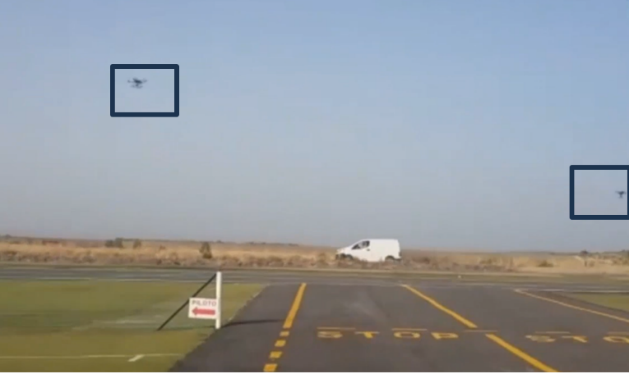
AI-Based Decision-Making Algorithms: For swarm coordination and task allocation, operational swarming strategies implemented by ETRA consists of assigning role-based missions to the drones conforming the swarm. In Figure 15, an example of ETRA’s drone swarm escorting a van is provided. In parallel to this, ETRA has significant expertise in the development of data-driven decision-support systems with applications in different fields: critical infrastructure protection, fighting crime and terrorism, etc. In the PRAETORIAN project, the system used a rule-based system to link real-time events with potential threats and vulnerabilities, providing mitigation measures based on identified risk levels. This system was successfully validated in pilot demonstrations, including airports, ports, hospital and power plants. In the PERIVALLON project, the system supported law enforcement and government agencies. The system evolved to automatically assess risks by learning from data collected from various sources, such as satellite images, drones, and the Darkweb. It adapts to emerging threats by continuously learning from past and current incidents and user decisions. Overall, ETRA's decision-support system is a configurable system that combines rule-based approaches with machine learning techniques to prioritize incidents based on risk levels and recommend/implement response actions to mitigate those risks effectively.
Figure 15: ETRA’s drone swarm escorting a van

Swarming
Radio-Based Swarm Navigation: The Institute of Communications and Navigation at the German Aerospace Center (DLR) has researched radio-based swarm navigation technologies for over a decade, focusing on decentralized network establishment, localization, and trajectory optimization in GNSS-denied environments. So, DLR's contribution to the SWARMER project focuses on developing an intelligent multi-agent system for GNSS-free navigation and communication, along with advanced data processing methods to enhance robustness and resilience. Utilizing swarms of autonomous agents can significantly improve sensing accuracy, efficiency, and autonomy—key traits for safety-critical applications. Unlike single-agent systems that rely on teleoperation, multi-agent systems demand greater autonomy and collaborative decision-making, especially in military applications where the reliability of agent decisions is vital. DLR will provide three core technologies for the project: swarm navigation, swarm networking and swarm control.
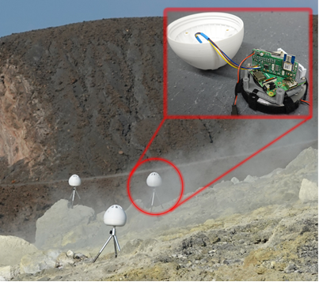
Swarm Navigation: DLR provides a swarm navigation system (Figure 16) utilizing ultrawideband (UWB) radio technology to measure distances based on signal propagation delays, enabling the calculation of relative positions. We have developed a decentralized particle filter that runs in real-time on the swarm agents and provides the swarm agents’ navigation state estimates such as position and velocity.
Swarm Networking: The DLR swarm navigation system utilizes decentralized self-organized time division multiple access (SO-TDMA). This algorithm operates in real-time on each swarm agent, eliminating the need for a central unit or pre-defined schedule. It adapts to changes in the swarm's topology, such as when nodes fail, drop out or rejoin.
Each swarm agent transmits a UWB signal during its designated TDMA slot, which is received by nearby nodes. Both transmission and reception are time-tagged, capturing distance information between the transceivers.
Swarm Control: The swarm can benefit from its situation awareness to conduct the mission in a controlled and efficient fashion. For example, in information seeking control, the swarm can adapt its trajectory, maximizing the gain of information on its own state and the environment. Specifically, the localization of the agent in the swarm depends on its location with respect to other agents (see image below).
Figure 16: UWB sensor nodes in an experimental environment at Vulacno Island for SO2 gas concentration measurement. Upper right: Assembly on a sensor node

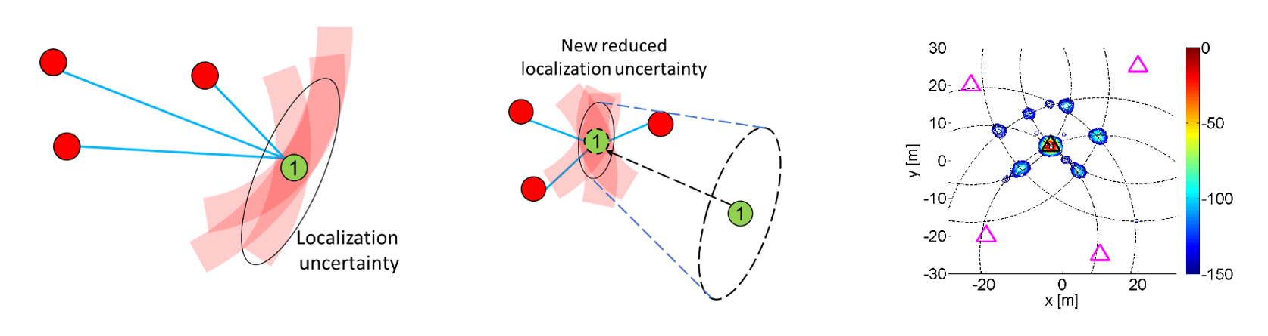
Figure 17: Localization uncertainty for the agent depends on its location; Relocation of the agent can significantly impact its localization accuracy; Simulation results or agent’s location and accuracy estimate

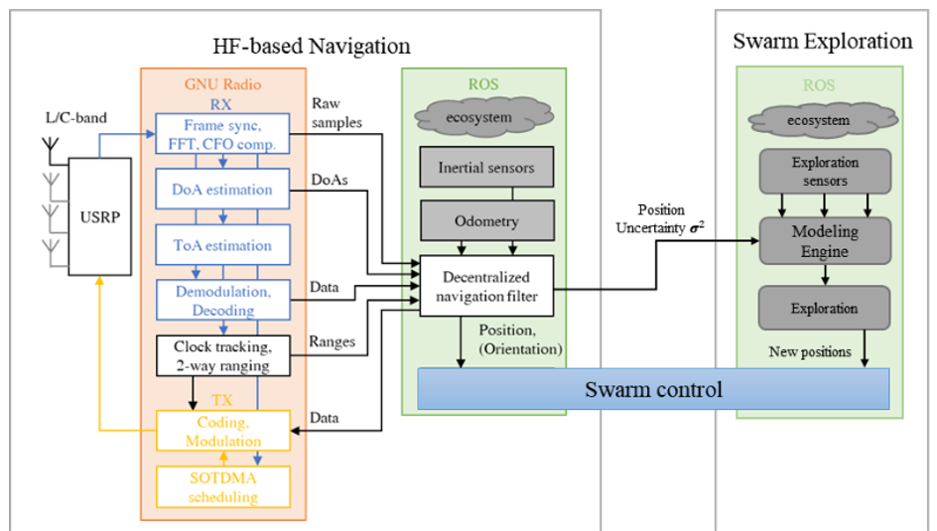
By moving the agents, the total localization uncertainty can be reduced (Figure 17), thus providing more accurate localization results. The corresponding swarm control algorithms thus identifies the movement direction for each agent to reduce this uncertainty. Such control strategy can be shown to be related to information seeking swarm behaviour: it modifies the swarm network topology such that new inter-agent range measurements increase information content with respect to the localization accuracy. In the current implementation, a self-localization information seeking control algorithm is running in real-time on our big robotic platforms with more computational power. As to the current compact UWB sensor node, the swarm control functionality is under development. The size, weight and power consumption of DLR’s UWB swarm navigation sensor nodes allow to operate them at comparable small swarm agents such as drones. For system performance analysis the UWB swarm navigation system devices provide capabilities to record data such as time tags, distance estimates, and channel impulse responses (CIRs). DLR has tested the UWB swarm navigation sensor nodes have been tested during large experiments. The figure below shows an example of 3 of a total of 15 sensor network in a static setup at the rim of a volcanic crater on Vulcano island, Italy. In this project, we propose to further develop our UWB swarm navigation and exploration system (Figure 18), integrating the UWB senor nodes on drone platforms, including real-time decentralized sensor fusion algorithm on each entity, feeding the state estimation into a swarm agent controller that is optimized for navigation and environmental inference performance maximization. Besides, we plan to focus on the robustness of our UWB swarm navigation system against topological- and environmental changes as well as measurement outliers. These contributions are reflected in the following components:
Swarm Network: We plan to further develop the UWB swarm network with SO-TDMA. This network is especially tailored for complex environments, which is self-adaptable to formation-, topology- and environmental changes. We particularly focus on challenging environments where agents in swarm are sparsely connected due to signal blockage, interference and coverage limitation. In these scenarios, the high package loss rate and frequently changing topology is an unsolved issue. In addition, we will study the information exchange aspect of the swarm, where the agents optimize the data carried by their transmitted messages, including time, state estimation, environmental information, uncertainty inference, etc., in order to use the network capacity efficiently for their navigation and exploration tasks.
Figure 18: Schematic for Integrated Swarm Exploration
Swarm State Estimation: For swarm state estimation, we plan to implement real-time decentralized sensor fusion algorithms on each sensor node. A multitude of active devices, which transmit and receive UWB signals, and an arbitrary number of passive devices, which can only receive signals, can exploit the network for self-localization and information exchange. Such “listen-only” devices are of high interest in defence applications, where stealth capabilities are essential. Due to the dense mesh network nature of the swarm, the system imperfections like clock offsets and drifts and antenna delays can be estimated simultaneously with localization, which dramatically simplifies the design and manufacturing of the robotic swarm and provides common geo- and time references for the swarm. We focus on joint localization and synchronization algorithms with a mixture of active and passive nodes. In addition, the algorithm should provide reliable uncertainty inference of the estimated state. The algorithm should be decentralized, scalable, robust, and with low complexity and high precision, ergo suitable for a drone swarm. We further plan to tightly couple and integrate swarm navigation and swarm exploration, i.e., environmental inference using a swarm. Specifically, the proposed Swarm navigation module will compute not only the coordinates of the agents in the network, but also the corresponding uncertainties. These are key elements in enabling information driven swarm control. This, on the one hand, will improve swarm localization that will direct the drones to locations or increase localization accuracy considering requirements coming from exploration, environmental sensing or mapping entities. We plan to demonstrate the real-time capability of communication and navigation solutions and compare it with that achievable with GNSS localization. Furthermore, we will investigate the localization performance variation with respect to swarm perturbations, such as the loss or inclusion of agents in the swarm collective.
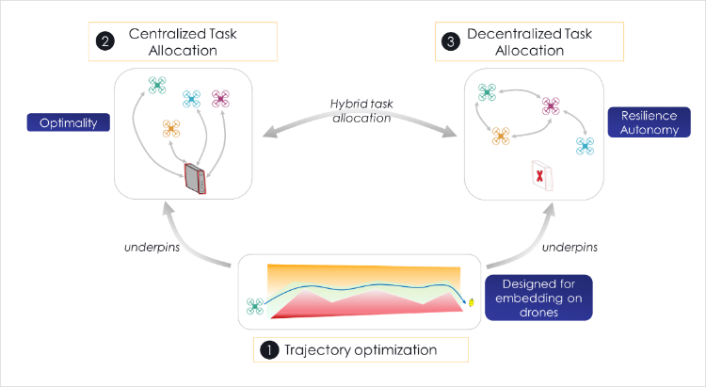
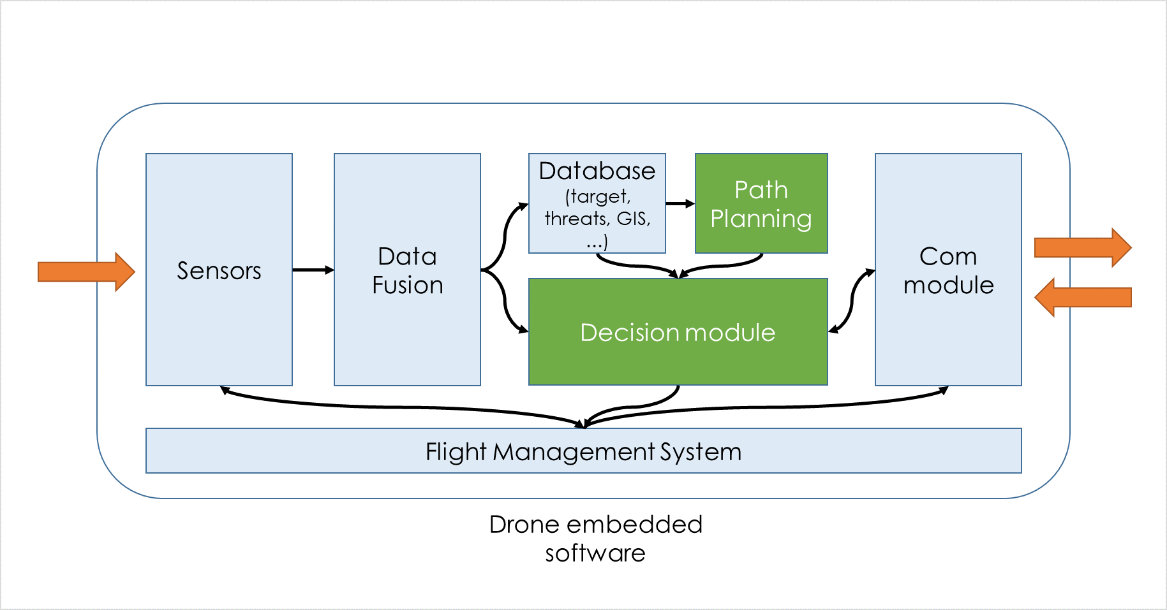
Swarm Coordination: Over the past 5 years, Thales Research & Technology has developed a software solution, named COHORT, to provide more and more autonomy to the swarms of drones. COHORT is made of different modules that were implemented gradually: starting from the basic need of a drone to safely and efficiently move from one point to another, it was then extended to allow covering an area with several agents. Later, additional functionalities were added to coordinate drones by automatically allocating tasks among the agents of a swarm. The task allocation, first computed centrally by a drone leader is now undertaken in a distributed way (decentralized approach). The different parts of COHORT may be summarized by Figure 19; COHORT aims to be integrated into the drone software ecosystem. As an example, the output of Path Planning module is a sequence of waypoints (whose granularity depends on the use case), handing over to the Flight Management System Module. To deliver the trajectories, the Path Planning Module relies on a database of any kind storing geographical information. The following figure presents a schematic presentation of the 2 main elements provided by COHORT for a drone to fulfil its mission (green boxes - Figure 20).
Figure 19: Parts of COHORT
Figure 20: Elements provided to the drone
Different Path Planning algorithms are available. 2D algorithms are fast to run and can be followed by a post-process to deliver a 3D trajectory to keep a specified altitude above ground. For specific needs, direct computation of 3D paths is available as well (Figure 21 - Error! Reference source not found.). 2D algorithms can consider anisotropic situations (wind / current) to provide the fastest path between 2 points. They can also be used on non-regular grids: some locations close to dangers could be described more precisely, and the granularity of the generated path can then be refined in these areas. Some of the algorithms show properties allowing massive parallel computation. In such cases, an alternative implementation is available to take advantage of GPGPU capacities. Concerning Coverage Path Planning - Figure 23, COHORT can handle coverage with a set of drones, by automatically splitting the area appropriately and producing for each drone an end-to-end trajectory. The area to cover, described by a polygon, can be non-convex and contain “holes” that should not be entered (this constraint is guaranteed to be respected provided the drones are holonomic). Regarding Task Allocation, as assigning a task appropriately implies considering information about paths the drone should follow, undertaking allocation is not followed by path calculation, but entangled with path generation functionalities. The centralized approach assumes the calculation unit has the entire situation awareness, allowing optimal results generation.
Different constraints may be added to the allocation problem formulation: agents might be heterogeneous, tasks can imply specific resources to allow completion (and these resources may be limited for some agents), tasks may require coordination between agents, etc. The decentralized approach stands here for “full decentralized way”: no agent plays a more important role than any other does. Therefore, the swarm gets rid of any “single point of failure” weakness. Despite, the fact that the optimal solution may not be reached by the set of agents, the quality of this solution is generally good, and the algorithms selected in COHORT provide guarantees on a minimum level of quality. This approach, despite being studied for 20+ years in the scientific literature, cannot easily be implemented in real life as different simplifying assumptions considered in theory do not hold up anymore (e.g. punctual communication disruption).

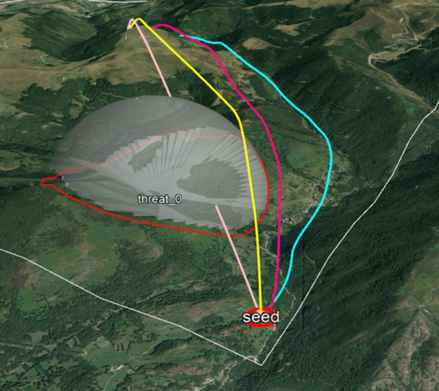  Figure 21: Different Path Planning Results | 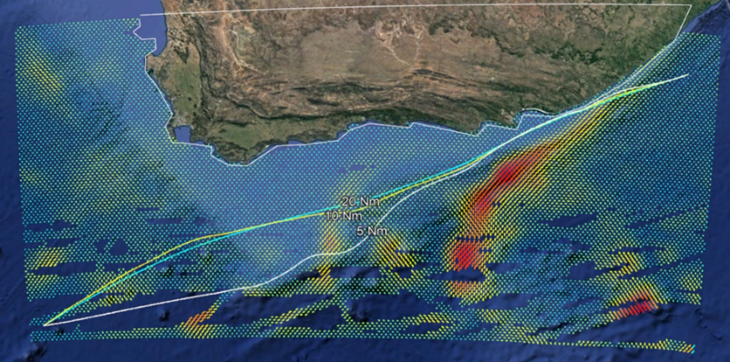  Figure 22: 2D algorithms can consider anisotropic situations | 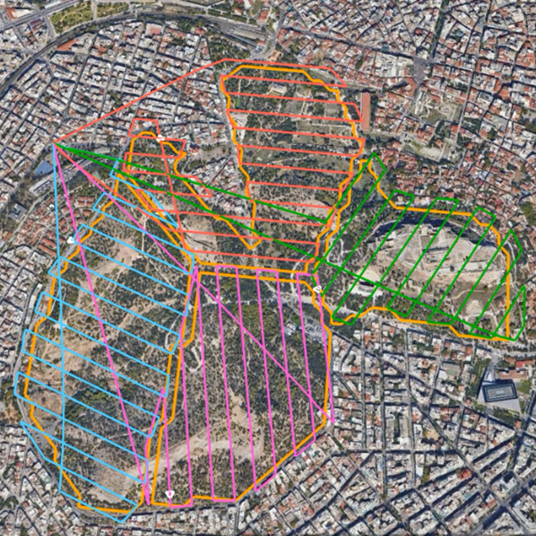  Figure 23: Coverage Path Planning

Knowledge/ technological modules to be developed within the project
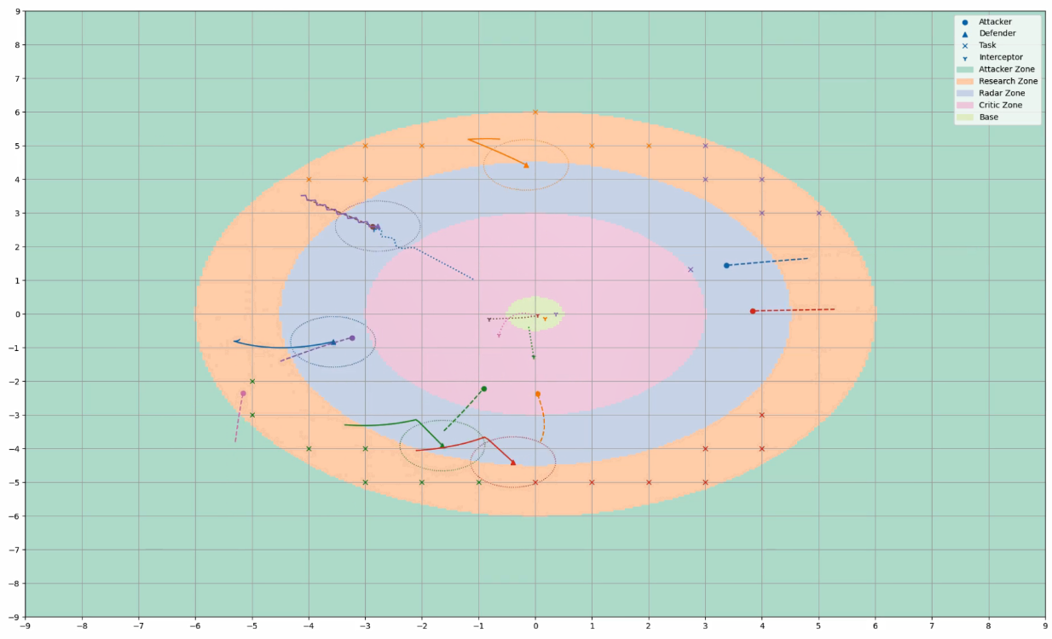
Adaptation of Path Planning algorithms to reset the geographical position in GNSS-denied environments: When the GNSS signal cannot be received anymore, the drone can estimate its position thanks to internal sensors. However, this estimation deteriorates over time and resetting the position with tangible elements may be necessary. Such elements can be, for example, specific landmarks or sets of recognizable areas that should be accessible to the drone quickly at any moment along the followed path. This implies some constraints on the trajectory that the drone is to follow, which should be integrated into the mission preparation. Then, during the mission execution, if the drone needs to fly over a specific area to reset its position, a new trajectory will be recomputed on the fly by the drone. Adaptation of trajectory to avoid collision: While a path had been calculated during mission preparation to stay close enough to areas that could lead to position reset, it may not be advisable to respect it when a collision can occur. The path should then be modified on the fly, as little as possible, to stay away enough to the danger. This alteration is dynamic and as several approaches could meet the collision avoidance requirements, staying in the neighbourhood of the initial path is not straightforward. It becomes even more complex when several agents should coordinate to avoid this collision. Improvement of current decentralized algorithms for real-life usage: The full decentralized decision algorithms (e.g. DCOP, Market-based) are known to provide consistent outputs as long as connectivity assumptions are respected. Unfortunately, these assumptions cannot be guaranteed in real life. To deal with this hurdle, some adaptations were proposed (like ACBBA), but if they improve the results in general, they do not assure that the results are consistent in all situations (a similar task may be assigned to 2 different agents). By defining and implementing some ad hoc rules, one can improve the situation to maximize the probability that the mission will be completed despite the alteration of the connectivity between drones. Implementation of complex decentralized allocation algorithms: The basic decentralized decision algorithms deal with rather simple problems. Adding several constraints is not straightforward and may lead to a long time to solve the problem. Different types of complex problems have already been studied in the literature. Adapting and improving them in the context of RADNP (potential coalition of several agents, autonomy) is key to efficiency. Additionally, Thales TRT has a large experience in European Projects. As such, it would support integration activities of algorithms into the drones and the C2 system and actively take part in the challenge on the field. A decentralized task allocation algorithm has been studied and simulated for countering UAV threats, where a swarm of defender UAVs protects a zone from an attacking swarm of UAVs. The defender UAVs can be grouped into two categories: scouts and interceptors. Scouts are responsible for detecting attackers as quickly as possible by exploring various sub-zones. Interceptors, on the other hand, are tasked with destroying the attackers once they are detected. The defenders are assisted by fixed ground-based radars. Given the two categories, two task allocation problems are considered. For scouts, different sub-zones are viewed as tasks, and each scout bids on them. Once a zone has been explored, its bids are reset, and it is treated as a new task. The scouts prioritize zones that have not been explored for a long time. For interceptors, the tasks are the detected attackers. Interceptors may need to form coalitions to increase the probability of a successful interception. Figure 24 illustrates a moment of the simulation. In the figure, a dot represents an attacker, a triangle represents a scout, and a "Y" symbolizes an interceptor. Crosses mark the different sub-zones assigned to scouts. The base is depicted with a light green background. The radar zone and the critical zone are areas where attackers are detected by ground-based radars. In the radar zone, detected agents are notified to scouts, who then verify whether the detected agent is indeed an attacker. In the critical zone, interceptors immediately attempt to intercept the detected agents, as they are too close to the base. The search zone comprises all sub-zones that scouts can explore.
Figure 24: Simulation for countering UAV threats
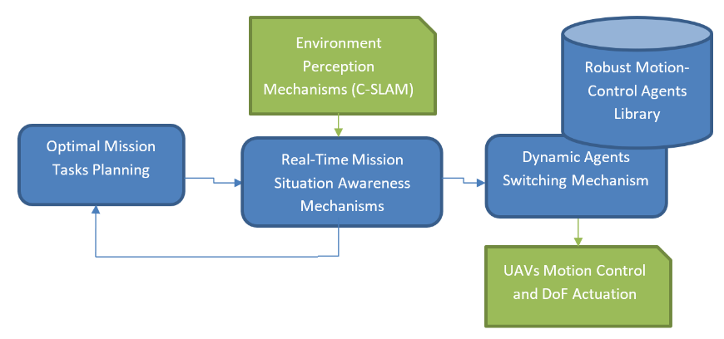
Dynamin Path Planning and Mission Management: Autonomous UAVs (Unmanned Aerial Vehicles) in military applications face several mission planning challenges such as: adaptive real-time decision-making responding to sudden changes, such as unexpected threats or mission updates; reliability and robustness against electronic adversarial attacks (jamming, spoofing), or inherit system failures, and harsh ad contested environmental mission conditions; energy management for maximizing the operational range and mission endurance of UAVs by continuously balancing energy consumption with emerging mission requirements.
Within SWARMER CERTH an innovative mission management and navigation system (Figure 25) will consist of appropriately designed software mechanisms that can respond in real time while running on the vehicle's extended computer unit. To this end, will capitalize on top of the abovementioned C-SLAM concept, to develop advanced adaptive AI-planning and robust motion control techniques to ensure coordinated mission execution efficiency, safety and reliability in dynamic non-permissive environments. Special attention will be paid in incorporating redundancy, fault tolerance, and robustness measures against exogenous unexpected disturbances (contested environment, communication jamming, spoofing, harsh weather) and endogenous uncertainties (system failure, malfunctions) to enhance the overall mission execution reliability. CERTH will leverage previous experience, to develop a 2-layer hierarchical framework: A) macroscopic multi-agent (swarm) AI-planning using lightweight graph-search heuristic algorithms for dynamic optimized on-the-fly reconfiguration of the mission based on the real-time environmental and swarm’s situation awareness and perception mechanisms foreseen in SWARMER,; B) based on the generated mission, CERTH will focus on developing real-time closed-loop motion control agents using advanced reinforcement learning (RL) algorithms to ensure energy-efficient (in-flight low-energy paths, in-flight recharging), reliable and safe mission tasks’ execution, based on real-time environmental feedback,,. A library of specialized RL agents will be generated, allowing their inter-switching (selective activation) based on tailored deep learning situation awareness mechanisms, during mission execution. Contrary to conventional federated optimization which heavily relies on information sharing,, the proposed approach will ensure minimized dependency on inter-communication within the swarm as well as to the ground control base, and consequently against enemy jamming and spoofing attacks.
Figure 25: Mission management and navigation system architecture
Knowledge/ technological modules to be developed within the project
Leveraging the envisioned SWARMER perception framework, the envisioned innovative mission management and navigation system will consist of appropriately designed software modules that can respond in real time while running on the vehicle's extended computer unit:
- For the dynamic planning of optimized (time, energy, navigation safety) surveillance/area coverage and search-and-rescue missions, meta-heuristic mission planning methods based on graph search methods (e.g. Iterative Deepening A*, Θ*, Particle Swarm Optimization, Ant Colony Optimization) will be used which will be appropriately parameterized to incorporate dynamic changes in the in the cost estimation of each task/task of the mission. The missions will consist of successive tasks/jobs that could potentially timely fulfilled in parallel.
- To deal with unexpected changes in the environment, appropriate deep learning AI mechanisms for dynamic assessment of the mission execution and swarm status situation will be implemented to dynamically redefine the current mission (based on the previous tool [A] in cases where significant changes in the environment (presence of vehicles, obstacles, etc.) are detected during the execution of the mission. These mechanisms will be based on closed-loop mechanisms with feedback from the environment perception mechanisms.
- Finally, a library of appropriately fine-tuned robust vehicle controllers will be developed according to the real-time environment conditions of the mission execution using deep reinforcement learning technologies (e.g., PPO, SAC, DDPG) for the safe and reliable execution of the individual tasks of the mission in different environmental conditions (e.g. obstacle avoidance, side wind effects, heavy rain, etc.).

Platforms
Military-grade fixed-wing and multirotor drones: ETRA’s latest technology facilities are equipped for the design, development and manufacturing of unmanned systems. ETRA provides such systems to its customers, be it defence and security forces. In the field of defence, actions have been carried out together with the Spanish MoD, as well as exercises with NATO with swarm flying units for complex missions. More information in the following link:
https://etraair.com/en/,
https://www.grupoetra.com/etrair-entrega-al-ministerio-de-defensa-un-dron-con-autonomia-de-vuelo-de-24-horas/
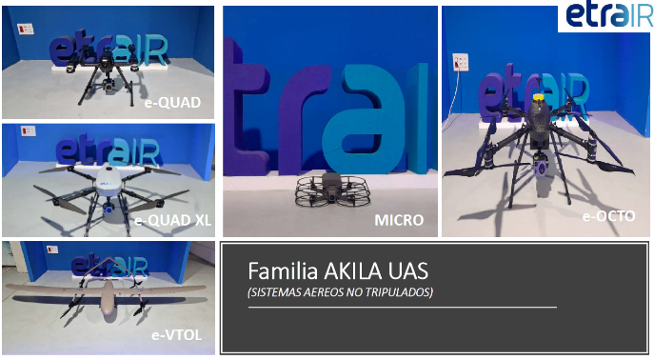 | 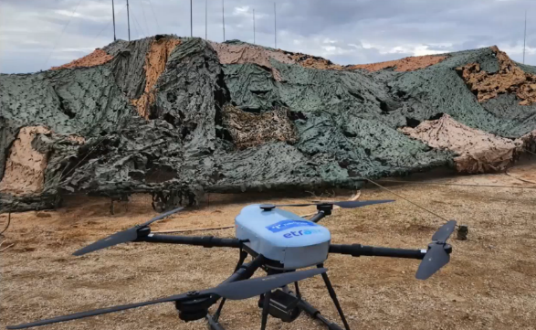
Figure 26: ETRA's drone platforms

ETRA's drones (Figure 26) that could be potentially used in SWARMER will belong to the AKILA UAS family, featuring drones of various sizes and capabilities to better adapt to different situations. Below are the drones that are part of this family and their respective functionalities:
MICRO E-AKILA: This drone stands out for its small size, measuring less than 24 cm, and its robustness, which allows it to impact obstacles without losing flight stability. It is designed for indoor operations and features multiple sensors that facilitate easy handling. With an autonomy of 25 minutes, it can fly in environments without GNSS signals.
Additionally, it includes a front camera capable of live video transmission in both day and night conditions, and it can incorporate various sensors such as radiological sensors or radiometric thermal cameras. e-QUAD: This drone features four engines and is designed for quick deployment, with an autonomy of 60 minutes. It includes several devices, such as a day camera with a wide zoom that can read vehicle license plates from 400 meters, a radiometric thermal camera, and a laser rangefinder that provides the coordinates of the observed target. Its easy-to-use system can be integrated with ground support systems. e-QUAD XL: This drone is a version of the e-QUAD that offers high load capacity, capable of lifting between 10 and 45 kilograms, and is intended for logistical use; one of its current applications is the placement of telephone antennas. e-VTOL: This drone has the capability for vertical take-off and landing (VTOL) to avoid obstacles, followed by the ability to fly like an airplane, with an autonomy of 300 minutes. It is designed for long-distance flights, lightweight at 15 kg MTOW, and has multipayload capability. e-OCTO: This drone is designed to ensure flight safety, featuring a dual battery system that ensures a safe emergency landing if one fails, double rotors on each arm allowing continued flight if one rotor fails, redundant parallel electronics, and a pyrotechnic parachute powered in parallel, ensuring deployment when necessary. It has an autonomy of 60 minutes and high resistance to adverse weather conditions.
UAVs provision and adaptation: In SWARMER, ETRA will work together with consortium partners to define the drone functional specifications. An assessment of the currently available drones and determination of the required changes will be carried out. Drones will be adapted at mechanical, electrical and software levels to cover the challenge scenarios, incorporating the necessary computing power to enable edge deployment. Evaluation and testing of the viability of the proposed changes, ensuring cost-effectiveness, will be an integral part of the work carried out.
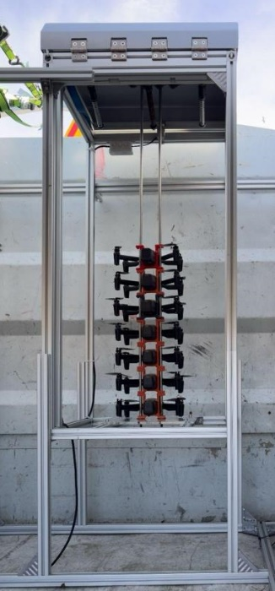
Smart Autonomous Drones Icarus has developed a fully integrated solution for the supervision and flight control of drone swarms (Figure 27, Figure 29). In particular, the company has developed a network of autonomous drones, to be deployed from fixed or mobile bases. Each drone is capable of measuring nuclear and radiological risks, and centralizing the information collected to a crisis management platform. With an area of action of 20km², the deployment of these drones enables real-time, three-dimensional mapping as soon as a crisis occurs, and regular measurements during the crisis, to provide authorities with precise knowledge of health and environmental threats and thus secure actions. In order to prepare for the “automatic landing” function, Dronisos has also developed a very rapid 3-D terrain reconstruction process (10 minutes in total to model 25 hectares using 10 drones). Our system is capable of generating photogrammetric data in real time. These calculations produce the elevation map and 3D model (Figure 28). The 3D model is an essential tool for selecting the most suitable landing sites for sampling. Its main aim is to avoid complex surfaces, such as trees, and to identify flat areas that are ideal for a safe landing or sampling maneuver.
Figure 27: Drones Storage Unit
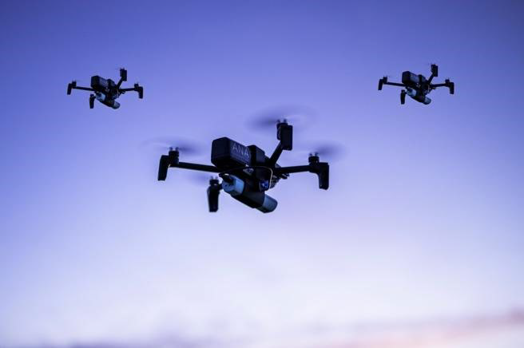
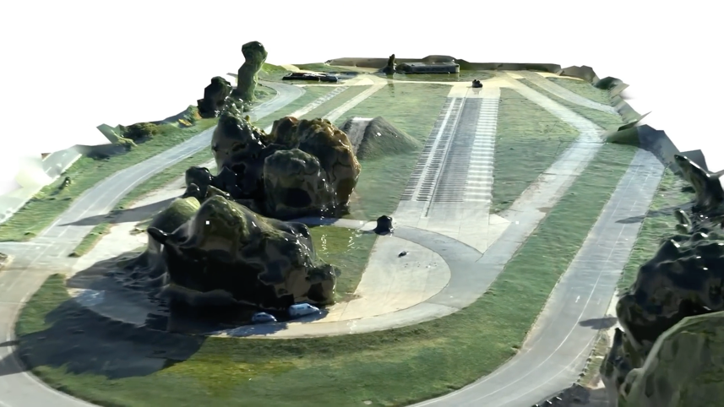
To make swarms autonomous, it is crucial to locate each drone precisely in relation to the others. In addition to conventional GNSS localization, we have developed an internal localization system for the swarm using Ultra Wide Band (UWB) transmitters. These transmitters provide the distance between the drones, and this data is fed into a global Kalman filter. This process significantly improves our understanding of swarm dynamics and provides an intra-swarm communication network.
Figure 28: 3D model using multiple drones simultaneously
Figure 29: ICARUS drones on flight
Since communication capabilities between devices can disappear at any time, each drone executes a purely local algorithm without making any assumptions about its neighborhood. Such a design guarantees resilience and scalability, even in hostile environments. The devices then have only a limited amount of information, sometimes obsolete due to transmission delays, to reconstruct a global view of the environment in which they are evolving, as well as the state of other devices and the progress of the mission.
Swarms can number up to several hundred drones (including the Anafi USA type designed by manufacturer Parrot). This is a powerful drone built to meet the requirements of first responders, firefighters, search and rescue teams, security agencies and surveying and inspection professionals. Featuring 32x zoom, 4K HDR video and industry-first thermal imaging capabilities, this UAV is an ultra-portable, secure and durable aerial camera platform. The 32x zoom is designed around two 21-megapixel cameras, enabling operators to see details clearly up to 5 km away. Anafi USA can see details as small as 1 cm accurately from 50 meters. The Anafi USA drone is dustproof and waterproof, enabling it to fly in wet weather. It has been designed to withstand the toughest flying conditions encountered on missions. What's more, its image stabilizer ensures top-quality images, even in wind gusts of up to 15 m/s. Finally, its Flir Boson infrared thermal camera module offers a detection range from -40C to +160C, with thermal sensitivity below 60mK.
Inspection tasks can be carried out with precision thanks to the following drone-integrated sensors: front camera, barometer, belly camera, optical sensor, inertial sensors, merged with a Kalman filter and Parrot's optimized filters. The infrared module, combined with 4K video and 32x optical zoom, enables high levels of detail to identify targets and objects. Communication and localization between the UAVs is carried out using ultra-wideband short-range (UWB) and WiFi radio protocols.
The approach for detection and tracking technologies is based on the development of a variant of the SLAM solution to estimate the position of targets in real time, while estimating their movements, with a collaborative filter shared by the drones. This method uses the relative position estimates given by each drone in the swarm. This approach offers the dual advantage of identifying targets and controlling drone navigation.
The Icarus team has also mastered a method for identifying targets during the mission. The imaging modules on board the UAVs, used as inputs, enable the relative positions of moving targets to be detected and estimated, using the on-board cameras associated with the IR camera in particular.
The communications architecture is based on three protocols designed to ensure fast, reliable communications while optimizing energy consumption. A radio link is set up between the UAVs to transfer low-bandwidth data, such as UAV position. In addition, a WIFI connection enables video streaming and the transfer of more information up to 3km away. Finally, communication between the UAVs is ensured by the UWB short-range protocol, to provide data and redundant localization within the swarm.

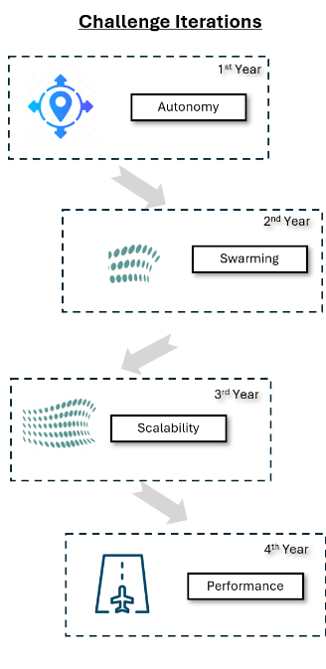
SWARMER METHODOLOGY
PARTICIPATION TO THE CHALLENGE

The SWARMER project is appropriately structured in order to address the Challenge by applying an Adaptive Life Cycle execution model - Figure 30. SWARMER will be implemented in four iterations, each running in parallel with the Challenge yearly plan as per “Annex 4 a” on the “Preliminary evaluation plan for the EDF technological challenge on Robust Autonomous Drone Navigation”. This approach allows for continuous improvements, consideration of new requirements as well as keeping up with the latest technological developments. In this regard, detailed plans are elaborated each year during iterations to accommodate easily for any changes, based on a high level plan defined in this document as well as at the initiation of the project and taking into consideration the Evaluation Plan Discussion Workshops outcomes. Each yearly iteration repeats at a great percentage a set of predefined activities-tasks allowing for a) a structured approach to extend through the course of the project, b) transfer of knowledge to the next iterations and c) improvements to be efficiently implemented based on lessons-learned.
Figures 31 and 32 illustrate the SWARMER project roadmap, which is divided into four distinct phases, each aligned with specific work packages (WPs) and timeframes. The roadmap outlines the progressive development of the system, starting with the establishment of autonomous capabilities and culminating in the refinement of the system's performance for real-world deployment.
Figure 30: Challenge Iterations
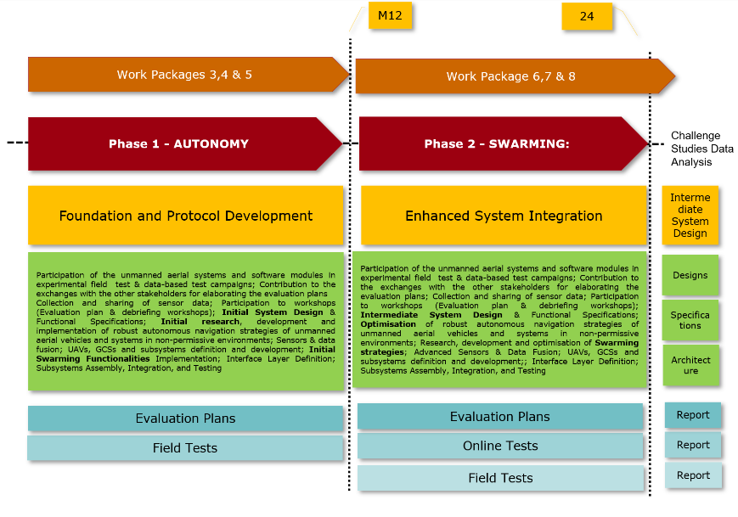
In the first image, the project begins with Phase 1: Autonomy (Months 0-12, WP 3, 4, and 5), where the focus is on Foundation and Protocol Development. During this phase, foundational work is carried out to develop robust autonomous systems for unmanned aerial vehicles (UAVs). The phase includes initial research, experimental field tests, and the development of protocols to enable autonomous operation. The objective is to create a reliable foundation for UAVs operating in non-permissive environments. Testing and evaluation are integral to this phase, with evaluation plans and field tests being executed as required by the Challenge Organisers.
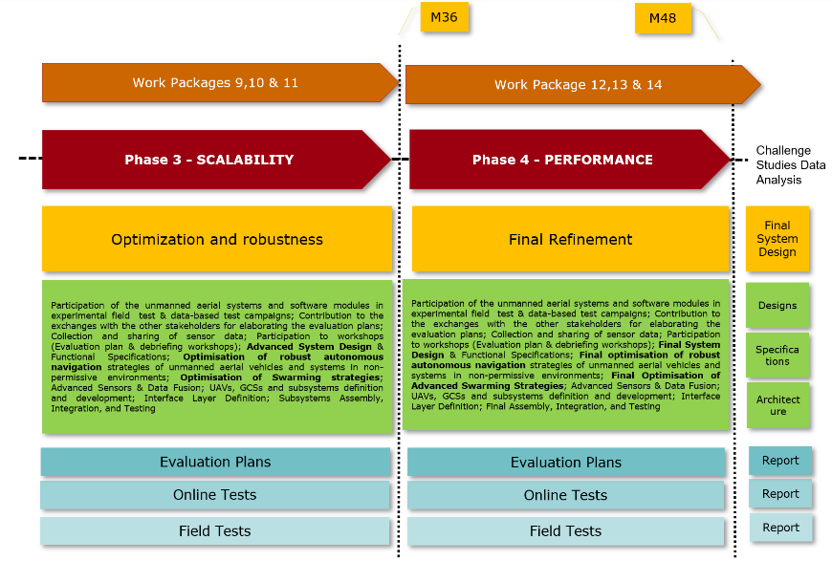
Following this, Phase 2: Swarming (Months 12-24, WP 6, 7, and 8) focuses on Enhanced System Integration, where the emphasis shifts to integrating swarming capabilities into the system. This phase deals with refining coordination between multiple drones and enhancing system robustness for swarming in more challenging conditions. The swarming strategies developed are tested through field tests and further evaluation, ensuring that the system can handle the complexities of coordinating multiple UAVs in real-time environments.
Figure 31: Project's Roadmap, Phases 1 and 2
Figure 32 outlines the subsequent phases. Phase 3: Scalability (Months 24-36, WP 9, 10, and 11) emphasizes Optimization and Robustness, where the goal is to optimize the system for larger-scale operations. This involves refining swarming strategies to ensure that the system can effectively scale, coordinating more drones in larger and more complex environments. The system undergoes further testing to ensure robustness, with extensive evaluation plans, online tests, and field tests.
Finally, Phase 4: Performance (Months 36-48, WP 12, 13, and 14) is focused on Final Refinement. In this phase, the system is fine-tuned to ensure maximum operational performance in non-permissive environments. The final testing and evaluation processes are designed to verify that the UAV system is fully capable of performing autonomously and as part of a swarm, ready for real-world deployment. This phase ensures the system's architecture is robust, scalable, and optimized for mission-critical scenarios.
Figure 32: Project's Roadmap, Phases 3 and 4
Throughout all phases, the project structure complies with the Organizer’s evaluation plans, online tests, and field tests to validate progress, with regular reporting to document developments and challenges at each stage. This structured approach ensures that the SWARMER system evolves consistently and effectively toward achieving fully autonomous and scalable swarming capabilities.
TESTING SITES
In addition to the planned evaluation events organized by the Challenge Organiser, the SWARMER project has access to four additional testing sites located in Cyprus, Germany, Spain, and France. These sites provide valuable opportunities for ad-hoc testing of SWARMER's systems, allowing the project team to conduct real-world trials under various environmental and operational conditions. The availability of these locations enables more frequent and flexible testing, ensuring that SWARMER’s autonomous and swarming capabilities are rigorously evaluated and refined outside of the scheduled Challenge evaluations. This access allows for more immediate identification of issues, enabling the team to optimize the system continuously and ensure its readiness for deployment in a wide range of non-permissive environments. Following is a detailed description of each test site.
Test Site in GERMANY
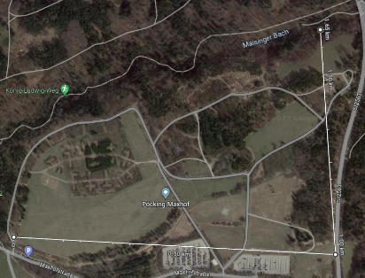
To validate the technologies developed within the SWARMER project the partners plan several test campaigns. Some of the tests, specifically those foreseen within the WP4 and WP6, will be performed in Germany. The details of the test sites are summarized below.
Test site “Poecking” (Figure 33): The test location “Poecking” is located at the premises of the Bundeswehr base General-Fellgiebel-Kaserne, Poecking district of Maising, Germany (geo:47.983781,11.304606). The military base was built in 1959 and houses parts of the Bundeswehr Information Technology School (formerly the Army Telecommunications School and Technical College for Electrical Engineering). Until the early 1990s, Battalion (LLFmLehrBtl) 9 and, until 2003, Training Company (GebFmLehrKp) 8 were stationed at the site. By 2016, training halls, functional, staff and accommodation buildings for course participants are to be built here for the planned nationwide central training facility for soldiers of the army, air force and navy working in telecommunications. Adjacent to the quarters is a training area (Figure 33) where flights and tests envisioned within the project can be performed. The test site has an area of roughly 1km², with diverse vegetation options, isolated man-made structures and some shallow trenches. There is also a dedicated parking space available. The dates and times of experiments have to be negotiated with the operators of the Poecking site, which should be done in advance to ensure that there are no other planned training exercises. Drone flights would require a valid insurance and security pilot with a valid drone pilot license. The area is also surrounded by a protective fence and warning signs, yet trespassers are not uncommon.
Figure 33: Poecking test site.
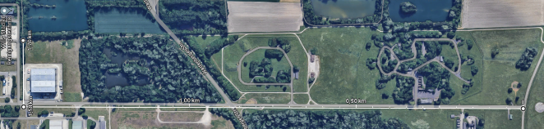
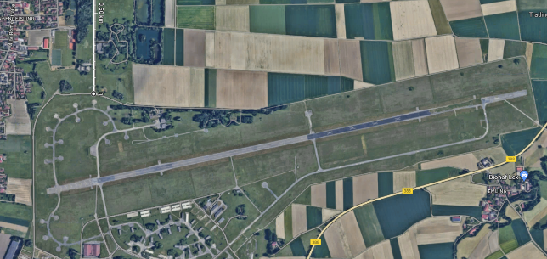
Test site “WIWeB” (Figure 34,35): The WIWeB test site is located at the premises of the Wehrwissenschaftliches Institut für Werk- und Betriebsstoffe (WIWeB). WIWeB is a scientific institution based in Erding, Germany, and subordinate to the Bundesamt für Ausrüstung, Informationstechnik und Nutzung der Bundeswehr (BAAINBw, Koblenz) of the German Federal Ministry of Defence (BMVg). Its task is to investigate and assess the defence-related properties of materials, consumables, textiles and chemicals.
Figure 34: Test site “WIWeB”
The department also supports the Bundeswehr in matters of environmental protection, chemical safety and occupational health and safety. Furthermore, among its many activities, WIWeB hosts an Innovation Laboratory “System Soldat” that investigates the use of robotic technologies and AI for future military operations. WIWeB is situated close to the Erding Air Base. The airbase was a military airfield of the German Air Force northeast of Erding in the Munich area. Flight operations were discontinued in 2014. The airbase was decommissioned at the end of 2015 and thus closed. Some of the areas, however, were transferred to the WIWeB to be used for experiments. The experimental area envisioned for SWARMER project (located at 48.33519462445325, 11.933612325339936) is about 1.5m x 0.2km wide (see Figure 34). It has diverse vegetation options, some man-made structures, old garaged and buildings, a shooting range and two artificial ponds. Adjacent to this area there is also an airfield (see Figure 35), which can likewise be used for performing drone experiments. In some areas of the test field, it is possible to have electrical power to be used during experiments. However, having an independent power source would be an advantage for SWARMER. To this end DLR will provide a measurement bus, can serve as a mobile control station, having a build in diesel power generator with 4kW capacity for prolonged experiments.
Figure 35 Airfield adjacent to the WIWeB test site which can also be used for testing.
Test Site in CYPRUS
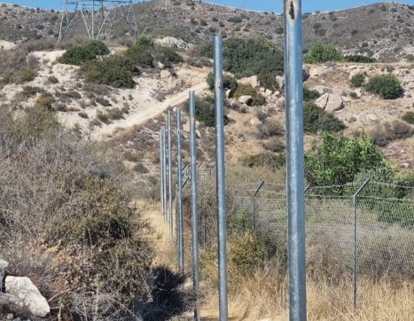
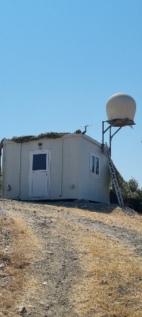
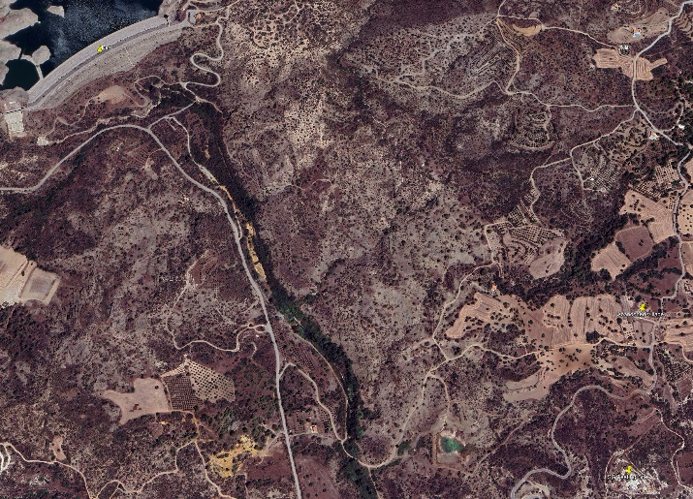
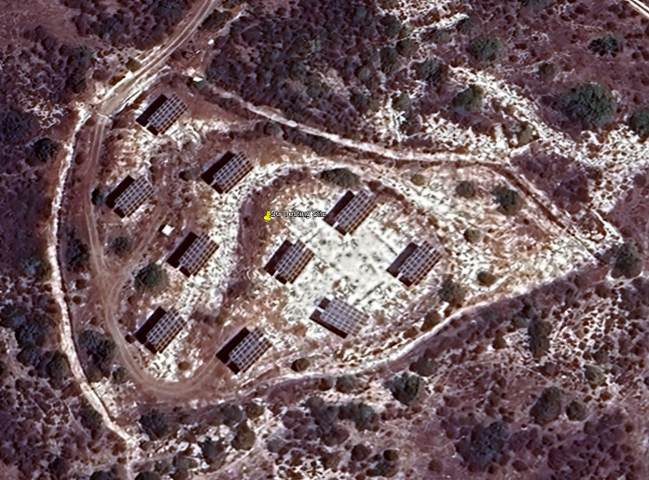
SignalGenerix's testing field - Figure 36 is situated in the southern and central part of the island, approximately 30 km from Limassol. The site includes a solar array installation, which can be utilized for testing and optimizing obstacle avoidance systems. Swarming capabilities can also be evaluated in more complex environments, such as the nearby abandoned village or over the dam, adding layers of challenge for coordination and navigation.
Figure 36: Testing site in Cyprus
The field is equipped for testing a wide range of systems, including passive RF systems, electronic warfare (E/W) systems like jammers and direction-finding (DF) systems, as well as various drone operational functionalities. Some of these technologies are ideal for SWARM testing activities.
The facility also includes an air-conditioned working room with SATLINK broadband connectivity, providing real-time monitoring and data analysis capabilities. The area simulates real-world environments, including spoofing challenges recently observed in the Eastern Mediterranean, offering a comprehensive testing ground for advanced drone swarm technologies.
Test Site in FRANCE
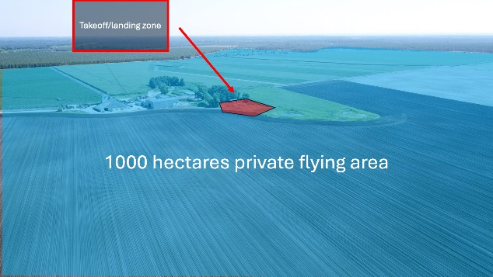
Icarus Swarms has a dedicated test site in Cestas - Error! Reference source not found., a vast 1,000-hectare playfield equipped with Civil Aviation clearance to fly drone swarms. This extensive area provides the ideal space for us to conduct drone flight experiments and demonstrations on a large scale. The size of this site allows us to test our drone technologies in real-world conditions, simulating the broad range of environments they may encounter in client projects. By conducting these tests with Civil Aviation clearance, we ensure that our operations adhere to regulatory standards and are performed safely within a controlled airspace. At this test facility, we carry out a wide range of experiments that push the limits of what drone technology can achieve. It is designed to handle various drone types and applications, offering flexibility for multiple kinds of tests and demonstrations. Our site is fully equipped to support different testing scenarios. This includes autonomous flight tests where drones navigate complex flight paths without human intervention, assessing how well they can react and follow designated routes. System integration is another major focus. We test how various hardware and software components work together in real-world settings, confirming that every element functions seamlessly as part of a larger drone ecosystem. Safety validation is one of our top priorities. Before any technology reaches a client project, it undergoes rigorous safety assessments. This process includes testing for weather resistance, operational stability, and fail-safe mechanisms. The test site is also used for demonstrations, allowing clients and stakeholders to witness the capabilities of our drones firsthand. By observing these live demonstrations, they gain a better understanding of the performance and reliability they can expect from our technology. We continuously innovate and adapt our testing protocols to stay ahead in the rapidly evolving field of drone technology. Our site in Cestas is essential in driving this progress, allowing Icarus Swarms to lead in developing cutting-edge, reliable drone solutions.
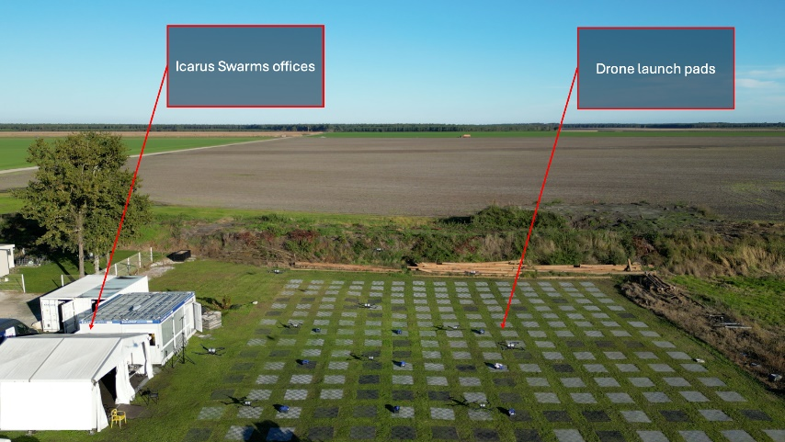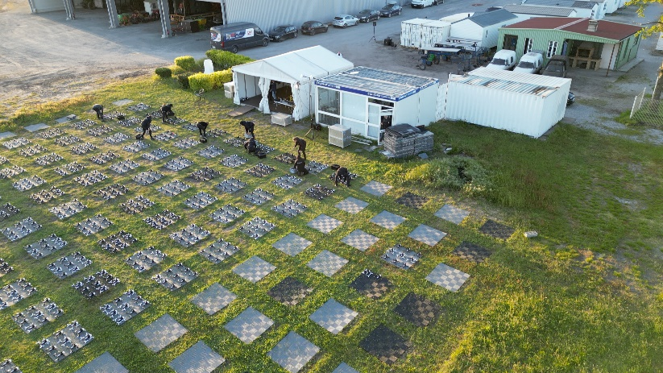
Figure 37:Test site in France

Test Site in SPAIN
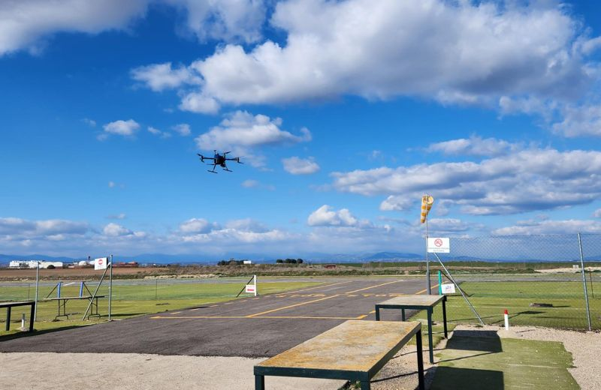
SWARMER partners will conduct a flight-testing campaign in Spain to validate the project technologies. A potential testing site available is the Ocaña Airfield, close to Madrid. The Ocaña Flight Testing Site is well-equipped with a main runway of 1,500 meters, complemented by additional shorter runways to accommodate a range of UAV operations. These runways are designed to support various sizes and types of drones, ensuring flexibility and adaptability for different testing scenarios. The infrastructure allows for smooth take-offs and landings, which is crucial for accurate testing and data collection. The site boasts dedicated, controlled airspace with flexible altitude capabilities reaching up to 5,000 feet. This controlled environment ensures both safety and privacy, allowing for uninterrupted testing activities. The airspace is carefully managed to avoid conflicts with commercial air traffic, providing a secure area for comprehensive drone trials. Ocaña’s facilities include multiple hangars, maintenance workshops, and control rooms equipped with state-of-the-art technology. These facilities support a wide range of testing activities, from routine maintenance to complex system evaluations. The on-site amenities ensure that testing teams have access to everything they need for efficient operations, including real-time data analysis and system integration testing. The final location for the Spanish flight tests will be reviewed upon the project starts in order to select the most suitable according to the challenge requirements.
Figure 38: Testing site in Spain

INDICATIVE SCENARIOS
To ensure that its capabilities address all potential parameters and challenges from the outset, the SWARMER consortium has developed a list of indicative yet representative flight scenarios, cross-referenced with the relevant technologies required for each. The following two tables (Table 1 and Table 2) provide a structured overview of the technological approaches used in different indoor and outdoor scenarios for autonomous drone operations in the SWARMER project. The goal of these scenarios is to outline the various challenges that autonomous drones, both in single-drone and swarm configurations, face under different environmental conditions, and to showcase the technologies being applied to address those challenges.

Table 1 : Indoor Scenarios
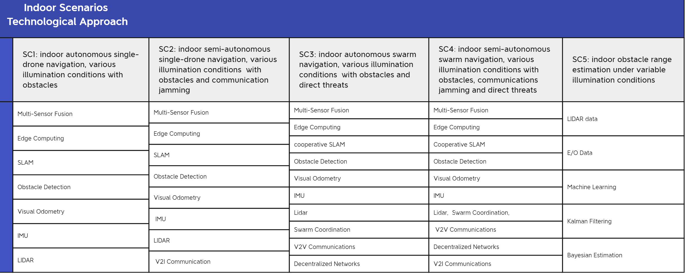

The indoor scenarios focus on navigating drones autonomously in enclosed environments with various obstacles, illumination conditions, and even communication jamming and direct threats. These scenarios demonstrate how drones can perform in complex indoor spaces, both individually and as part of a swarm, using technologies like multi-sensor fusion, edge computing, and SLAM. The outdoor scenarios are designed to test drones in more dynamic, open environments, including extreme weather conditions, GNSS jamming or spoofing, and direct threats. These scenarios also emphasize the drones' ability to operate in both single-drone and swarm configurations. The technological solutions focus on maintaining robust communication, navigation, and obstacle detection under harsher, more unpredictable conditions.
Table 2: Outdoor Scenarios
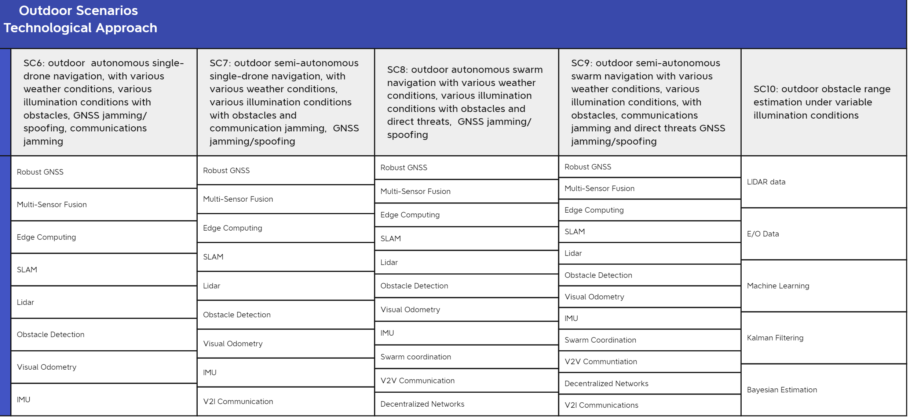

The overall goal of these images is to highlight the comprehensive testing framework in both indoor and outdoor environments, detailing how various technologies are used to address the unique challenges presented in each scenario. This framework ensures that the SWARMER system is capable of performing in a wide range of operational contexts, from tightly controlled indoor spaces to unpredictable outdoor environments, ensuring resilience and adaptability in real-world applications.
#§CON-MET-CM§#

1.2 Objectives — Scope and types of activities — Functional requirements — Expected impact
Objectives — Scope and types of activities — Functional requirements — Expected impact
Describe how your proposal complies with the objectives, scope (including targeted activities), functional requirements and expected impact of the topic as set out in the call for proposals.

COMPLIANCE WITH THE OBJECTIVES OF THE TOPIC
SWARMER comprehensively addresses the Call’s objectives of the next generation of unmanned aerial systems (UAS) that are expected to offer an increased level of autonomy while their effective deployment necessitates key features of swarming and navigation. It is doing so by merging state of the art technologies used in the unmanned and autonomous navigation field of multi-sensor fusion, intelligent obstacle detection, autonomous non-GNSS based navigations and AI-driven swarming technologies. The ultimate goal is to design an autonomous, resilient, and efficient drone system of low SWaP-C, scalable, and capable of operating in non-permissive environments. In the frame of rigorous evaluation through quantitative performance measurement, the following objectives were defined, in line with the objectives set out in the call for proposals, to ensure SWARMER system design achieves the highest level of performance and innovation.
O1: To fulfil their missions, the next generation of unmanned aerial systems (UAS) are expected to offer an increased level of autonomy.
SWARMER is designed to develop highly autonomous drone systems capable of operating independently in GNSS-denied and contested environments. The system leverages AI-driven decision-making algorithms and machine learning to enable real-time adaptation to dynamic situations. Key technologies include path planning, obstacle detection, and multi-sensor data fusion, allowing drones to operate with minimal human intervention. The autonomy level is increased through the integration of edge computing, enabling real-time data processing and decision-making on board the drones.
O2: Their effective deployment necessitates key features of swarming and navigation to target positions when GNSS availability is contested or lost and more generally in non-permissive environments.
SWARMER addresses this objective by developing robust swarming capabilities that allow drones to collaborate and operate in challenging environments where GNSS signals are disrupted or unavailable. The project incorporates Vehicle-to-Vehicle (V2V) communication, enabling drones to share positional and environmental data, and coordinate tasks autonomously. The system's decentralized swarm intelligence ensures that even when GNSS is lost, drones can still navigate to target positions using advanced technologies like SLAM (Simultaneous Localization and Mapping) and inertial navigation systems (INS). This allows for effective deployment in hostile or unpredictable environments.
O3: The use of various types of sensors (e.g. inertial, optical, infrared, hyperspectral, radar, LIDAR, acoustic, etc.) and intelligent information fusion are needed to provide the necessary capabilities to tackle these technical and operational challenges.
The SWARMER project incorporates a wide range of sensors — including LIDAR, optical, INS and GNSS — to provide comprehensive situational awareness. These sensors work in tandem with an intelligent information fusion system, which processes data from multiple sources to improve the accuracy and reliability of the drones' navigation and decision-making capabilities. This multi-sensor fusion ensures that drones can overcome environmental challenges and navigate in non-permissive environments, even in the absence of GNSS.
O4: Such intelligent navigation payloads should be usable on a wide range of unmanned assets, including in swarm formations.
SWARMER’s navigation systems are designed to be modular and scalable, making them adaptable to a wide range of unmanned platforms beyond just the drones involved in the project. The system’s architecture supports interoperability, allowing the navigation payloads to be integrated into different UAVs and other unmanned assets. Additionally, the swarm coordination algorithms developed by SWARMER can be applied to larger drone formations, enabling synchronized mission execution and dynamic task allocation across the swarm.
O5: Have a low SWaP-C (Size, Weight, Power and Costs).
SWARMER places a strong emphasis on SWaP-C optimization. The project focuses on designing systems that are lightweight, power-efficient, and cost-effective, ensuring that the drones' navigation and swarming systems can be deployed in operational environments without significant resource burdens. The project’s design includes edge computing solutions that minimize the need for high-power, centralized processing, allowing the drones to operate efficiently within the constraints of SWaP-C. The two SWARMER drone providers ETRA and ICARUS will provide their long proven experience and expertise in low SWaP-C platforms.
O6: The SWARMER system’s performances should be measured in a quantitative, objective and comparable way.
SWARMER ensures that the performance of the drone systems will be measured in a quantitative, objective, and comparable manner on close collaboration with the Challenge Organising Consortium. The project includes extensive participation in experimental field tests and data-based evaluation campaigns, where system performance metrics will be rigorously assessed. These tests will use standardized protocols and benchmarks to measure navigation accuracy, resilience in GNSS-denied environments, swarm coordination, and energy efficiency, ensuring that the system meets the required operational standards. The collected data will also be shared and analyzed in debriefing workshops to refine and enhance the system’s capabilities.

COMPLIANCE WITH WORK PROGRAMME SCOPE (INCLUDING TARGETED ACTIVITIES)
SWARMER proposal is fully aligned with the Call’s requirements through its design and scope of activities. Following is a breakdown of how SWARMER addresses each of the Call's key requirements in line with the art 10(3) of EDF Regulation.
SWARMER addresses the overarching goal of providing “technological solutions for autonomous aerial drone navigation in non-permissive environments” by designing an autonomous navigation swarm system of drones capable of flying in GNSS-denied and contested environments. The project is specifically designed to develop robust navigation systems capable of functioning in environments where traditional GPS systems are jammed or compromised by fusing a variety of sensors (e.g., LIDAR, optical sensors, INS), enabling drones to operate without heavy reliance on GNSS alone and with limited Ground Control communications. SWARMER system will be repeatedly and intensely “evaluated through the testing environment set up in the framework of the technological challenge” by participating in evaluation and testing environments to validate system performance in non-permissive scenarios, ensuring compliance with the technological challenge.
SWARMER will execute the following four (4) targeted activities as these are defined by the text of the Call as well as by the art 10(3) of EDF Regulation i.e.:
STUDIES Activities under this category involve mainly work on the project management and coordination of the entire project. In that respect WP1 and WP2 will undertake the key tasks of project coordination, daily and periodic management, project quality assurance and risk management, legal, ethical, security and IPR management as wells as scientific and technical coordination. In this type of activities the dissemination, communication and exploitation of results relevant tasks are also incorporated.
GENERATING KNOWLEDGE e SWARMER project advances knowledge in autonomous multi-drone navigation specifically for non-permissive environments. By integrating diverse sensors (e.g., optical, radar, LIDAR) and AI-driven decision algorithms, SWARMER will pioneer navigation strategies tailored for complex conditions. Key work packages (WP3, WP6, WP9, and WP12) focus on ensuring efficient challenge participation and collaboration with stakeholders for plan and data exchange. SWARMER will work with other stakeholders to develop evaluation plans, participate in field tests, and focus on real-time data collection and navigation performance. Sensor data sharing will support reproducibility and system improvements, while debriefing workshops will assess system performance and resilience enhancements in challenging environments, to enable reproducibility and system improvement. Participation in debriefing workshops will help assess the system’s performance and provide insights into improving operational resilience in non-permissive environments.
DESIGN SWARMER project has planned multiple activities dedicated both to the design of modules individual as well as an integrated system that can achieve robust autonomous multi-drone (swarm) navigation in hostile environments. WP4, WP7, WP10 and WP13 are dedicated to iteratively improving the system’s design and performance at all levels while increasing the complexity of its functionalities. By using cutting-edge AI, multi-sensor fusion and Intelligent information fusion techniques to process data from various sensors, enhancing navigation accuracy and adaptability in real-time, real-time decision-making capabilities and by exploring disruptive technologies such as autonomous swarming and decentralized decision-making for drone coordination, SWARMER will design and optimize systems to overcome GNSS-denied and high-autonomy flight challenges.
INTEGRATING KNOWLEDGE SWARMER is putting significant effort into the integration tasks throughout the Challenge. WP5, WP8, WP11 and WP14, incorporate all the necessary work relevant to integrating generated knowledge, designs and systems modules of all levels. System Integration works aim at strengthened interoperability and resilience through ● UAVs, GCSs and subsystems definition and development ● Interface Layer Definition ● Communications Framework definition ● Subsystems Assembly, Integration, and Testing. By integrating these tasks SWARMER ensures that the entire system—from individual drones to the broader swarm and ground control systems—functions as a unified and resilient platform. These integration efforts are fundamental to achieving operational success and ensuring that the system can perform effectively in non-permissive environments, where robust interoperability and real-time communication are paramount.

FUNCTIONAL REQUIREMENTS
The following table outlines the critical functional requirements for SWARMER, ensuring that the system meets the necessary capabilities for position estimation, navigation in GNSS-denied environments, performance evaluation, and data recording for future integration and operational use. These requirements will be key in shaping SWARMER's development and ensuring it performs effectively in non-permissive environments. Requirements in Italic fonts are taken from EDA’s Action Plan on Autonomous Systems (APAS brochure) with the goal of considering the list of Key Technological Challenges within the course of SWARMER project.
Requirement ID | Functional Requirement | Description
SYSTEM
FR-01 | System Architecture | Modular, open architectures for interoperability and cross-domain integration.
FR-02 | System Architecture | Miniaturisation of components and low-cost systems for large-scale, mass applications.
FR-03 | Performance Measurement via Test Campaigns | System performance in position estimation and navigation must be measured through test campaigns, following protocols and metrics outlined in the preliminary evaluation plan.
FR-04 | Compliance with the Evaluation Plan | The proposed systems should detail how they address the tasks described in the preliminary evaluation plan and mention any relevant performances measured in previous technological challenges, if applicable.
NAVIGATION
FR-05 | Accurate Position Estimation | The unmanned aerial systems (UAS) must accurately estimate their positions in non-permissive environments, where GNSS signals and communications may be degraded or lost.
FR-06 | Target Area Navigation | UAS must reliably navigate to designated target areas in non-permissive environments, ensuring high accuracy and mission success despite GNSS disruptions.
FR-07 | Obstacle Avoidance | The system must implement advanced obstacle detection and avoidance algorithms using multi-sensor data (LIDAR, radar, optical, etc.), ensuring drones can navigate safely in dynamic and cluttered environments.
FR-08 | Localization in GNSS-Denied Environments | The system should ensure robust localization capabilities in environments where GNSS signals are unavailable or jammed, using alternative technologies such as SLAM, INS, and multi-sensor fusion.
FR-09 | Mobility | Smart navigation in GNSS-denied/degraded environments and unstructured terrain.
AUTONOMY
FR-10 | Mission Planning and Task Allocation | The drones must support autonomous mission planning and task allocation within the swarm, optimizing resources and dynamically adjusting task priorities based on evolving mission conditions.
FR-11 | Thinking/Decision | Intelligent autonomy with embedded AI for advanced value- and ideas-based reasoning and decision-making.
FR-12 | Thinking/Decision | High-performance computing to transform large data volumes into actionable insights.
FR-13 | Acting | Advanced AI for detection.
FR-14 | Acting | Explainable AI to build trust in autonomous systems for multiple applications.
SWARMING
FR-15 | Swarm Formation and Control | UAS must support coordinated swarm formation and control, enabling autonomous organization and re-organization of drones based on real-time mission needs and environmental factors, without requiring human intervention.
FR-16 | Swarm Resilience | The swarm must maintain operational efficiency even in the event of individual drone failures or communication loss, with other drones adapting to continue the mission. Redundancy and self-healing capabilities are required.
FR-17 | Scalability | The system should support scalability, allowing for flexible operation of small to large drone swarms without degradation in performance or communication quality, ensuring seamless task coordination as the swarm size increases.
COMMUNICATIONS
FR-18 | Resilient and Decentralized Communications | Drones must communicate using a decentralized communications framework, supporting Vehicle-to-Vehicle (V2V) and Vehicle-to-Infrastructure (V2I) communication for real-time coordination and data exchange.
FR-19 | Communications and Networking | Self-healing mesh networks with onboard data processing for secure communication.
FR-20 | Communications and Networking | High-bandwidth, low-latency tactical networks (5G/6G) for stable, robust connectivity.
PLATFORMS
FR-21 | Data Logging and Analysis | Drones must log all mission-critical data (sensor data, communications, decision-making processes) in a structured format, enabling post-mission analysis, replay, and continuous improvement of systems and algorithms.
FR-22 | Sensing | Lightweight, high-resolution, passive or non-detectable sensors.
FR-23 | Sensing | Multi-mission, multi-function sensors with software reconfiguration for different user needs, and advanced multimodal fusion systems.
FR-24 | SWaP-C Optimization for Future Integration | The proposed technologies should optimize Size, Weight, Power, and Cost (SWaP-C) to ensure suitability for future integration into operational missions.
FR-25 | User Interface Design for Pilot Usability | The user interfaces should assist pilots in understanding and anticipating system behaviors, providing clear and intuitive control of UAS functionalities.
FR-26 | Sensor Data Recording and Replay | Systems must record data from onboard sensors to enable full replay of flights and reproduction of experiments in a software environment. The types of data that can be shared with other teams should be described.
FR-27 | Data Sharing for Reproducibility | The system must enable data sharing with other teams, promoting reproducibility of experiments and facilitating collaborative advancements in the framework of the technological challenge.
FR-28
FR-29 | Self-Monitoring* | Reduced platform signatures and passive modes for enhanced stealth and protection.

EXPECTED IMPACT
The SWARMER project is expected to generate significant outcomes in terms of enhancing the capabilities of Unmanned Aerial Systems (UAS) and strengthening the European Defence Technological and Industrial Base (EDTIB) and can be described in detail as follows:
Enhanced UAS Capabilities for EU Member States Armed Forces: SWARMER will contribute to the development of highly autonomous UAS, enabling collaborative combat capabilities and enhancing the efficiency of tactical operations in non-permissive environments. By leveraging swarm intelligence and decentralized decision-making, SWARMER will enable drones to operate autonomously and adapt to real-time mission dynamics without requiring constant human intervention. This level of autonomy will allow armed forces to execute missions with greater flexibility, efficiency, and precision, even in environments where GNSS signals are disrupted or unavailable. Through the integration of multi-sensor fusion, AI-driven obstacle avoidance, and predictive modelling, SWARMER will enhance the ability of UAS to navigate complex terrain, avoid obstacles, and perform sophisticated tasks such as reconnaissance, surveillance, and coordinated attacks. The use of Vehicle-to-Vehicle (V2V) and Vehicle-to-Infrastructure (V2I) communication frameworks will enable seamless coordination between multiple drones, creating a tactical cloud where information is shared and processed collaboratively, further improving operational efficiency. This increased level of autonomy and collaboration will significantly improve the tactical and operational capabilities of the EU Member States' armed forces, ensuring that they can maintain superiority in contested environments and carry out collaborative combat operations more effectively.
Strengthening the Competitiveness and Innovation Capacity of the European Defence Technological and Industrial Base (EDTIB): The SWARMER project will play a critical role in enhancing the competitiveness, efficiency, and innovation capacity of the European defence industry by driving the development of advanced technologies in autonomous systems and swarm intelligence. By contributing to the strategic autonomy of the European Union, SWARMER will reduce reliance on non-EU technologies and ensure that the EU maintains freedom of action in critical defence domains. The project’s focus on low SWaP-C (Size, Weight, Power, and Cost) optimization ensures that the UAS developed through SWARMER will be scalable, cost-effective, and adaptable for a wide range of defence missions. This flexibility will make European-developed UAS more competitive on the global market, providing a clear advantage in both military and commercial applications. In addition, SWARMER’s innovations in areas such as swarm resilience, decentralized communication, and autonomous decision-making will contribute to the broader ecosystem of European defence technologies, enabling further advancements in tactical autonomy, secure communication, and multi-domain operations. These technological advancements will foster collaborative synergies among European defence companies, research institutions, and governments, leading to new opportunities for growth and technological leadership.
Contribution to EU Strategic Autonomy and Freedom of Action: SWARMER’s development of cutting-edge autonomous systems and swarm technologies directly aligns with the European Union’s goals of achieving strategic autonomy in the defence sector. By reducing dependence on external technology providers and fostering a strong European defence industrial base, SWARMER contributes to ensuring that the EU can independently develop, deploy, and maintain critical UAS systems. This independence not only strengthens the freedom of action for EU Member States in defence and security operations but also enhances the resilience of European forces in scenarios where they must operate in isolation or against adversaries who may attempt to interfere with critical technologies like GNSS or communication systems.
Considering the above, the SWARMER project is expected to deliver significant improvements in the autonomy, efficiency, and resilience of UAS for EU armed forces, enhancing their combat readiness and ability to operate in non-permissive environments. By strengthening the European defence technological base and contributing to the EU's strategic autonomy, SWARMER will ensure that Europe remains at the forefront of defence innovation, enabling greater security and freedom of action in future conflicts. The project will also foster collaborative synergies within the European defence ecosystem, driving long-term growth and leadership in autonomous systems and swarm intelligence technologies.

1.3 Advantage and potential of disruption
Advantage and potential of disruption
Explain how the objective and expected outcome of the action differs from and represents an advantage at strategic, technological or defence operational level over existing defence products or technologies, or has a potential of disruption in the defence domain.
The SWARMER project represents a transformative approach to ISTAR operations in defence by integrating cutting-edge AI and autonomous swarm capabilities that strategically, technologically, and operationally surpass existing solutions. Traditional defence systems face constraints in data availability, communication limitations, and processing complexity, which impede the effective integration of AI models. Although recent advancements have been made, there remains a hesitation to fully adopt AI in autonomous military operations due to reliability concerns. SWARMER addresses these gaps by leveraging miniaturized AI designed for real-time autonomous navigation and decision-making, even in GNSS-denied environments. This enhanced autonomy allows drones to operate individually or as a cohesive swarm, effectively adapting to dynamic battlefield conditions and reducing the need for continuous operator control. This not only frees up personnel to focus on tactical and strategic decisions but also enhances mission success rates in high-risk scenarios where drones are vulnerable to enemy interference.
Technologically, SWARMER’s innovative design includes a swarm of drones, varying from consumer-grade to mission specific drones connected through ultrawideband ranging, enabling a robust, adaptable navigation system that maintains operational integrity despite high RF interference or the loss of individual units. This resilient architecture is paired with advanced AI-driven functionalities, such as decentralized decision-making, collision avoidance, and distributed task allocation, allowing the swarm to respond autonomously to environmental changes. Furthermore, the flexibility to integrate additional drones and unmanned or manned systems offers a scalable and interoperable solution that can evolve with mission requirements, setting SWARMER apart from current limited-use systems.
Strategically, SWARMER’s miniaturized AI board enables high-precision positioning and autonomous navigation in unknown terrains, both indoors and outdoors, strengthening European defence capabilities and operational independence. Its decentralized architecture supports real-time tactical decision-making at the unit level, enhancing situational awareness and adaptability in contested environments. This aligns with the growing need for swarm-based approaches, as seen in recent battlefield scenarios, where the decentralized control of thousands of drones improves operational resilience, efficiency, and mission continuity even under intense adversarial conditions.
Operationally, SWARMER introduces a new, multi-mission capability that can be deployed across all force levels, from task units to task forces, offering substantial advantages such as extended endurance, reduced operational costs, optimized decision-making, and minimal manpower requirements. This enhanced survivability and efficiency in GNSS-denied settings support persistent surveillance and mission success in challenging environments, making SWARMER not only a strategic asset but also a potentially disruptive technology in the defence domain.
#§PRJ-OBJ-PO§# #§REL-EVA-RE§# #@IMP-ACT-IA@#

2. INNOVATION AND TECHNOLOGICAL DEVELOPMENT

2.1 Innovation potential
Innovation potential
Explain how your proposal demonstrates innovation potential and contains ground-breaking or novel concepts and approaches (e.g. new products, services or business and organizational models), new promising technological improvements, or the application of technologies or concepts previously not applied in the defence sector.
SWARMER demonstrates substantial innovation potential by integrating groundbreaking concepts and novel approaches in autonomous drone swarming, introducing features previously unexplored in defence applications. This project advances current ISTAR (Intelligence, Surveillance, Target Acquisition, and Reconnaissance) operations by overcoming limitations in data availability, restricted communication, and the time constraints that have hindered the effective adoption of AI in defence. SWARMER's approach directly addresses these issues by developing a miniaturized AI-powered system capable of high-precision positioning, reliable navigation, and intelligent decision-making in GNSS-denied environments. With both centralized and decentralized capabilities, SWARMER redefines swarm autonomy, allowing drones to navigate and complete tasks independently while cooperating as a single cohesive entity, a function that can drastically reduce operator burden and increase mission success rates, even in complex scenarios where individual drones are at risk.
AUTONOMOUS NAVIGATION: Given the low-airspace flight environment of UAVs, reliable obstacle avoidance is of the utmost importance to guarantee safe flight tasks. LIDAR-based obstacle avoidance can obtain complete 3D information of the environment with strong ability to perceive the distance of obstacles. Vector Field Histogram (VFH) algorithms are used for real-time obstacle avoidance in robots, with recent experiments in unmanned aerial systems in combination with rotating LIDAR to view the world in 360-degree 3D in real-time. However, such approaches still require further investigation and testing in challenging scenarios such as indoor environments and when combining multiple drones as a swarm. SWARMER will combine both centralised and decentralised LIDAR-based obstacle avoidance algorithms to guarantee flight safety and efficiency under different swarming configurations. Obstacle perception and avoidance will be optimised by sharing the outputs of a swarm-based VFH algorithm to perform autonomous adaptations on the drone flight path while holding the desired swarm configuration.
Autopilots are responsible for controlling the drone aircraft, including navigation, stability, and executing pre-programmed flight plans or commands. As a critical component for assurance of military goals, research has been conducted to protect drones against hardware and software attacks. Anomaly detection algorithms have been proposed to detect changes in autopilot control flow as well as malicious events on drone computers. Other research work have developed AI-based controllers including fuzzy logic algorithms and sliding mode contact (ASCM). On the other hand, LABYRINTH project develops new swarm drone application to enhance safety in civil systems transport. However, there is a lack of research in resilience of autopilot systems for centralised and decentralised drone swarms. SWARMER will implement a resilience-based failsafe algorithm to protect each individual drone and the entire swarm against hardware and software threats. Health monitoring mechanisms will be implemented to monitor drone onboard sensors (GPS, battery, etc.) and early identify anomalies which may hinder flight performance and safety. Unsupervised machine learning techniques, such as K-Means, Isolation Forest and 1-class SVM will be explored. Different protocols will be established to guarantee swarm safety and performance based on the particular scenario (e.g., hold position, kill switch, return-to-home, mission cancellation, etc.).
Given the high requirements necessary for successful mission execution among them is the size weight and power consumption of the payload so that the autonomy is extended as much as possible. Moreover, high computational resources are required due to the multimission/multiwheather capabilities and also by algorithms with high computational burden in order to detect and track air/surface/ground targets on the move. It is therefore a challenging task to develop on-board computer in order to meet such a strict requirement with high computational resources given the limited space and weight available. A powerful AI-edge computer processing unit for executing algorithms near-real time capabilities for robust autonomous navigation and intelligent information fusion is to be developed with low power consumption, lightweight and low volume specifications to meet the specifications of the SWARMER enabling intelligent functionalities including SLAM for localisation, computer vision-based navigation and obstacle avoidance.
Focus will be also given on developing advanced cloud-based systems for autonomous drone technologies and enabling communication infrastructure. The primary technological components that we will be designed are: 1. Cloud-Based Real-Time Processing and Decision-Making Systems: We will focus on building cloud-based frameworks that allow drones to offload computationally intensive tasks such as swarm coordination, and environmental mapping. This involves (a) Edge-Cloud Task Distribution Framework: Creating dynamic frameworks for task offloading between the drone's edge node and the cloud, based on real-time latency, bandwidth availability, and task complexity; (b) Real-Time Data Analytics: Implementing high-speed processing of telemetry data, camera feeds, and sensor data in the cloud to provide actionable insights in near-real-time.
2. Secure Communication Protocols for Drone-Cloud Interaction: Reliable and secure communication between the drones, the cloud, and other drones in a swarm is crucial for successful deployment. Our contributions will include (a) V2V (Vehicle-to-Vehicle) Protocols: Researching and implementing low-latency mesh communication protocols that enable reliable drone-to-drone coordination in situations where cloud access is limited; (b) 5G and Edge Connectivity: Enhancing communication reliability through advanced networking techniques such as 5G, network slicing, and ultra-reliable low-latency communication (URLLC) for real-time cloud-to-drone updates; (c) Cybersecurity Frameworks: Developing robust encryption and authentication mechanisms to protect data transmitted between drones and the cloud from potential threats.
Swarm coordination and Decision-making: Research work has explored decision-making methods for swarm agents in attack-defence confrontations. Decision-making in task allocation rely on the mission objectives and constraints. While some academic work exist, most of them focus on theoretical approaches and require further testing. In combination with the resilience-based failsafe algorithms, SWARMER will provide a decision-support system which will offer autonomous or semi-autonomous flight strategies and protocols to improve task allocation within the swarm. The system will combine multisensory data available onboard of each drone of the swarm and the experience of the drone operator to improve mission-planning as well as dynamic mission-updating.
Within the scope of automate and enhance the detection capabilities of defence products to perform ISTAR operations, non-civilian objects (hence low data availability) and rare occurrences comprise the main objective of such models as well as the overall performance (low processing times and increased accuracy). Moreover, collective behavior for mission management and navigation, with minimized real-time exogenous intercommunication needs, could contribute to the decrement of the overall time for completing one mission in a highly reliable manner ensuring robustness-by-design against digital attacks or unexpected internal faults. The adoption of such capabilities in defence products could be considered limited and most of them, depend on obsolete approaches, or have a more focused and constrained objective. With the adoption of advanced models for visual object detection and incorporating frugality principles, ISTAR operations are expected to be simplified and automate the recognition and reconnaissance processes. Moreover, hierarchical mission management and real-time locomotion control based on robust RL agents with reduced intercommunication needs are expected to ensure reliability and vulnerability to exogenous digital attacks as well as inherit system failures. In case of an increased potentiality as an assessment of the models during the validation process, such models could render a novel and innovative defence product that could present such functionalities (AI-based detections for reconnaissance, part of an advanced navigational system for RPAS systems, collective behavior and synergetic operations to maximize the use of the available resources) to the defence sector.
The Path Planning subject has been studied for long, leading to many different approaches that are more or less appropriate depending on the use case. In a recent review of these approaches and related challenges, these approaches are classified using this typology: Graph-based shortest path algorithms, Sampling-based, Artificial Potential Fields, Metaheuristics, Learning based methods, Control theory based methods. All these fields continue to raise interest and improved algorithms are continually proposed in the literature. In a static environment (which may be more applicable during mission preparation), many of these approaches can be used efficiently. A mix of both of them, namely the Fast Marching Method, which dates back to 1990s, is designed to solve the discrete Hamilton Jacobi Bellman equation using a Dijkstra-like algorithm. It has been enhanced during the next 20 years, including some specific constraints of the agent (for example where constraints of non-holonomic vehicles are considered), and can in some cases take advantage of massively parallel computation. One advantage of this generic approach over the more standard graph-based algorithms (A* …) is that it produces smooth path with a similar algorithmic complexity. The basic Fast Marching Method is efficient in terms of computation time and power requirements, which allows it to be embedded on drones to produce a single agent or reference trajectory. This could be qualified of “global” approach. If the environment is dynamic (moving dangers to avoid), the Fast-Marching Method is no more the approach of choice, as it mainly relies on the static property of the points with regards to the indicator to optimize. Among the other approaches listed previously, the Artificial Potential Fields is a good option. Since its introduction , the method has been widely improved. When used as a “global” approach, it is known to produce paths that can be significantly longer than the optimal solution. On the other side, it is quite appropriate to use as a way to adapt a reference path when necessary (risk of collision with a moving danger for example). The path adaptation would then be restricted to a limited part of the global path that would be reached a little further to resume the initial trajectory. Artificial Potential Fields require low calculation means, which make it a solution of choice to be embedded on drones. Mixing global and local approaches has already been broached in the literature. For example, the combination global A* approach and the local Virtual Forces were studied. In our current case, the combination of Fast Marching Method and Artificial Potential Fields is proposed, which we find more appropriate as Fast Marching Method is better for smooth paths as A*. Additionally, the Artificial Potential Fields is a known approach to deal with drones paths in a swarm. By defining appropriately the potentials, each drone of the swarm can adapt its position relative to its neighbours while following the global path defined by the global Path Planning approach. The combination of the 2 selected global and local approaches is then applicable to both single agent dynamic path planning and swarm drones trajectories. Centralized methods involve a central agent making decisions for the other agents in the fleet. While these methods often result in decisions close to optimality, they require the central agent to have perfect knowledge of the entire multi-agent system. This means that agents must constantly communicate with the central agent. This approach has two major drawbacks: communication channels to the central agent tend to become saturated, and if the central agent can no longer communicate, the multi-agent system is unable to complete the assigned mission. This is why distributed methods are of significant interest. They allow each agent to make decisions or compute control autonomously, using only the information available to them. This makes the multi-agent system more flexible and autonomous in dealing with potential challenges. In particular, these methods are robust against the loss of agents, which is the main weakness of centralized methods. Distributed methods are gaining increasing attention in the literature and have been applied to both agent control and decision-making. For decision-making, there is a wide range of methods, but the two main approaches are Distributed Constraint Optimization Problems (DCOP) and auction-based methods . DCOP methods formalize decision-making as a constrained optimization problem. These methods can be exact but slow, or approximate and faster. Auction-based methods, on the other hand, are only suited to task allocation. They provide approximate solutions, tend to converge quickly, and generally require less communication. However, whether DCOP or auction-based, these methods are rarely applied to real-world problems and often rely on strong assumptions about the environment, particularly regarding perfect communication.
It is evident that SWARMER solution showcases a substantial innovation through its incorporation of a swarm-based operational framework, specifically designed to function effectively in GNSS-denied environments. This innovation is underpinned by a tight combination of cutting-edge swarm navigation, communication and control technologies. By leveraging these diverse technologies, the solution not only overcomes the challenges posed by GNSS limitations but also ensures reliable and resilient navigation and communication capabilities in complex, GNSS-denied scenarios. This integrated approach represents a significant step forward in addressing the demands of modern navigation and communication systems in challenging and dynamic environments with high interference levels.
#@COM-PLE-CP@#

2.2 Complementarity with previous and ongoing R&D activities
Complementarity with previous and ongoing R&D activities
Describe, to the extent possible, how your proposal integrates of existing knowledge and previous or ongoing R&D activities in the defence and civil sectors when applicable, while avoiding unnecessary duplication.
The SWARMER consortium members bring extensive expertise in the technological domains relevant to this proposal, gained through active participation in various R&D projects in recent years. This existing knowledge will be leveraged and further developed within the framework of SWARMER. Key prior engagements are summarized in the table below:
Table 3: Previous and Ongoing Projects
[Project Name] (Duration) | Partner(s) Involved | Project Aim – Relevance to SWARMER objectives | Gaps addressed in SWARMER Project
PERIVALLON (2022-2025) | ETRA, CERTH | Combatting organized environmental crime through intelligent threat detection tools, including optimised swarm path planning | Autonomous obstacle avoidance and non-permissive environments were not addressed
POP-ART (2023-2025) | ETRA | Increasing the security of public spaces by means of an advance AI-driven command a control platform, including drone-related data analytics. Deployed on premises in the Spanish National Police | Expand drone mission situational awareness to drone swarms
PRAETORIAN (2021-2023) | ETRA, THALES | Protection of critical infrastructures against combined cyber-physical threats, including rapid drone-based 3D mapping of critical infrastructures and hostile drones | Leverage on the experience gained in the project
PRESERVE (2024-2027) | ETRA | Protecting EU public spaces against emergent hostile drone threats, including drone swarms and autopiloted drones. | Experienced gained on swarm-based counter-UAS systems will be leveraged to develop solutions resilient to GNSS jamming/spoofing
STEALTH (2025-2027) | AIA | STEALTH aims to contribute to the European Defence technological capacity of autonomous GNSS-free navigation in an uncertain or hostile air-space domain with Unmanned Autonomous Vehicles (UAV) swarms. | Visual-based autonomous navigation capabilities in GNSS-denied environments will be further developed in SWARMER.
E-NACSOS (2024-2028) | AIA | The European Naval Collaborative Surveillance Operational Standard (E-NACSOS) project aims to ensure superiority at sea of EU naval surface vessels while securing the EU naval surveillance sovereignty by developing novel protocols, interfaces and target architecture enabling to tackle new and asymmetric threats from Anti-Air-Warfare / Air & Missile Defence domain. | Algorithms related to the detection of threats will be further developed in SWARMER.
GENIUS (2024-2027) | AIA | The project will study and design solutions to increase the accuracy of UXO/IED explosive detections. | Improvement of centralised and decentralised multi-sensor data fusion algorithms.
CONVOY (2023-2027) | AIA | CONVOY will improve the detection of improvised explosive devices through sensor learning in a cloud infrastructure. | Algorithms related to the detection and avoidance of threats will be further developed in SWARMER.
KOIOS (2022-2025) | AIA | KOIOS seeks to improve AI for military applications, spanning simulation, use cases, metrics, and real-world experiments. | AI Algorithms related to military applications will be further developed in SWARMER.
USSPs (2021-2025) | AIA | USSPS develops a system to improve Maritime Surveillance by exploiting unmanned semi-fixed platforms at sea. | Algorithms related to autonomous navigation will be further developed in SWARMER.
DECISMAR (2020-2024) | AIA | The objective of the DECISMAR project is to develop a decision support toolbox (DSTx), implemented as a cyber-secured and future-proofed integrated IT environment. | Algorithms related to simulation of field scenarios and challenges will be further developed in SWARMER.
[FaRADAI] [12/2022-05/2026] | CERTH, TRT, TSGF | FaRADAI project aims at delivering AI-based and state of the art technologies addressing the core obstacle of utilizing such technologies in the defence sector, data availability. | Frugal AI- based detectors will be improved and tailored only to aerial imagery while they will be improved to contribute also to a navigational system. Collective behavior will also enrich their capacities and improve the overall performance for mapping and localization actions.
[CASSATA] [12/2023-11/2026] | CERTH, TRT, TSGF | The concept of CASSATA relies on exploiting (1) optronics, (2) acoustics/seismic sensing, (3) RF and radar systems, and (4) adaptive and collaborative sensing to enhance European armed forces’ target acquisition and reconnaissance capabilities. | A more structured communication link and data exchanged framework will be developed as concerns optic sensors as payloads.
[TESTUDO] [10/2023-09/2026] | CERTH | TESTUDO, aligned with the need of a holistic and autonomous security approach in CI protection domain and with the European Commission’s objectives, will utilize advanced unmanned vehicles along with existing equipment to deliver a highly mature platform for continuous monitoring even at harsh environments and remote territories. | The knowledge extracted within the scope of the TESTUDO project, concerning the optic-based detections, collective behavior and the robotic platforms used will be reused acting as a research basis and to be further extended.
ASSISTANCE H2020-SU-DRS02-2018-2019-2020 (3 years) | ETRA INVESTIGACION Y  DESARROLLO SA (ETRA) – Spain  Thales SA - France | Project aim: Adapted situation awareness tools and tailored training scenarios for increasing capabilities and enhancing the protection of first responders.  Link between Thales activities in project and SWARMER objectives: Path planning algorithms with geographical constraints to respect. Task allocation between drones of a fleet. | Our algorithms were mainly focused on mission preparation, no dynamic adaptation of route.
RAPID H2020-MG-2018-2019-2020 (3 years) | Thales SA | Project aim: RAPID delivers an early warning system that will detect critical deterioration in transport system infrastructure, while also minimizing system disruption and delays to critical supply chains.  Link between Thales activities in the project and SWARMER objectives: Path planning algorithms with variable map precision. Distributed task allocation between drones. | There was no dynamic adaptation of route.  Few constraints during mission planning in decentralized task allocation algorithm.
SILVANUS H2020-LC-GD-2020 (4 years) | Thales SA | Project aim: SILVANUS envisages delivering an environmentally sustainable and climate resilient forest management platform through innovative capabilities to prevent and combat against the ignition and spread of forest fires.  Link between Thales activities in project and SWARMER objectives: Multi-drone Coverage Path Planning. | Managed from Ground Control System. It may be improved to allow patrolling in a distributed way.
BECOM HORIZON-CL5-2021-D5-01 (4 years) | Thales SA | Project aim: BeCoM will develop and assess measures to largely reduce or eliminate the global mean contrail radiative forcing, hence a substantial reduction of aviation’s share of global warming to be achievable on a short time horizon.  Link between Thales activities in project and SWARMER objectives: Path planning in dynamic environment. | The environment evolution is known during mission preparation. This may be extended to deal with unknown evolution.
CoHoMa II (1 year) | Thales SA | Project aim: Challenge organized by French Army during which a mission must be fulfilled with a set of drones which number is larger than the number of operators.  Link between Thales activities in project and SWARMER objectives: Path planning and multi-drone Coverage Path Planning (live experiment, complex constraints like No Fly Zones inside the battlefield …). | The similar results should be met with swarm autonomy.
LOTUS (1/12/2020-31/08/2024) | SG | The design and development of a hardware mission computer for the Drone Airborne Platform and participated in the design of the air-to-air communication system for the data exchange between the Mothership and the Drones. | Onboard AI-edge computer development for sensor data fusion and AI algorithm execution.
PASITHEA (01/12/2023 – 01/12/2026) | SG | The design and development of an onboard sensing system with AI capabilities for the Drone Airborne Platform | Onboard AI-edge computer development for sensor data fusion and AI algorithm execution.
SMOTANET (1/12/2020-30/11/2023) | SG | The design and development of a preliminary testbed comprising of a number of nodes that include an SDR and a custom PCI express card with Wi-Fi, LoRa and GNSS modules interfaced with an industrial single-board computer. | Onboard AI-edge computer development for sensor data fusion and AI algorithm execution.
iFURTHER (1/12/2022-31/12/2025) | SG | The design and development of state-of-the-art Signal Processing algorithms and SDR receivers for 1) Long range air area supervision, 2) Long range maritime area supervision, 3) Early warning for missile activities and 4) Combat surveillance gap filler | Onboard AI-edge computer development for sensor data fusion and AI algorithm execution.
ARCHES | DLR | Develop swarm navigation technology for teams of robots, exploring in space and deep sea. | Use of comparably small swarm agents (drones) with low weight and low power consumption.
AmEx | DLR | Develop swarm navigation technology for extraterrestrial exploration missions to the Moon and Mars | Interference resistant, robust technology for navigation and communication in a team of robotic platforms or in a swarm.
iFOODis | DLR | Develop teams of robotic platforms to support agriculture in coastal regions | Use of comparably small swarm agents (drones) with low weight and low power consumption.

#§COM-PLE-CP§#

2.3 Potential for spin-offs
Potential for spin-offs
Describe the potential for the innovations or technologies developed under this proposal could spin-off to other defence applications and products.
The SWARMER project demonstrates the substantial potential for spin-offs across various defence applications and product categories, drawing on innovative technologies developed by its key innovators. These advancements, particularly in autonomous navigation, swarm coordination, and AI-driven decision-making, provide a solid foundation for evolving SWARMER from a prototype to a finished product. The project’s focus on modularity and integrability enables SWARMER’s functionalities to seamlessly adapt to a wide range of defence systems beyond the project’s initial scope.
IKH’s innovations within the SWARMER project present extensive spin-off potential for various defence applications, particularly in combining cloud computing with autonomous navigation and swarm coordination algorithms. Leveraging a modular framework, IKH’s contributions to AI-driven decision-making and real-time mission adaptability offer adaptable solutions that can integrate into diverse defence systems, from ground and air operations to maritime and intelligence applications. By focusing on both edge and cloud computing capabilities, IKH enables seamless data processing across multiple platforms, enhancing operational resilience in GNSS-denied environments. This adaptability positions SWARMER’s technology as a flexible solution that can extend beyond its initial scope to support broader, multi-domain defence operations.
DLR’s work on ultra-wideband (UWB) swarm navigation, for example, presents exciting opportunities for application in underwater defence operations. By adapting UWB technology from radio to acoustic links, DLR is addressing the unique propagation challenges posed by underwater environments, aiming to facilitate reliable communication and decentralized navigation among underwater swarm agents. This adaptation is expected to enhance operational capabilities in hazardous material recovery, underwater surveillance, and complex military operations in large aquatic environments, showcasing a direct spin-off potential for defence applications in challenging, heterogeneous media.
ETRA has focused on the ease of configuration and seamless integration of the SWARMER demonstrator with existing defence systems. This approach positions SWARMER as a foundational platform that can be readily adapted for diverse mission requirements, extended to various drone types, and equipped with multiple payloads. Such flexibility enables SWARMER’s technology to integrate into existing defence infrastructure, supporting missions that range from ISTAR operations in GNSS-denied environments to cooperative swarm actions in contested airspaces. ETRA’s modular approach enhances SWARMER’s relevance across multiple defence domains, providing defence forces with a versatile and easily deployable solution.
TRT’s innovations in dynamic path-planning algorithms also offer significant spin-off potential. The algorithms, initially designed for SWARMER’s unmanned aerial systems, are applicable to a wide range of other unmanned systems, such as unmanned ground vehicles (UGVs), unmanned surface vehicles (USVs), and unmanned underwater vehicles (UUVs). TRT’s path-planning advancements also extend to manned systems, such as fighter aircraft and helicopters, which can leverage these optimized path calculations to enhance flight management. Moreover, TRT’s development of a distributed task allocation approach, which moves beyond traditional centralized methods, has the potential to support decision-making in multi-agent teams. This innovation could directly support future soldier systems by allocating tasks among team members while managing computational resources efficiently across a distributed network.
SG’s work on miniaturized AI edge computing further amplifies SWARMER’s spin-off potential across different defence applications. This technology, critical for mission planning and situational awareness in GNSS-denied environments, could transition to a variety of ISTAR operations beyond unmanned aerial systems. SG’s edge computing capabilities are designed to support surface and ground missions, making SWARMER adaptable to a broader range of ISTAR applications. With robust processing power, lightweight construction, and low energy consumption, SG’s innovations facilitate multi-environment deployment from air to surface and ground—an invaluable capability for defence scenarios requiring versatile, cross-domain intelligence solutions.
In addition to these spin-off applications, autonomous navigation and AI-driven decision-making technologies in SWARMER have dual-use potential for civil-military cooperation (CIMIC). These solutions can support disaster response, search and rescue operations, and logistics in civilian and military settings alike. The AI-based navigation algorithms, for instance, could be integrated into virtual and augmented reality-based training systems for defence personnel, simulating GNSS-denied environments for training exercises in complex operational scenarios. Moreover, the modular design and adaptability of the SWARMER platform enable it to serve as a bridge between military and civil domains, creating opportunities for cross-sector use in areas like emergency management and critical infrastructure protection.
By establishing a flexible, scalable technological foundation applicable across a wide range of defence and civil applications, SWARMER’s innovations exemplify the potential for significant spin-offs, enhancing defence capabilities through interoperability, adaptability, and state-of-the-art autonomous functionalities. The SWARMER consortium is confident in the transformative impact these

3. COMPETITIVENESS

3.1 Competitive advantage
Competitive advantage
Describe the foreseen competitive advantage of your product/technology/solution vis-a-vis existing or planned products/technologies/solutions across the EU and beyond.
Explain the consideration given to the balance between performance and cost-efficiency of the solution.
The SWARMER project offers several competitive advantages over existing and planned UAS (Unmanned Aerial Systems) technologies across the EU and globally. By integrating advanced sensor fusion, AI-driven navigation, and swarm intelligence capabilities, SWARMER is designed specifically to operate effectively in GNSS-denied and contested environments, providing unparalleled autonomy and resilience in hostile conditions. The following points highlight SWARMER’s distinct advantages and its strategic approach to balance performance with cost-efficiency:
Autonomy and resilience in GNSS-denied environments: One of the most significant challenges for current UAS is maintaining operational integrity in environments where GNSS signals are disrupted or unavailable due to jamming, spoofing, or natural obstacles. SWARMER addresses this by incorporating Inertial Navigation Systems (INS) combined with vision and LiDAR-based navigation technologies, enabling accurate positioning and flight control even without GNSS. This capability ensures that SWARMER drones remain operational and effective in high-risk zones, such as electronic warfare areas and conflict regions where adversaries attempt to disrupt communications and navigational systems.
Advanced swarm coordination and decentralized decision-making: SWARMER leverages AI and machine learning algorithms for real-time swarm coordination, allowing multiple drones to operate as a cohesive unit. Unlike traditional systems relying on centralized control, which are vulnerable to single points of failure, SWARMER’s decentralized approach distributes decision-making capabilities across the swarm, enhancing robustness and adaptability. The use of self-organization techniques and consensus algorithms ensures that SWARMER drones can autonomously allocate tasks and adapt to changing mission requirements without human intervention, reducing operational latency and increasing efficiency in complex environments.
Balance between performance and cost-efficiency: SWARMER’s design focuses on achieving an optimal balance between high performance and cost-efficiency. By utilizing modular components and edge computing solutions, SWARMER minimizes the reliance on centralized computing power, reducing overall hardware and energy costs. The AI modules are optimized for low power consumption, ensuring longer flight durations and operational sustainability without compromising computational capabilities.The deployment of multi-sensor fusion technology, integrating data from various sensors like cameras, LiDAR, and radar, allows SWARMER drones to maintain situational awareness and adapt to rapidly changing conditions with minimal resource consumption. This efficiency in data processing reduces both energy usage and costs associated with deploying high-power hardware.
Scalability and interoperability: SWARMER is designed to scale efficiently across various mission sizes, from single-drone operations to large swarms, making it versatile for different defence applications, such as reconnaissance, surveillance, and combat support. The system’s architecture supports seamless integration with existing defence infrastructure and command and control systems, enabling clients to expand their operational capabilities without incurring significant additional infrastructure costs.Interoperability is also a key feature, as SWARMER is built to integrate with both legacy and modern defence systems across the EU and beyond. This flexibility allows defence agencies to deploy SWARMER technology alongside existing assets, maximizing their return on investment and ensuring compatibility with NATO and allied forces.
Cost-effective customization and modular design: SWARMER offers a modular and customizable architecture, enabling defence agencies to tailor the system to their specific operational needs. Whether focusing on stealth, high-altitude surveillance, or swarm-based search-and-rescue missions, SWARMER’s adaptable platform ensures that only the necessary modules are deployed, minimizing costs while maximizing mission effectiveness. The platform supports a plug-and-play model for additional payloads or sensor upgrades, allowing agencies to enhance their capabilities without investing in entirely new systems. This approach lowers long-term maintenance and upgrade costs, providing a sustainable and cost-effective solution for defence operations.
Edge computing and AI-driven autonomy: By implementing cutting-edge edge computing technology, SWARMER reduces latency in processing critical flight and mission data, ensuring near-instantaneous decision-making and response times. This capability is crucial in fast-evolving military scenarios, such as urban combat zones or hostile environments where real-time adaptation is essential. The integration of AI-driven autonomy for navigation and target recognition enhances SWARMER’s operational effectiveness, allowing it to independently navigate complex terrains and identify potential threats with high precision. The advanced algorithms also support continuous learning, enabling the drones to improve performance and adapt based on mission data, thereby extending the lifespan and operational relevance of the technology. Robust security and compliance with EU defence standards: SWARMER adheres to the highest security standards for defence technology, implementing robust encryption and cybersecurity measures to protect mission-critical data. The platform ensures that communication within the swarm and with ground control stations is secure, minimizing the risk of interception or tampering by adversaries. The system is designed to comply with EU defence regulations, including those set by the European Defence Fund (EDF). By aligning with these standards, SWARMER ensures smooth integration into EU defence initiatives, positioning itself as a preferred choice for European military forces and promoting technological sovereignty within the EU.
In summary, SWARMER’s competitive advantage lies in its ability to operate autonomously in GNSS-denied environments, its scalable and cost-effective architecture, and its alignment with EU defence standards. By prioritizing a balance between performance and cost-efficiency, SWARMER provides defence agencies with a powerful, adaptable, and sustainable solution that meets the evolving demands of modern military operations across the EU and beyond.

3.2 Potential to accelerate growth
Potential to accelerate growth
Describe how your project has the potential to accelerate the growth of companies throughout the EU.
Include an analysis of the EU internal market and the global market place and indicate, to the extent possible, the size and the growth potential of the market your proposal addresses, as well as expected volumes of sales both within and outside of the EU. Focus on the defence market.
Where your analysis has limits or important uncertainties (e.g. for new technologies with uncertain market perspectives), address those limits and justify why the analysis is partial.
Global market potential
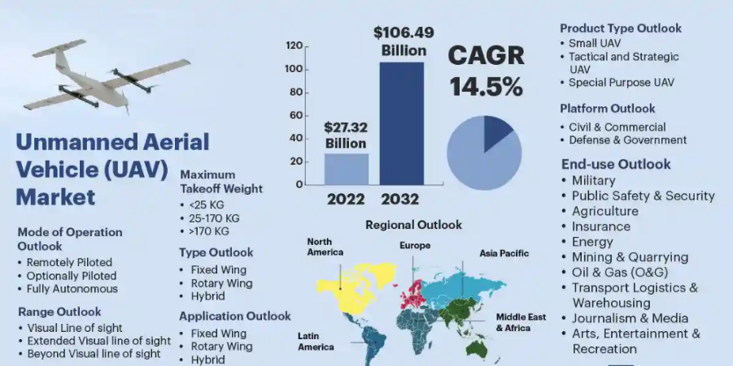
The global defence market presents expansive opportunities, particularly with the integration of UAV and AI technologies . The UAV market size reached USD 27.32 Billion in 2022 and is expected to register a revenue CAGR of 14.5% reaching USD 106.49 Billion in 2022. The AI in military market is projected to grow from USD 9.2 billion in 2023 to USD 38.8 billion by 2028, showcasing a rapid CAGR of 33.3%. This growth is largely propelled by increased demand for sophisticated surveillance systems, precision-guided weaponry, and automated combat support solutions across various regions. In North America,Figure 39, the U.S. leads with high defence budgets focused on homeland security and advanced tech integration. The U.S. UAV market, projected at USD 9.6 billion by 2036, sees substantial investments in AI for autonomous defence systems, creating a strong foundation for partnerships in customizable UAV solutions. The Asia-Pacific region, including China, India, and Japan, is rapidly advancing in military AI and UAVs. China’s strategy incorporates autonomous systems for surveillance and combat, India is investing in UAVs for military objectives, and Japan emphasizes AI in defence, making the region an important market for UAV technology. In the Middle East, Turkey and Israel are expanding their defence tech capabilities. Turkey has emerged as a UAV technology leader, while Israel’s advanced UAV industry provides global partnership opportunities. SWARMER is positioned to access these markets with innovative UAV systems for surveillance and combat, forming partnerships with NATO and international collaborators. These alliances facilitate market access, knowledge exchange, and compliance with global defence standards, supporting SWARMER’s growth and scalability.
Figure 39: UAV global market

EU internal market overview The European Union’s defence market is rapidly evolving, with significant investments in UAVs, AI, and data analytics to enhance military and border security - Figure 40. Germany, France, and Italy are spearheading these efforts, dedicating substantial portions of their defence budgets to technology modernization. Germany is set to increase defence spending by 20% over the next five years, supporting projects that integrate AI-powered UAVs for surveillance and combat. Its Future Combat Air System (FCAS), in collaboration with France and Spain, aims to redefine air combat with next-generation UAVs. France is focusing on AI-driven UAV surveillance to strengthen border security against diverse threats, with support from the European Defence Fund (EDF) to boost interoperability and technology innovation. Italy is investing in modular UAV technologies for various defence missions, aligning with EU standards and enhancing collaborative potential. The EU’s regulatory frameworks, like the EDF, promote defence interoperability and support adaptable UAV solutions. By aligning with these frameworks, projects can drive growth, supporting cross-border partnerships and advancing EU military capabilities through collaborative technological development.
Market analysis and growth potential - Market segmentation: The defence sector’s UAV and AI market can be segmented into three primary categories: hardware, software, and services. Each of these categories plays a critical role in shaping the development and deployment of defence technologies, and they offer distinct growth opportunities. Understanding the dynamics within each segment provides insight into how the market is evolving and where the most significant potential for growth lies. Hardware segment: The hardware segment comprises physical components such as airframes, propulsion systems, sensors, and navigation technologies. This segment is essential as it forms the backbone of UAV systems, enabling them to operate efficiently and effectively in various military scenarios. Components like high-performance sensors, multi-rotor propulsion units, and modular airframe designs are seeing increased investment due to their pivotal roles in enhancing the range, speed, and versatility of UAV platforms.

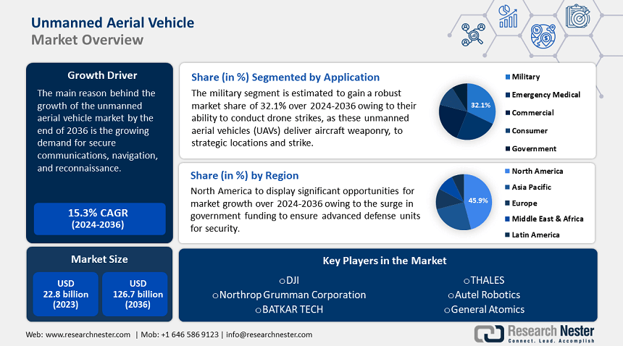
Airframes: Militaries are increasingly demanding advanced, lightweight, and modular airframes capable of carrying multiple payloads. This trend is driving innovations in materials like carbon composites and advanced alloys, improving UAV maneuverability and extending range. Companies in this sector benefit from military contracts focused on developing versatile UAV models for diverse missions, such as reconnaissance and combat. Propulsion Systems: The UAV propulsion segment is advancing with hybrid engines and electric propulsion systems, reflecting the shift toward more efficient and sustainable military technology. These advancements allow UAVs to stay airborne longer, enhancing their strategic value in surveillance and combat. Countries like the U.S., China, and the EU are investing significantly in R&D to improve propulsion efficiency and reduce fuel-related logistical needs. Navigation and Control Technologies: As UAV missions grow in complexity, precise navigation systems are essential. The development of GPS-denied navigation and terrain mapping systems is critical for UAVs in contested or signal-jammed environments. Companies like Thales and Raytheon lead in this area, creating solutions that combine LIDAR, radar, and IMUs for reliable navigation.
Figure 40: UAV market segmentation
Software segment: The software segment is crucial for the growth of UAV and AI defence markets, focusing on AI algorithms, data analytics, and command and control systems that enable automation and intelligence in UAV platforms. As defence technology shifts toward autonomous operations and AI-driven decision-making, software development is essential.
AI Algorithms and Autonomous Systems: AI-driven systems are at the core of military UAVs, allowing for autonomous navigation, target recognition, and real-time decisions. With machine learning (ML) and deep learning (DL) integration, UAVs perform complex tasks without human intervention, increasing demand for these technologies as nations prioritize automation for risk reduction and efficiency. Command and Control Systems: Growth in command and control software is accelerating, as these systems enable secure, efficient UAV-ground communication. Cloud-based solutions and edge computing further enhance these systems' adaptability, making them vital for surveillance and offensive operations. Companies like Northrop Grumman lead investments in this area to support multi-domain missions. Cybersecurity and Data Analytics: With increasing reliance on UAV data, demand for cybersecurity and analytics tools has intensified to protect data integrity and mission security. Companies specializing in encryption, secure communication, and real-time analytics are experiencing heightened interest and investment.
Services segment: The services segment covers system integration, maintenance, training, and technical support, all essential as UAV technology advances in complexity. System Integration: Integrating UAV components, from sensors to AI navigation systems, is critical to ensure defence systems perform optimally. This service is in high demand as defence agencies seek modular, mission-adaptable UAV solutions. Maintenance and Upgrades: The growing UAV fleet requires efficient, scalable maintenance to reduce downtime. Predictive maintenance, powered by AI, is a trend enabling proactive system health management. Training Programs: With increased UAV adoption, specialized training for military personnel is essential. Training includes technical operation and strategic deployment, with demand rising for simulation-based and hands-on programs to ensure readiness.
Growth opportunities and sales projections Each segment—hardware, software, and services—shows strong growth potential. The software sector, especially in AI-driven command and control systems, leads due to its essential role in modern military operations. Companies creating AI algorithms for UAV navigation are seeing high demand, with major players like Thales and Northrop Grumman investing to maintain a competitive edge. Hardware, while more capital-intensive, offers growth as nations develop specialized UAV models for diverse missions like surveillance and electronic warfare. The services segment, covering integration, training, and maintenance, is expanding rapidly as militaries adopt UAV technologies on a larger scale. Within the EU, UAV and AI defence technology demand is set to surge as member states prioritize modernization. Projects like Germany’s FCAS program and France’s autonomous UAV initiatives underscore this trend. With projections estimating EU sales in UAV and AI defence to exceed USD 50 billion by 2030, significant investment from key countries will drive this growth. Outside the EU, North America and Asia-Pacific represent lucrative markets. The U.S., with high defence budgets and AI integration, is expected to dominate, contributing over USD 70 billion by 2035. Asia-Pacific markets, led by China and India, are projected to surpass USD 45 billion. Positioning SWARMER to capture these trends will ensure competitiveness and access to key global markets.
Strategic path for SWARMER market uptake SWARMER aims to maximize exploitation opportunities and facilitate future market adoption of its technologies through close collaboration with technical and validation work packages. The project will employ a Go-To-Market-oriented approach supported by targeted actions, including: Exploitation Plan Development: An exploitation plan (Tasks T1.5 and T2.5) will outline the strategy, including ROI analysis and action steps for both during and post-project, focusing on market entry for SWARMER technologies. Joint Exploitation Agreement: A collaborative agreement will complement the Consortium Agreement, defining IPR and partner roles across exploitation channels to ensure successful commercialization. Market and Business Model Analysis: Specific analyses will define target markets, stakeholders, and the value chain, focusing on defence and military sectors for SWARMER’s effective market strategy. Return on Investment Analysis: ROI analysis will estimate returns for adopters, including financial, security, and socio-economic benefits, validating the project’s business impact. Internal Meetings and Workshops: Regular workshops will refine the exploitation strategy, align IPR approaches, and maximize market impact. External Stakeholder Engagement: Engagement with potential users in defence, through workshops and exchanges, will validate the plan and position SWARMER’s testing as a market-oriented activity. Impact Assessment: KPI-based assessments of SWARMER’s impact on defence and civil security will shape the exploitation strategy, identifying key EU markets and military units for adoption.
Exploitation will start early and proceed in three structured phases, with key milestones ensuring a streamlined Go-To-Market process beyond project completion support - Figure 41.

SWARMER exploitation model and business cases:

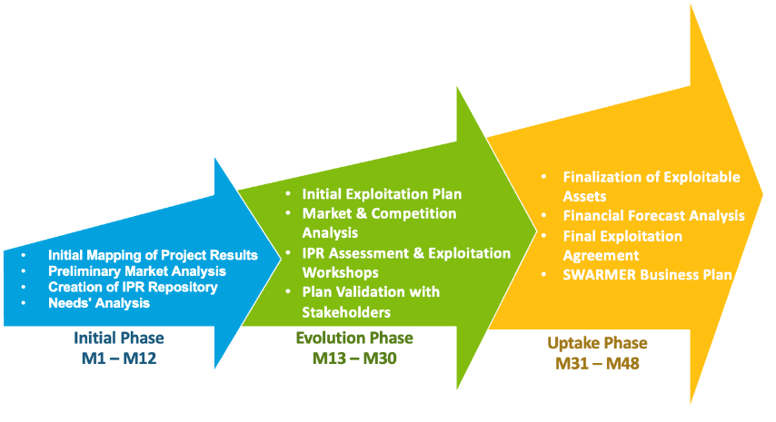
The SWARMER project addresses the European Defence Sector's demand for advanced UAV swarm solutions to support autonomous operations in surveillance, reconnaissance, and tactical. As modern battlefields grow increasingly complex and digitalized, there is a critical need for UAV swarms that can perform reliably in diverse, challenging environments, necessitating robust and scalable technologies. SWARMER’s framework surpasses current solutions by delivering a system that is:
Figure 41: Exploitation and market uptake phases during SWARMER project
● Effective: Ensures precision in coordinating multiple UAVs using advanced algorithms for navigation, mission planning, and threat detection, thus enhancing situational awareness and tactical capability ● Efficient: Maximizes swarm operational capacity with real-time data processing and optimized communication protocols, allowing faster deployments and decision-making ● Automated: Leverages AI and machine learning to reduce human input, enabling autonomous mission execution and adaptive UAV coordination to respond to mission and environmental changes ● Modular and Adaptable: The flexible architecture allows for varied configurations, supporting integration of different sensors, payloads, and software modules, making SWARMER suitable for a broad range of missions and adaptable to various defence technological ecosystems.

STRENGTHS | WEAKNESSES
EU Defence Strategy Alignment: SWARMER aligns with EU goals to boost situational awareness and enhance interoperability among member states.  Cutting-Edge Technological Expertise: The project utilizes advanced AI, UAV, and fiber-optic technologies from leading industry and research partners.  Strong Collaborative Network: Partnerships with defence agencies and technology experts ensure SWARMER’s operational relevance.  Modular, Scalable Design: Solutions are adaptable for varied defence scenarios, providing flexibility across different terrains.  Proven Interdisciplinary Success: The consortium’s history of successful EU collaborations reinforces SWARMER’s credibility and impact potential. | High Complexity and Integration: Integrating various sensing technologies with AI adds complexity, requiring close coordination across project teams.  Access to Defence Data: Securing defence-specific data for model training is challenging due to confidentiality concerns.  Multi-Component Integration Dependency: Seamless integration of fiber-optic, AI, and UAV systems needs sophisticated engineering.  Intellectual Property (IP) Issues: Joint IP ownership can complicate commercialization and exploitation.  Post-SWARMER Sustainability: Maintaining leadership and relevance post-project is crucial for lasting impact and collaboration.
OPPORTUNITIES | THREATS
Collaboration with EU Defence Bodies: SWARMER enables close partnerships with defence agencies, facilitating joint technology development and deployment.  Civilian Security Market Expansion: SWARMER’s advanced sensing and AI technologies can be adapted for border security, infrastructure protection, and disaster response.  Growing AI Defence Demand: Increasing use of AI in autonomous systems opens substantial market opportunities.  EU Defence Funding Potential: Additional support from EU programs like the European Defence Fund (EDF) can propel further development.  Influence on EU Standards: SWARMER can contribute to establishing best practices and standards in defence AI and sensing.  Scalability and Customization: Its modular design offers adaptability for varied defence and security applications, boosting commercial and strategic value. | Competitive market dynamics: entry of other market players and defence technology providers could intensify competition, potentially affecting market share.  Regulatory and bureaucratic challenges: navigating complex regulations and bureaucratic procedures for technology deployment and compliance may delay market penetration.  Uncertainty in policy changes: changes in EU defence policies or member state regulations may impact the adoption and integration of SWARMER solutions.  High development and operational costs: the cutting-edge nature of the technologies and the need for extensive testing may lead to high development and operational costs.  Resistance to new technologies: defence operators may be hesitant to adopt new, unproven technologies, affecting SWARMER’s deployment opportunities.  Geopolitical risks: shifts in geopolitical alliances or conflicts could influence defence spending patterns and affect the project’s market potential.

Business Model: SWARMER, while primarily a Research Action, emphasizes the substantial impact of result exploitation. The consortium has outlined the SWARMER Business Model and key business cases, aligning with defence sector needs and opportunities. Organization Model: Partner roles in exploitation are defined by their ownership of Key Exploitable Results (KERs) and expertise areas. The model considers each partner's role in deployment, licensing, and revenue distribution. Through scenario analysis, SWARMER explores risks, such as creating a New-Co spinoff, addressing potential strategic vision differences between commercial and non-profit partners, and investigating viable licensing paths and appointing Business Champions for joint exploitation. Role Definition: Due to SWARMER’s complexity, roles are distributed among three primary entities: Seller: Manages marketing, sales, and revenue distribution. Service Provider: Offers products and services, including consultancy, deployment, training, and support. Owner: Holds ownership of specific commercializable components, defined through IPR activities. Delivery and Deployment Models: Product Sales Model: Direct UAS hardware sales to defence, government, and commercial clients, with scalable production partnerships to meet demand. Licensing and Subscription Model: Licensing AI-driven navigation software for UAS, generating revenue through subscriptions and usage-based fees. Service-Based Model (Training and Maintenance): Ongoing training and maintenance for operational readiness, scalable via service centers and online platforms. Data-Driven Business Model: Bundles navigation software with data services, offering clients insights via analytics subscriptions and custom reports. Managed UAS Service Model: Full-service UAS operations for clients needing comprehensive support, with scalable remote partnerships. Partnership/Joint Venture Model: Co-develops UAS technologies with defence agencies and tech firms, allowing co-innovation, shared IP, and diversified market solutions.These models provide SWARMER with a versatile strategy to capture various UAS market segments, driving revenue and expanding market reach.

3.3 Intellectual property strategy
Intellectual property strategy
Describe the IP strategy (e.g. patents) associated with your solution and its strength to support the competitiveness and growth of the company.
The IPR (Intellectual Property Rights) aspect is of paramount importance in SWARMER. Effective exploitation of research results depends on the proper management of IPR, which is integral to the overall knowledge management strategy within the project. To ensure the success of SWARMER, all partners agreed before the project commenced on explicit rules regarding IPR ownership, access rights to any Background and Foreground IPR necessary for the execution of the project, and the protection of IPRs. Clear rules for managing ownership, protection, and the granting of knowledge within the Consortium are essential to achieve the following objectives: (1) Stimulate effective cooperation among the partners during project implementation; (3) Encourage innovative contributions from all partners, regardless of their share of work; (4) Protect the commercial interests of the partners; (4) Facilitate further research developments and commercial exploitations of SWARMER technologies; (5) SWARMER is expected to generate several research outcomes and technological innovations. As a result, special attention will be given to knowledge management and protection from the project’s outset and throughout its duration. All details regarding the management and protection of knowledge created within SWARMER will be formalized in the Consortium Agreement (CA), following established models such as DESCA. The CA will address the following: ● Confidentiality of information disclosed by partners during the project; ● Ownership of results arising from the project execution; ● Legal protection of project outcomes through patent rights; ● Commercial exploitation of results, considering scenarios of joint ownership; ● Patents, know-how, and information related to pre-existing knowledge owned by partners, resulting from work conducted prior to the agreement; and ● Sublicenses to third parties within well-defined boundaries.
The principal basis of information and know-how exchange among SWARMER partners, formalized in the CA, will be based on a free access rights principle. This approach ensures effective collaboration among SWARMER partners and the sharing of information necessary for the implementation and success of project outcomes.
Ownership and IP of all results will be closely monitored throughout the project using a continuously updated Results and IP Registry. This registry will include detailed information on project results, clear identification of the owner(s), relevant software licenses (where applicable), and references to any background knowledge used. Additionally, the registry will integrate the Results Ownership List (ROL), which will also be updated continuously and reported in the Final Periodic Report.
By implementing these measures, SWARMER ensures that the IPR management process not only protects the rights of each partner but also fosters a collaborative and innovative environment, maximizing the potential for successful commercial exploitation of the project's technological advancements.
Initial provisions for managing SWARMER Results
The following section shows the agreements that will be made among partners in the Consortium Agreement. Hereafter a summary of major points: • The results resulting from the project is owned by the partner(s) generating it. • Jointly generated results have joint ownership. • Joint owners may USE their jointly owned results for non-commercial research activities on a royalty-free basis. • Joint owners may EXPLOIT their jointly owned results and to grant non-exclusive licenses to third parties behind prior notice of 45 calendar days and fair and reasonable compensation.

Dissemination of own results | During project and for 12 months from the end of the project | Prior notice of the final version at least 45 calendar days before publication  Written objection with precise request for necessary modifications may be raised within 30 days after publication notice  Objection may request publication delay of up to 90 calendar days
Dissemination of another partner’s results or background | Always | Regards: i) results which are not publicly available, ii) unpublished background, iii) confidential information  Requires prior written approval  Absence of an objection is not considered as an approval

Access rights to a foreground software shall comprise:
• access to the object code, and/or
- access to APIs
Access rights to a background software shall comprise:
• only to object code

Purpose | Access right to Background | Access right to Results | Timing (to request access rights)
Needed for the implementation of the project activities | Royalty-free | Royalty-free | Until the end of the project
Needed for Exploitation | Fair and reasonable conditions + Separate written license agreement | Fair and reasonable conditions | Until 12 months after the end of the project or the termination of the partner concerned

Finally, project partners may introduce update and agree on the ownership and exploitation conditions of SWARMER background and results by defining: ● Owner for both the background and foreground; ● Technology readiness level for both the background and foreground; ● Conditions and limitations for project-life implementation and post-project exploitation ● Expected issue licence for the results

4. EDTIB AUTONOMY

4.1 EDTIB autonomy
EDTIB autonomy
Describe to which extent the proposed action will contribute to the autonomy of the EDTIB by increasing the Union’s industrial and technological non-dependency from third countries.
The SWARMER project is strategically designed to significantly contribute to the autonomy of the European Defence Technological and Industrial Base (EDTIB) by reducing the EU’s dependency on third countries for critical defence technologies. In line with the EU’s strategic objectives to strengthen defence capabilities and increase technological independence, SWARMER supports the development of an advanced and resilient UAS (Unmanned Aerial Systems) ecosystem within Europe. This contribution aligns with the European Defence Fund’s (EDF) priorities and the broader EU agenda for defence autonomy. SWARMER will enhance the autonomy of the EDTIB by reducing dependency on non-european technologies: SWARMER’s development focuses on utilizing only European components, software, and expertise to build advanced UAS capabilities. By integrating sensor fusion, AI-driven navigation, and autonomous mission planning technologies sourced from within the EU, SWARMER minimizes reliance on non-European suppliers. This approach ensures that critical UAS technologies remain under European control, reducing vulnerabilities and enhancing the EU's ability to act independently without reliance on external nations; fostering technological sovereignty: the SWARMER consortium, consisting entirely of European partners, is dedicated to developing key UAS technologies such as swarm intelligence, GNSS-denied navigation, and advanced threat detection systems. By advancing these essential technologies within Europe, SWARMER supports technological sovereignty, ensuring that sensitive defence capabilities are not outsourced to external entities. This control over critical technologies is vital for maintaining the security and operational integrity of EU defence forces; enhancing industrial competitiveness: the collaborative nature of the SWARMER project enhances the competitiveness of the European defence sector by pooling resources and expertise from across the EU. By focusing on cutting-edge technologies and ensuring the development of scalable and modular UAS solutions, SWARMER enables European defence companies to gain a competitive edge in the global market. This boost in industrial competitiveness not only strengthens the EDTIB but also attracts further investment into the European defence ecosystem, fostering growth and innovation; establishing standardization and interoperability: SWARMER promotes the development of standardized UAS technologies that are interoperable across different European defence systems. By working towards common technical standards, SWARMER ensures that its solutions are compatible with existing and future European defence platforms, enhancing joint operational capabilities and facilitating seamless cooperation among EU defence forces. This interoperability is essential for executing coordinated defence operations and bolstering Europe’s collective security; development of a knowledge and skill ecosystem: the SWARMER project is structured to facilitate the transfer of knowledge and skills among consortium partners, building a skilled and sustainable workforce within the European defence industry. By engaging with European universities, research institutions, and defence firms, SWARMER promotes a continuous exchange of expertise in areas like AI, drone design, and sensor integration. This focus on skill development not only enhances the EDTIB’s capabilities but also lays the foundation for future technological advancements and self-sufficiency within the European defence sector; alignment with EU strategic policies and objectives: SWARMER’s objectives are closely aligned with the strategic priorities set by the EU, including those under the European Defence Fund and the Permanent Structured Cooperation (PESCO) framework. By adhering to EU defence policies and focusing on achieving technological independence, SWARMER contributes directly to the EU’s vision of strategic autonomy. This alignment ensures that SWARMER’s outcomes are in harmony with the EU’s broader goals, enhancing the relevance and impact of its innovations on the European defence landscape; secure and reliable supply chains: SWARMER emphasizes the establishment of secure and resilient supply chains within Europe, ensuring the availability of critical components and technologies necessary for UAS development. By sourcing materials and technology partners from within the EU, SWARMER mitigates risks associated with global supply chain disruptions and geopolitical dependencies. This approach guarantees that European defence forces have reliable access to the technologies they need, even in crisis scenarios, reinforcing the strategic autonomy of the EU.
The SWARMER project significantly contributes to the autonomy of the EDTIB by developing advanced UAS technologies within the EU, promoting industrial competitiveness, and ensuring that Europe’s defence capabilities are not dependent on non-European technologies. By focusing on technological sovereignty, standardization, and the development of a skilled workforce, SWARMER supports the EU’s strategic ambition of achieving greater independence and self-sufficiency in defence technology.

4.2 Security of supply
Security of supply
Describe the beneficial impact that the proposed activities will have on the strength of the European security of supply, including the creation of a new supply chain.
The SWARMER project will have a profound and beneficial impact on strengthening the European security of supply by creating a new, resilient, and autonomous supply chain for Unmanned Aerial Systems (UAS) technology within the EU. This aligns with the European Commission’s commitment to building a competitive and efficient defence sector that supports the Common Security and Defence Policy (CSDP). By reducing dependency on third-country suppliers and enhancing control over critical defence technologies, SWARMER contributes directly to the EU’s strategic objectives of operational sovereignty and security of supply. The following points illustrate how SWARMER strengthens the security of supply:
- Diversification of the European defence supply chain: SWARMER will diversify the defence supply chain by bringing together a consortium of European partners specializing in various aspects of UAS technology, including hardware manufacturing, software development, and integration services. By leveraging expertise from multiple countries, SWARMER reduces reliance on a limited number of suppliers and creates a more resilient and geographically distributed supply network. This diversification enhances the EU’s capacity to withstand disruptions caused by geopolitical tensions, trade conflicts, or unforeseen events, ensuring a robust and reliable defence supply chain.
- End-to-end control over critical UAS components: SWARMER focuses on developing all critical components of the UAS ecosystem within Europe, from sensor technology and AI algorithms to communication systems and flight control software. This comprehensive approach allows EU countries to maintain end-to-end control over the development and production of essential defence technologies, minimizing vulnerabilities associated with dependency on non-EU suppliers. With complete control over the production process, SWARMER ensures that the European defence sector retains autonomy over its technological capabilities, shielding it from external pressures and ensuring uninterrupted access to critical systems.
- Driving innovation in the European UAS supply chain: by developing cutting-edge UAS technologies, including GNSS-denied navigation, swarm intelligence, and advanced threat detection capabilities, SWARMER positions European companies at the forefront of technological advancements in the global defence market. This innovation not only enhances the operational performance of European defence systems but also strengthens the competitiveness of the EU’s defence industry on a global scale. A technologically advanced and innovative supply chain increases the attractiveness of European defence solutions, fostering growth and technological leadership within the sector.
- Adaptability and customization of UAS solutions: SWARMER’s modular and customizable architecture enables European defence forces to tailor UAS solutions to their specific operational requirements and environmental conditions. This adaptability ensures that SWARMER technologies can be optimized for diverse scenarios, such as urban warfare, border surveillance, and maritime operations, while addressing the unique needs of each EU member state. The ability to customize technologies locally enhances the security of supply by ensuring that European nations have solutions precisely aligned with their defence challenges, independent of non-EU technologies.
- Strategic stockpiling of critical components and technologies: to further enhance the resilience of the EU’s defence capabilities, SWARMER emphasizes the development of strategic stockpiles of critical UAS components and technologies. By maintaining reserves of essential parts, such as sensors, propulsion systems, and AI modules, SWARMER ensures that European countries have a continuous supply of critical technologies during periods of heightened demand or geopolitical disruption. This strategic stockpiling minimizes the impact of supply chain disruptions and secures the long-term operational readiness of European defence forces.
- Economic growth and job creation within the EU: the SWARMER project will stimulate economic growth and job creation across the EU by expanding the defence supply chain and creating employment opportunities in UAS technology development, manufacturing, and support services. By developing a skilled workforce and fostering expertise in advanced UAS and AI technologies, SWARMER contributes to building a robust and sustainable defence industry. This economic growth enhances the EU’s ability to support its defence infrastructure while contributing to the broader economic stability and development of the region.
- High-security standards in the supply chain: SWARMER’s consortium is committed to implementing and adhering to high-security standards throughout the supply chain. By ensuring that all technologies developed meet rigorous security criteria, SWARMER reduces the risk of vulnerabilities and unauthorized access. This adherence to strict security protocols guarantees the integrity and confidentiality of sensitive defence technologies and communications, safeguarding the European defence ecosystem from potential cyber threats and attacks.
To sum-up, SWARMER strengthens the European security of supply by creating a diversified, resilient, and autonomous defence supply chain. Through the development of critical UAS technologies within Europe, SWARMER reduces dependency on non-EU suppliers, drives technological innovation, and enhances economic growth. This comprehensive approach ensures that the European Union remains self-sufficient and prepared to meet its defence challenges independently, contributing to the overall strategic autonomy and security of supply for the EU.

4.3 Member State defence capability priorities
Member State defence capability priorities
Explain how the project outcome will contribute to the defence capability priorities agreed by Member States within the framework of the Common Foreign and Security Policy (CFSP), and in particular in the context of the Capability Development Plan (version releasable to the industry) .
Where appropriate, explain how the proposal addresses regional or an international priorities when they serve the security and defence interests of the Union as determined under the CFSP, where they do not exclude the possibility of participation of any Member State or EDF associated country.
The SWARMER project aligns closely with the defence capability priorities agreed upon by EU Member States within the framework of the Common Foreign and Security Policy (CFSP), specifically in the context of the European Defence Agency's (EDA) Capability Development Plan (CDP). SWARMER supports several key areas identified within the CDP, contributing to the EU’s defence capabilities in three major domains: ● Intelligence, Surveillance, and Reconnaissance (ISR) ● Operational Autonomy and Resilience in Contested Environments ● Cross-Domain Integration and Enhanced Interoperability

Key Capability Area 1: Intelligence, Surveillance, and Reconnaissance (ISR)
SWARMER directly contributes to the EU’s priority of enhancing ISR capabilities by offering advanced autonomous UAS systems that provide superior situational awareness and information superiority. These capabilities also have spin-off potential for other critical defence applications: Autonomous ISR operations: SWARMER’s UAS technology integrates advanced AI and sensor fusion capabilities, enabling it to conduct autonomous ISR missions even in GNSS-denied environments. This functionality ensures continuous monitoring and real-time data collection, providing the EU with the information superiority needed as outlined in the CDP. This technology is foundational for applications in "Ground Combat Capabilities – Next Generation Manned and Unmanned Armoured Platforms," where autonomous ISR capabilities can be adapted to ground combat scenarios. Multi-sensor integration for enhanced data collection: SWARMER’s integration of LiDAR, infrared, and optical sensors enables comprehensive intelligence gathering from various sources, autonomously processing this data to aid decision-making and situational understanding. These advancements align with EU Member States’ requirements for enhanced information management in EU-led missions and can extend into "Land Based Precision Engagement – Next Generation Close Fire Support Systems," where autonomous situational awareness would be critical for precision engagements and unmanned support systems. Real-time data analysis and threat detection: AI algorithms embedded within SWARMER UAS facilitate real-time analysis, allowing rapid identification and classification of potential threats. This capability enhances situational awareness and aligns with the EU’s priority of improving speed and accuracy in decision-making for defence operations. The technology's potential also translates well into "Underwater and Seabed Warfare – Underwater Force Protection Systems," where real-time situational awareness is essential for enhancing operational safety and efficacy in underwater missions.

Key Capability Area 2: Operational Autonomy and Resilience in Contested Environments
WARMER addresses the EU's defence capability priority of operational autonomy, specifically within contested and GNSS-denied environments where traditional systems face severe limitations. These innovations build a foundation for operational resilience across various defence domains: GNSS-denied navigation: SWARMER’s UAS integrates advanced INS, vision-based, and LiDAR-based navigation, enabling reliable operations even in compromised GNSS environments. This capability supports autonomy in complex and hostile settings and directly contributes to the EU’s objectives of operational resilience and self-sufficiency. The algorithms and autonomous navigation features have significant applications for "Air Combat – Next Generation Air Combat Systems (fixed and rotary wings)," where future combat systems will increasingly rely on autonomous and resilient navigational capabilities to enhance mission effectiveness. Swarm coordination and adaptive mission planning: Leveraging AI and swarm intelligence, SWARMER allows fleets of UAS to autonomously coordinate and adjust mission parameters in real-time. This technology provides a strategic advantage for the EU by enabling coordinated, multi-domain operations without reliance on external communications, essential for preserving mission integrity in contested spaces. This adaptive approach is vital to "Next Generation Close Fire Support Systems" by providing an autonomous solution for coordinated close-fire engagements, supporting the EU’s vision for operational autonomy in real-time, high-stakes environments. Resilience against electronic warfare: SWARMER’s decentralized control systems are engineered to withstand jamming and electronic interference, maintaining functional communication and navigation capabilities under hostile conditions. This resilience enhances the EU’s ability to conduct operations independently of external support, aligning with its objective of achieving operational sovereignty. These decentralized control systems also hold significant potential for "Next Generation Manned and Unmanned Armoured Platforms" in ground combat, where resilience against electronic warfare is essential for maintaining mission-critical functionalities.

Key Capability Area 3: Cross-Domain Integration and Enhanced Interoperability
SWARMER’s focus on cross-domain capabilities aligns with the EU’s objective of developing interoperable technologies that integrate seamlessly across multiple defence domains: Interoperability with existing and future EU defence systems: SWARMER’s architecture is designed to be fully compatible with existing European defence platforms and systems, such as command and control (C2) networks. This ensures that SWARMER can integrate seamlessly into joint operations, supporting EU-led missions and enhancing mission effectiveness across various platforms, including "Air Combat – Next Generation Air Combat Systems (fixed and rotary wings)" and "Underwater Force Protection Systems." The project’s focus on interoperability also strengthens cooperation within NATO frameworks and with allied forces, advancing EU security goals under the CFSP. AI-driven cross-domain communication: the AI capabilities within SWARMER enable autonomous communication and coordination across land, sea, and air operations. This flexibility supports the EU's ambition for multi-domain defence integration, as well as the "Ground Combat Capabilities" where a unified approach to land, air, and underwater operations maximizes operational effectiveness. SWARMER’s technologies support this integration by providing a versatile platform for joint, multi-domain environments. Alignment with EU and international priorities: SWARMER’s technology is designed to meet both EU and international defence priorities, ensuring compatibility with EDF-associated countries. By supporting initiatives such as PESCO, SWARMER enhances regional and international defence capabilities. The technologies align with the requirements of systems like "Next Generation Manned and Unmanned Armoured Platforms" and "Underwater Force Protection Systems," which benefit from the multi-environment adaptability inherent to SWARMER's capabilities, enhancing cooperation without excluding participation from any EU or EDF-associated country.

Contribution to regional and international defence priorities
SWARMER’s capabilities not only align with EU defence objectives but also reinforce regional and international collaboration, reflecting the broader security priorities of the EU under the CFSP framework: Supporting EU regional defence initiatives: SWARMER is designed to integrate seamlessly with regional initiatives such as PESCO, ensuring that its technologies contribute to strategic objectives that enhance European defence autonomy. SWARMER’s applicability in systems like "Land Based Precision Engagement" for unmanned close-fire support systems enables EU defence forces to carry out precision missions autonomously, supporting broader regional security frameworks. International collaboration opportunities: the capabilities developed within SWARMER are also compatible with NATO and other international defence standards, strengthening cooperation with global allies. By maintaining adherence to international defence standards, SWARMER supports EU goals of bolstering security through partnerships with like-minded nations, extending its utility to "Underwater and Seabed Warfare – Underwater Force Protection Systems," where cooperative underwater ISR and operational applications are critical.
In alignment with the Capability Development Plan (CDP) and the Common Security and Defence Policy (CFSP), SWARMER presents transformative contributions to the EU’s defence capabilities across ISR, operational autonomy, and cross-domain integration. Incorporating Thales' specialized components, including algorithmic advancements and decentralized control systems, SWARMER addresses the nuanced needs of "Next Generation Manned and Unmanned Armoured Platforms," "Land Based Precision Engagement," "Underwater Force Protection Systems," and "Air Combat Systems." The SWARMER consortium remains committed to developing autonomous, resilient, and interoperable technologies that uphold the EU’s long-term defence and security priorities, reinforcing Europe’s strategic autonomy and operational readiness across a full spectrum of defence applications.

5. CREATION OF NEW CROSS-BORDER COOPERATION

5.1 New cross-border cooperation
New cross-border cooperation
Describe to what extent the proposed action will create new cross-border cooperation between legal entities established in Member States or EDF associated countries, in particular SMEs and mid-caps, especially compared to former activities in the technological area of the topic and taking into account the specificity of the market.
The SWARMER project is a catalyst for new cross-border cooperation among legal entities across EU Member States and EDF-associated countries, especially targeting SMEs and mid-caps in the defence technology sector. This consortium comprises a dynamic mix of SMEs, research institutions, and large industry players from Greece, Germany, Ireland, Spain, Cyprus, Poland, and France. This multinational collaboration includes entities such as iKnowHow, DLR, ETRA, Applied Intelligence Analytics, CERTH, Signal Generix, TRT, and Icarus Swarms, forming a robust alliance that fosters innovation and strengthens the European defence sector. The SWARMER project emphasizes an interdisciplinary approach to the development of cutting-edge autonomous UAS (Unmanned Aerial Systems) technologies for defence applications, enabling synergies that surpass previous efforts in this technological area.
Through a well-structured framework, SWARMER not only introduces new partnerships but also reinforces existing ones, such as ETRA’s past collaborations with DLR and CERTH on H2020-PRAETORIAN and HE-PERIVALLON. New connections, particularly with Signal Generix and Applied Intelligence Analytics, expand the collaborative reach into specialized areas like secure communications and data analytics. SWARMER’s consortium composition benefits from a balance of agility and specialized expertise from SMEs with the scale and resources of large defence firms like Thales, allowing knowledge transfer and co-development of technologies that enhance operational resilience, interoperability, and situational awareness.
The project also prioritizes technology transfer and knowledge sharing, as research institutions from Greece, Germany, and Poland bring advanced R&D insights to SMEs and industry partners. This interaction accelerates the implementation of AI-driven UAS systems, data fusion, and autonomous decision-making. For instance, Signal Generix contributes expertise in secure, resilient communication protocols, facilitating real-time, low-latency coordination within the UAS swarm. This role exemplifies how SWARMER leverages the specialized capabilities of smaller entities to enhance Europe’s strategic autonomy, reducing dependence on non-European technology. Meanwhile, DLR’s ultra-wideband (UWB) swarm navigation technology is being adapted for underwater applications, overcoming unique challenges such as acoustic-based communication in water. This adaptation opens new defence-related applications for underwater force protection and hazardous material recovery, directly supporting the EU’s priorities in underwater and seabed warfare.
Furthermore, SWARMER’s geographical diversity provides enhanced market access and regional representation, which is vital for addressing unique defence requirements across EU nations. For SMEs, the project offers a structured path to enter new markets, scale innovations, and access defence-oriented networks, such as their involvement in the European Defence Agency’s CapTech Aerial Systems group and CERIS (Community of European Research and Innovation for Security). This collaboration aligns with the EU’s goals of fostering long-term partnerships that reinforce the European Defence Industrial and Technological Base (EDTIB). It establishes strategic alliances that are expected to persist beyond the project’s timeframe, helping smaller entities overcome market entry barriers and leveraging joint resources for a more competitive presence in the defence market.
By pooling resources and expertise, SWARMER also supports joint market entry strategies, ensuring a competitive edge for participating SMEs and mid-caps. This shared approach enables cost reductions in R&D, minimizes entry barriers, and promotes innovative solutions that may be challenging to achieve independently. Additionally, SWARMER establishes platforms for regular meetings, workshops, and knowledge exchange, creating a rich ecosystem for cross-border networking within the defence technology field. This ecosystem allows consortium members to exchange best practices, technical insights, and advancements, significantly benefiting smaller entities by giving them access to a wealth of expertise.
Finally, SWARMER’s cross-border cooperation model is deeply aligned with European defence policy objectives, enhancing the resilience, competitiveness, and market access of all participating entities while promoting a unified, innovative European defence industry. The consortium’s diversity and shared expertise not only meets the EU’s strategic defence objectives but also reinforce Europe’s position as a global leader in autonomous UAS technologies for defence. This approach builds a resilient UAS technology ecosystem, fostering long-term collaboration that strengthens European defence capabilities, autonomy, and technological sovereignty

5.2 Planned future cross-border cooperation
Planned future cross-border cooperation
Describe the planned future cross-border cooperation between legal entities established in Member States or EDF associated countries (if any) and cooperation opportunities created by the proposed activities.
The SWARMER project is structured to promote robust and ongoing cross-border cooperation among legal entities from EU Member States and EDF-associated countries, fostering a collaborative environment for SMEs, mid-caps, research institutions, and larger defence firms. This partnership approach goes beyond the scope of the project, establishing networks and expertise-sharing mechanisms that will continue to create opportunities for technological and strategic advancements within the EU defence ecosystem.
1. New and strengthened partnerships for cross-border innovation: the SWARMER consortium unites a diverse set of entities, including iKnowHow, PPHS, DLR, ETRA, Applied Intelligence Analytics, CERTH, Signal Generix, TRT, and Icarus Swarms, each contributing unique expertise across various EU regions such as Greece, Poland, Germany, Cyprus, Spain, and France. This integration of specialized SMEs, larger industry players, and research institutions provides a platform for knowledge-sharing and joint innovation. By linking experienced partners like ETRA and DLR with SMEs such as Signal Generix and Applied Intelligence Analytics, SWARMER establishes a foundation for future collaboration across Europe. Building on successful partnerships from H2020 projects like PRAETORIAN, SWARMER expands on these relationships, introducing new cross-border cooperation for AI navigation, sensor fusion, and secure communication frameworks, effectively setting a new standard in UAS technology.
2. Engagement of SMEs and mid-caps in niche technologies: A key component of the SWARMER project is to integrate SMEs and mid-caps, such as Signal Generix and AIA, into a network traditionally dominated by larger entities, like Thales and DLR. These smaller entities bring niche capabilities, such as Signal Generix's secure V2V communication protocols and AIA’s data analytics expertise, into a broader defence ecosystem. This cooperative environment allows SMEs and mid-caps to contribute cutting-edge technology and benefit from expertise and resources that would be challenging to access independently. The shared technology platforms and standardized frameworks facilitate seamless cooperation between the entities, creating long-term opportunities for these organizations to engage in future European defence projects and broaden their market reach.
3. Structured technology transfer and market expansion: SWARMER creates structured technology transfer opportunities, enabling defence stakeholders across Europe to adopt and adapt project innovations in AI, sensor integration, and swarm intelligence. By developing technology transfer programs and sharing best practices within the consortium, SWARMER fosters a stronger, interconnected defence ecosystem across the EU and EDF-associated countries. For instance, CERTH’s advancements in sensor fusion provide a model for integrated systems, which can be scaled across various applications, enhancing the EU’s defence autonomy and creating new market opportunities within Europe and beyond.
4. Knowledge exchange and cross-border training initiatives: SWARMER’s future cooperation includes specialized training platforms, workshops, and digital knowledge-sharing forums, which will empower defence personnel and technology developers across Member States with the skills and insights gained from the project. Through targeted training in UAS deployment, AI-based decision-making, and swarm operational strategies, SWARMER supports ongoing cross-border knowledge exchange that strengthens Europe’s collective defence capabilities. Annual consortium events and defence technology forums will also serve as hubs for partners to discuss recent innovations, share operational experiences, and explore new collaboration pathways, further enhancing the project's impact.
5. Alignment with EU defence standards and interoperability guidelines: By sharing project insights with European policymakers, SWARMER’s consortium can influence future EU standards and guidelines, supporting a cohesive framework for defence technology innovation. This alignment with EU policies enables SWARMER to promote cross-border interoperability, enhancing Europe’s defence landscape and reinforcing the EU’s strategic autonomy. The establishment of common regulatory frameworks based on SWARMER's technological advancements ensures that Member States and EDF-associated countries can benefit from interoperable, scalable UAS solutions tailored to European defence needs.
6. Long-term strategic alliances and expanded opportunities: The cooperative model established in SWARMER has the potential to create long-term alliances among participating entities. For instance, ETRA’s extensive involvement in the European Defence Agency’s CapTech Aerial Systems group and CERIS positions it as a hub for defence technology and innovation. By connecting SMEs and mid-caps with this wider EU network, SWARMER facilitates new partnerships and business opportunities, allowing participants to expand their market presence and tap into additional funding opportunities for defence innovation. Through strategic alliances, consortium members will have opportunities to participate in additional EU and EDF projects, where their combined expertise can contribute to ongoing defence needs and capabilities within the EU.
Through these avenues, SWARMER sets the stage for enduring cross-border cooperation, facilitating a unified European defence technology network that aligns with EU strategic priorities and builds a resilient, autonomous defence ecosystem. By providing a collaborative framework and fostering sustained partnerships, SWARMER strengthens Europe’s technological edge and strategic independence in critical defence areas.

5.3 Cross-border cooperation by SMEs and mid-caps
Cross-border cooperation by SMEs and mid-caps
Explain to which extent SMEs and mid-caps which cooperate cross-border participate substantially and describe the industrial or technological added value brought by them.
The SWARMER consortium integrates four SMEs that play a pivotal role in advancing the project’s objectives. Their involvement is instrumental in laying the technological foundation for the SWARMER system, which will continue to evolve through additional design, research, and evaluation phases. Each SME brings unique technical expertise and commercial value, contributing significantly not only during the project’s lifecycle but also in the post-project phase. This collaboration not only enhances the technological depth of the SWARMER system but also fosters the development of advanced capabilities in autonomous UAV swarming, real-time analytics, and AI-driven navigation. These SMEs are committed to supporting the commercial rollout of SWARMER’s innovations within the defence sector and exploring applications in adjacent fields such as logistics, border security, and emergency response. The integration of their technologies will support SWARMER’s resilience in GNSS-denied environments and improve swarm autonomy, critical factors for next-generation defence operations. Additionally, the SMEs’ cross-border collaboration with larger defence contractors and research institutions enriches the consortium's diversity of expertise and strengthens the technological ecosystem, further contributing to Europe's strategic autonomy in defence innovation. The two tables below, Table 4 and Table 5, provide a comprehensive overview of the technological contributions and cross-border cooperation fostered by these SMEs within the SWARMER project.
Table 4: Technological Added Value by Each SME Partner in SWARMER

SME | TECHNOLOGICAL ADDED VALUE
IKH | iKnowHow from Greece introduces cloud-enabled processing solutions, which significantly enhance SWARMER’s ability to handle high-intensity data processing in communications-friendly environments. By allowing data processing to shift dynamically between cloud and edge environments, iKnowHow's technology supports SWARMER’s capability for real-time data analysis and decision-making, enhancing operational adaptability. This cloud-based flexibility not only boosts processing power but also enables drones to manage complex tasks remotely, ensuring high operational efficiency across varied mission contexts.
AIA | AIA from Ireland specializes in AI-driven analytics and data processing algorithms that are tailored for SWARMER’s operations in GNSS-denied environments. AIA’s technology allows SWARMER drones to autonomously adapt to real-time mission requirements, even when satellite navigation is compromised. By enabling real-time adaptability and autonomous decision-making, AIA enhances SWARMER’s resilience and efficiency in challenging environments, such as urban or dense terrain, where conventional navigation systems are less effective. This expertise in adaptive AI further strengthens the project’s ability to perform reliably in complex defence scenarios.
SG | Signal Generix from Cyprus brings specialized knowledge in edge computing integration, key for SWARMER’s real-time autonomous operations within swarming drone systems. With their experience in miniaturized AI-powered edge computing, Signal Generix enables SWARMER to handle onboard data processing and fleet coordination tasks with minimal latency. This technology is crucial for SWARMER’s distributed operational model, where drones need to communicate and coordinate seamlessly within the swarm. By reducing dependency on external communications, Signal Generix's edge integration supports autonomous operations even in compromised network conditions, enhancing SWARMER’s adaptability.
ICARUS | Icarus Swarms from France contributes core expertise in swarm coordination algorithms and decentralized decision-making protocols, enabling low Size, Weight, Power, and Cost (SWAP-C) platforms to operate autonomously and reliably in swarm formations. These capabilities allow SWARMER drones to execute coordinated missions effectively, even in GNSS-denied or resource-constrained environments. Icarus Swarms’ technology ensures that each drone within the swarm can make decisions independently yet remain in sync with the larger fleet, maximizing operational flexibility and resilience. This capability is particularly valuable for complex, high-stakes defence missions requiring real-time coordination and swift adaptability.

Table 5:Cross-Border Collaboration and Technological Integration in SWARMER

 | IKH | AIA | SG | ICARUS
IKH |  | Cloud implementation of AI algorithms | Synergetic architecture for on-board and cloud-based processing | Cloud implementation of swarming and autonomy modules
AIA |  |  | AI-enabled on-board processing | AI-driven algorithms for task allocation modules
SG |  |  |  | Enhanced on-board autonomous data processing

6. LIFECYCLE EFFICIENCY (n/a for Research Actions and Lump Sum Grants for Research Actions)

6.1 Improved lifecycle efficiency
Improved lifecycle efficiency (n/a for Research Actions and Lump Sum Grants for Research Actions)
Explain how the proposed solution will provide an improvement in terms of the efficiency across the lifecycle in comparison to existing solutions (for example, improvement in terms of cost-effectiveness by lower production, operational, maintenance, repair and overhaul or disposal costs and/or potential simplification of processes or combination with existing processes for procurement, maintenance and disposal).
Insert text
#§IMP-ACT-IA§#

7. MEMBER STATE COOPERATION (n/a for Research Actions and Lump Sum Grants for Research Actions)

7.1 Member State cooperation
Member State cooperation (n/a for Research Actions and Lump Sum Grants for Research Actions)
Recall the number of Member States that have committed to jointly use, own or maintain the final product or technology in a coordinated way.
You can provide your view on the contribution of the above-mentioned commitments by Member States to the integration of the European defence market.
Describe how your proposal contributes to the increase in cooperation potential between Member States.
Insert text
#@QUA-LIT-QL@# #@WRK-PLA-WP@#

8. IMPLEMENTATION

8.1 Work plan
Work plan
Describe the structure of the work plan (work breakdown structure) including the inter-relations of the different work packages and their components, showing its effectiveness and practicality. Illustrated the structure of the work plan (Pert chart or similar).
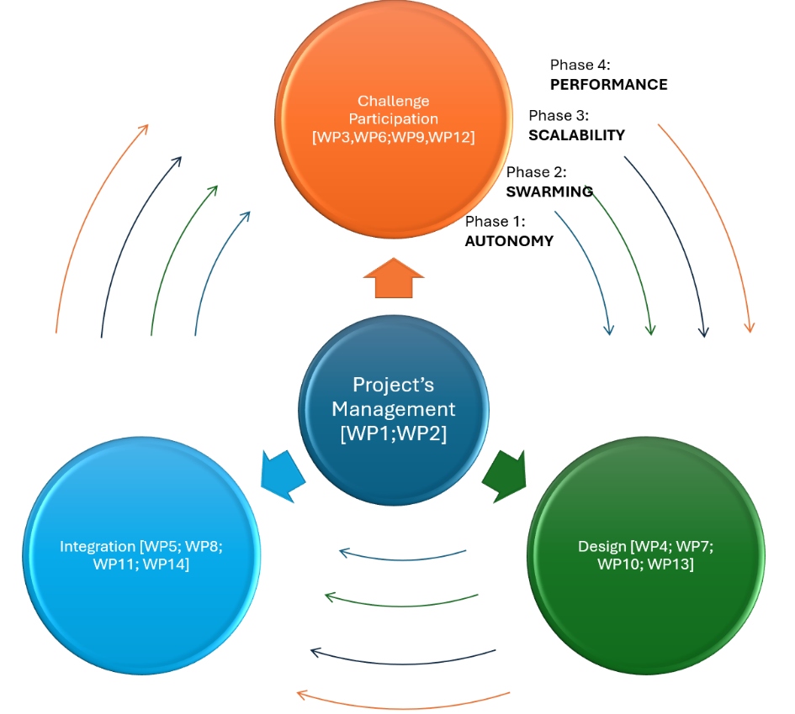
To ensure the smooth and effective execution of the SWARMER project, the workflow is organized into seven (14) work packages (WPs) over a 48-month period - Figure 42. Each consortium member actively participates in activities within their designated areas, covering knowledge generation, design, and knowledge integration. The SWARMER project is divided into four key Phases following the Preliminary Evaluation Plan of the Call comprising of specific work packages (WPs) and tasks aligned with the project’s goals. The synthesis of each Phase’s WPs and Tasks follows an iterative approach each year, in order to support progress and continuous improvement of the SWARMER system throughout the Challenge. In this regard, there is a basic skeleton of WPs that repeat each year containing, in a great percentage, identical tasks with the other years. Few tasks are added, removed or modified through the course of the Phases to address new needs and requirements of the plan. Thus, each Phase contains four WPs i.e. one for Project Management, a second one for Coordination of the consortium’s participations to the Challenge, a third WP for the design of the modules and a fourth for the integration and testing of the complete system. The first phase, Autonomy (Foundation and Protocol Development), spans from Month 1 to Month 12 and is focused on establishing the fundamental protocols and systems needed for SWARMER's autonomous operations and swarming. During this phase, work packages such as WP1 (Project Management and Coordination), WP3 (Participation to the Challenge - 1st Year), and initial design, integration and testing of modules in WP4 and WP5 set the stage for the project’s core capabilities. The second phase, Swarming (Enhanced System Integration), takes place from Month 13 to Month 24 and shifts the focus to integrate advanced swarming functionalities within SWARMER. Work packages WP8 and WP9 are dedicated to the design and integration of the updated modules, which enhance SWARMER’s swarming capabilities. Additionally, WP6 tasks include participation in the second-year of Challenge, allowing for the Consortium’s seamless participation to the field and online tests. The third phase, Scalability (Optimization and Robustness), spans Months 25 to 36 and emphasizes the optimization and scalability of SWARMER’s systems. This phase involves WPs WP9, WP10, and WP11, focusing on refining swarming strategies and enhancing the system’s resilience to handle larger-scale operations. In the final phase, Performance (Final Refinement), from Months 37 to 48, the emphasis is on refining SWARMER’s performance to meet high standards for real-world deployment. Work packages WP12, WP13, and WP14 focus on final system integration and rigorous testing, preparing SWARMER for reliable operation across diverse environments. Throughout each phase, SWARMER includes evaluation plans, online tests, and field tests, with reporting milestones to track progress and ensure accountability. Each work package contributes to the cohesive development of SWARMER, ensuring that the project achieves its goals of advanced autonomy, scalability, and high performance in UAV swarming within GNSS and communications’ denied environments. Detailed presentation of the WPs and the corresponding tasks, milestones, deliverables and interdependencies can be found in Section 8.2.
Figure 42: Workflow Pert Chart

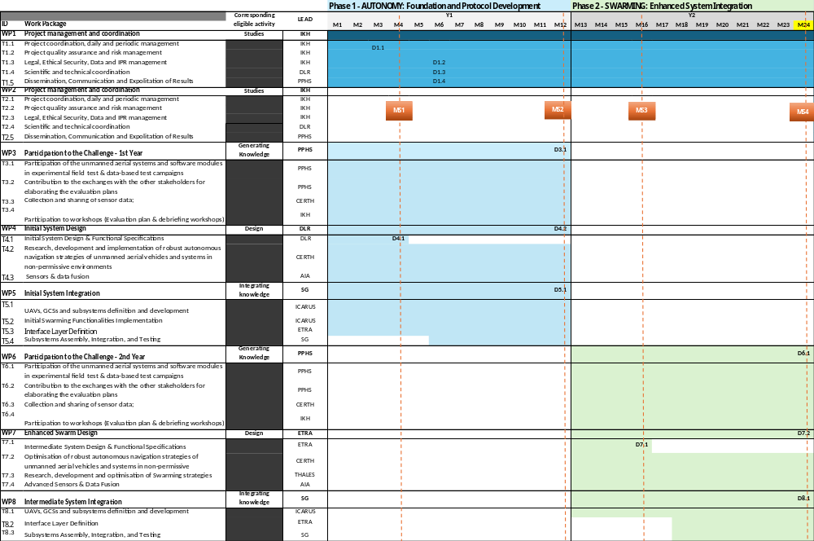
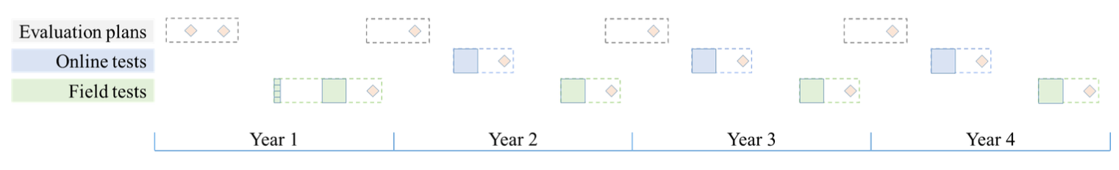
Figure 43 - SWARMER Gantt Chart – Phases 1 & 2

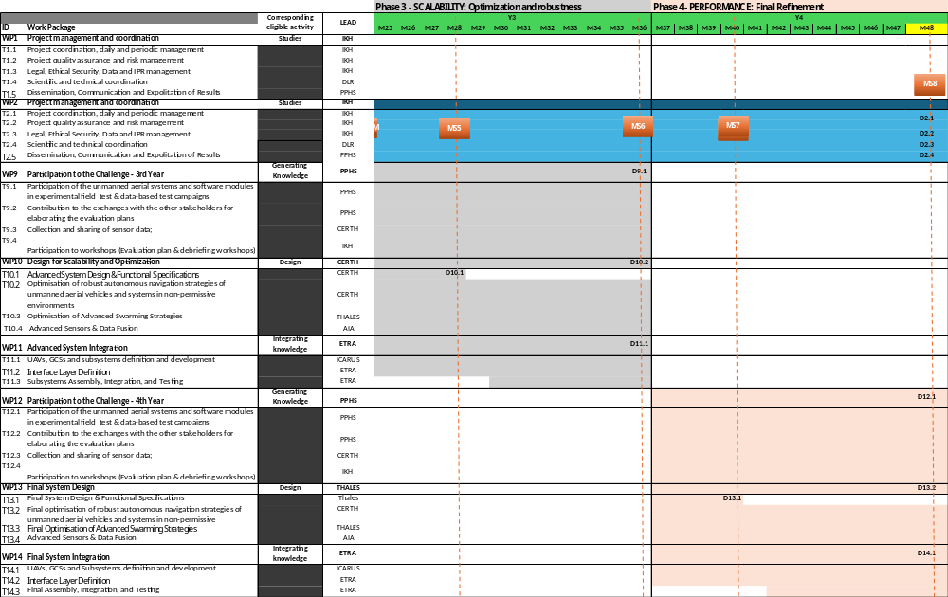
Figure 44: SWARMER Gantt Chart – Phases 3 & 4

8.2 Work packages, activities, resources and timing
WORK PACKAGES
Work packages
This section concerns a detailed description of the project activities.
Group your activities into work packages. A work package means a major sub-division of the project. For each work package, enter an objective (expected outcome) and list the activities, milestones and deliverables that belong to it. The grouping should be logical and guided by identifiable outputs.
Projects should normally have a minimum of 2 work packages. WP1 should cover the management and coordination activities (meetings, coordination, project monitoring and evaluation, financial management, progress reports, etc) and all the activities which are cross-cutting and therefore difficult to assign to another specific work package (communication and dissemination activities, etc). Do not try splitting these activities across different work packages. WP2 and further WPs should be used for the other project activities. You can create as many work packages as needed by copying WP1.
The work package division must comply with the following:
- the types of activity (section 2 Call document) may be broken down into several work packages
- a work package must cover one type of activity only
- the funding rate for WP 1 — Project management and coordination (including other cross-cutting activities) must be the one for the type of activity (c) Studies.
Work packages covering financial support to third parties ( only allowed if authorised in the Call document) must describe the conditions for implementing the support (for grants: max amounts per third party; criteria for calculating the exact amounts, types of activity that qualify (closed list), persons/categories of persons to be supported and criteria and procedures for giving support; for prizes: eligibility and award criteria, amount of the prize and payment arrangements).
Enter each task/milestone/output/outcome/deliverable only once (under one work package).
Ensure consistence with the detailed budget table/calculator (if applicable).
Objectives
List the objectives to which the work package is linked.
Tasks and division of work (WP description)
Provide a concise overview of the work (planned tasks). Be specific and give a short name and number for each task.
Show who is participating in each task: Coordinator (COO), Beneficiaries (BEN), Affiliated Entities (AE), Associated Partners (AP), indicating in bold the task leader.
Add information on other participants’ involvement in the project e.g. subcontractors, in-kind contributions.
Note:
In-kind contributions: In-kind contributions for free are cost-neutral, i.e. cannot be declared as cost. Please indicate the in-kind contributions that are provided in the context of the work package.
The Coordinator remains fully responsible for the coordination tasks, even if they are delegated to someone else. Coordinator tasks cannot be subcontracted.
If there is subcontracting, please also complete the table below.
Milestones and deliverables (outputs/outcomes)
Milestones are control points in the project that help to chart progress (e.g. completion of a key deliverable allowing the next phase of the work to begin). Use them only for major outputs in complex projects, otherwise leave the section empty. Please limit the number of milestones by work package.
Means of verification are how you intend to prove that a milestone has been reached. If appropriate, you can also refer to indicators.
Deliverables are project outputs which are submitted to show project progress (any format). Refer only to major outputs. Do not include minor sub-items, internal working papers, meeting minutes, etc. You may be asked to further reduce the number during grant preparation.
For deliverables such as meetings, events, seminars, trainings, workshops, webinars, conferences, etc., enter each deliverable separately and provide the following in the 'Description' field: invitation, agenda, signed presence list, target group, number of estimated participants, duration of the event, report of the event, training material package, presentations, evaluation report, feedback questionnaire.
For deliverables such as manuals, toolkits, guides, reports, leaflets, brochures, training materials etc., add in the ‘Description’ field: format (electronic or printed), language(s), approximate number of pages and estimated number of copies of publications (if any).
For each deliverable you will have to indicate a due month by when you commit to submit it to the granting authority. The due month of the deliverable cannot be outside the duration of the work package and must be in line with the timeline provided below. Month 1 marks the start of the project and all deadlines should be related to this starting date.
The labels used mean:
Public — fully open ( automatically posted online on the Project Results platforms)
Sensitive — limited under the conditions of the Grant Agreement
EU classified — RESTREINT-UE/EU-RESTRICTED, CONFIDENTIEL-UE/EU-CONFIDENTIAL, SECRET-UE/EU-SECRET under Decision 2015/444. For items classified under other rules (e.g. national or international organisation), please select the equivalent EU classification level.

Work Package 1
Work Package 1: Project management and coordination
Duration: |  |  | M1 – M24 |  |  |  | Lead Beneficiary: |  | 1-IKH
Activity type:  (art 10(3) EDF Regulation) |  |  | studies |  |  |  | Link to other WPs:  (dependence with inputs from other WPs/outputs contribute to other WPs) |  | WP [3,4,5,6,7,8,9,10,11,12,13,14] |  | Classified information: |  |  |  |  | NO
Objectives
WP1 encompasses the overall management, coordination, administration, financial and reporting activities of the project, including oversight of the Consortium and project meetings. The primary objectives of this work package are: (i) ensuring effective communication with the European Commission (EC) and within the Consortium, (ii) managing the financial, legal, ethical, security, intellectual property rights (IPR), and administrative aspects of the project, and (iii) implementing robust quality assurance and risk management processes to identify and continuously address potential risks effectively (iv) Dissemination, Communication and Exploitation of the Project’s Results.
Tasks and division of work (WP description)
Task No  (continuous numbering linked to WP) | Task Name |  |  | Description |  |  |  |  |  |  | Participants |  |  |  | In-kind Contributions and Subcontracting  (Yes/No and which)
Task No  (continuous numbering linked to WP) |  |  |  |  |  |  |  |  |  |  | Name |  | Role  (COO, BEN, AE, AP, OTHER)
T1.1 | Project coordination, daily and periodic management |  |  | This task is led by the Project Coordinator IKH and involves managing the organizational, administrative, financial, and communication aspects of the project. The Consortium Management will be overseen by the Project Coordinator, along with the Project Management Board (PMB) and the General Assembly (GA). Key responsibilities include planning upcoming activities, monitoring the project timeline and progress, implementing corrective actions when necessary, coordinating financial and technical reporting to the European Commission (EUC), and developing a comprehensive communication plan and reporting on the activities carried out. All partners will contribute to this task through regular reporting and by participating in the decision-making bodies. |  |  |  |  |  |  | IKH; DLR; AIA; CERTH; ETRA; SG; PPHS; ICARUS; THALES |  | COO, BEN |  | NO
T1.2 | Project quality assurance and risk management |  |  | This task, led by IKH, focuses on implementing policies related to quality assurance and the risk registration and monitoring of the project. Methodologically, the quality plan will be executed by the Coordinator through a Quality and Risk Management (QRM) plan, adhering to guidelines set forth by standards such as PMBOK®, ISO 31000:2018, AQAP-2110, and AQAP 2000. The activities of the SWARMER project will be closely aligned with planned risk management efforts, utilizing the quality system of IKH, which complies with the ISO 9001:2015 standard, under which the company is certified. All partners will contribute accordingly to this task. |  |  |  |  |  |  | IKH; DLR; AIA; CERTH; ETRA; SG; PPHS; ICARUS; THALES |  | COO, BEN |  | NO
T1.3 | Legal, Ethical Security, Data and IPR management |  |  | This task, led by IKH, focuses on ensuring the effective management, protection, compliance, and oversight of the project’s resources and results from the perspectives of security, social responsibility, legal and ethical considerations, privacy, data protection, and intellectual property rights (IPR). Key activities include: (a) Developing a comprehensive ethical protocol and a consortium code of conduct, (b) Conducting bi-annual reviews of key project outputs, (c) Establishing a confidential conflict resolution process, (d) Promoting gender equality, (e) Developing a Data Management Plan to ensure confidentiality, privacy, and data protection, and (f) Formulating an IPR Management Plan along with a Results and IP Registry. Additionally, a Security Advisory Board (SAB) will be established to oversee the handling of sensitive project results in accordance with established procedures and measures. All partners will contribute accordingly to this task. |  |  |  |  |  |  | IKH; DLR; AIA; CERTH; ETRA; SG; PPHS; ICARUS; THALES |  | COO, BEN |  | NO
T1.4 | Scientific and technical coordination |  |  | This task, led by DLR, involves overseeing and guiding the project’s research and development efforts to ensure they are aligned with the overall project objectives. This includes monitoring and coordinating the various scientific and technical activities to ensure that all WP are progressing according to plan. It also involves synchronizing efforts between different teams to prevent duplication and ensure consistency across the project’s technical outputs. Additionally, Scientific and Technical Coordination ensures that all research and development activities adhere to high-quality standards and follow best practices, guaranteeing that the project’s scientific methods and technical solutions are robust and reliable. Another important aspect of this task is managing the technical deliverables, as well as ensuring technical coherence throughout the lifetime of the project and transfer of knowledge from one phase to the next, ensuring that insights and advancements made in earlier stages of the project are effectively applied to subsequent phases. |  |  |  |  |  |  | IKH; DLR; AIA; CERTH; ETRA; SG; PPHS; ICARUS; THALES |  | COO, BEN |  | NO
T1.5 | Dissemination, Communication and Exploitation of Results |  |  | This task, led by PPHS, involves a comprehensive approach to ensuring the visibility, accessibility, and practical use of the project’s outcomes in close collaboration with the EC. This task includes the dissemination of research findings through scientific publications, presentations at conferences, and the development of technical reports and newsletters aimed at industry, academia, and policymakers. It also encompasses communication activities, such as maintaining a project website, engaging on social media, and organizing public events, workshops, and webinars to raise awareness among a wider audience, including the general public. These activities often involve crafting press releases and media articles to present the project’s impact in a way that is easily digestible for non-experts. |  |  |  |  |  |  | IKH; DLR; AIA; CERTH; ETRA; SG; PPHS; ICARUS; THALES |  | COO, BEN |  | NO
Milestones and deliverables (outputs/outcomes)
Milestone No  (continuous numbering not linked to WP) |  | Milestone Name |  |  | Work Package No | Lead Beneficiary |  | Description |  |  |  | Due Date  (month number) |  | Means of Verification
MS1 |  | Definition of overall Project Management Plan and Initial Design and Specifications. |  |  | 1 | IKH |  | Managerial and operational baseline has been set up to proceed including Legal, Ethical Security, Data and IPR Management, Scientific and Technical Coordination, and Dissemination, Communication, and Exploitation of Results along with the evolution of the SWARMER project as well as the Initial Design and Specifications have been defined |  |  |  | M6 |  | D1.1; D1.2; D1.3; D1.4; D4.1
Deliverable No  (continuous numbering linked to WP) |  | Deliverable Name |  |  | Work Package No | Lead Beneficiary |  | Type |  | Dissemination Level |  | Due Date  (month number) |  | Description  (including format and language)
D1.1 |  | Project Management, Quality Assurance and Risk Management Plan |  |  | 1 | IKH |  | R — Document, report |  | SEN — Sensitive |  | M3 |  | Project Management, Quality Assurance and Risk Management Plan
D1.2 |  | Legal, Ethical Security, Data and IPR - Management Plan |  |  | 1 | IKH |  | R — Document, report |  | SEN — Sensitive |  | M6 |  | Legal, Ethical Security, Data and IPR - Management Plan
D1.3 |  | Scientific and technical coordination- Management Plan |  |  | 1 | DLR |  | R — Document, report |  | SEN — Sensitive |  | M6 |  | Scientific and technical coordination- Management Plan
D1.4 |  | Dissemination, Communication and Exploitation of Results - Management Plan |  |  | 1 | PPHS |  | R — Document, report |  | SEN — Sensitive |  | M6 |  | Dissemination, Communication and Exploitation of Results - Management Plan

Work Package 2
Work Package 2 Project management and coordination
Duration: |  |  | M25 – M48 |  |  |  | Lead Beneficiary: |  | 1-IKH
Activity type:  (art 10(3) EDF Regulation) |  |  | studies |  |  |  | Link to other WPs:  (dependence with inputs from other WPs/outputs contribute to other WPs) |  | WP [3,4,5,6,7,8,9,10,11,12,13,14] | Classified information: |  |  |  |  | NO
Objectives
Identical to WP1 objectives and will continue in M25-M48.
Tasks and division of work (WP description)
Task No  (continuous numbering linked to WP) | Task Name |  |  |  | Description |  |  |  |  | Participants |  |  |  | In-kind Contributions and Subcontracting  (Yes/No and which)
Task No  (continuous numbering linked to WP) |  |  |  |  |  |  |  |  |  | Name |  | Role  (COO, BEN, AE, AP, OTHER)
T2.1 | Project coordination, daily and periodic management |  |  |  | Identical to T1.1 description |  |  |  |  | IKH; DLR; AIA; CERTH; ETRA; SG; PPHS; ICARUS; THALES |  | COO, BEN |  | NO
T2.2 | Project quality assurance and risk management |  |  |  | Identical to T1.2 description |  |  |  |  | IKH; DLR; AIA; CERTH; ETRA; SG; PPHS; ICARUS; THALES |  | COO, BEN |  | NO
T2.3 | Legal, Ethical Security, Data and IPR management |  |  |  | Identical to T1.3 description |  |  |  |  | IKH; DLR; AIA; CERTH; ETRA; SG; PPHS; ICARUS; THALES |  | COO, BEN |  | NO
T2.4 | Scientific and technical coordination |  |  |  | Identical to T1.4 description |  |  |  |  | IKH; DLR; AIA; CERTH; ETRA; SG; PPHS; ICARUS; THALES |  | COO, BEN |  | NO
T2.5 | Dissemination, Communication and Exploitation of Results |  |  |  | Identical to T1.5 description |  |  |  |  | IKH; DLR; AIA; CERTH; ETRA; SG; PPHS; ICARUS; THALES |  | COO, BEN |  | NO
Milestones and deliverables (outputs/outcomes)
Milestone No  (continuous numbering not linked to WP) |  | Milestone Name |  | Work Package No |  | Lead Beneficiary |  | Description |  |  | Due Date  (month number) |  | Means of Verification
MS8 |  | Completion of Final System Implementation and Comprehensive Project Reporting |  | 2 |  | IKH |  | This milestone marks the successful completion of SWARMER’s fourth year, including the Report on Participation in the Challenge - 4th Year, which provides a final assessment of system performance in operational settings. The Report on Final System Design and Report on Final System Integration confirm that all system components are fully aligned and integrated for optimal functionality. Additionally, final reports on Project Management Quality Assurance and Risk Plan, Legal, Ethical Security, Data and IPR Management, Scientific and Technical Coordination, and Dissemination, Communication, and Exploitation of Results demonstrate the consortium's commitment to high standards, transparency, and effective stakeholder engagement. Together, these deliverables encapsulate the project’s outcomes, ensuring all objectives are met and preparing SWARMER for its next phase of deployment or commercialization. |  |  | M48 |  | D12.1; D13.2; D14.1; D2.1; D2.2; D2.3; D2.4
Deliverable No  (continuous numbering linked to WP) |  | Deliverable Name |  | Work Package No |  | Lead Beneficiary |  | Type |  | Dissemination Level | Due Date  (month number) |  | Description  (including format and language)
D2.1 |  | Project Management quality assurance and risk plan - Final Report |  | 2 |  | IKH |  | R — Document, report |  | SEN — Sensitive | M48 |  | Project Management quality assurance and risk plan - Final Report
D2.2 |  | Legal, Ethical Security, Data and IPR management - Final Report |  | 2 |  | IKH |  | R — Document, report |  | SEN — Sensitive | M48 |  | Legal, Ethical Security, Data and IPR management - Final Report
D2.3 |  | Scientific and technical coordination - Final Report |  | 2 |  | DLR |  | R — Document, report |  | SEN — Sensitive | M48 |  | Scientific and technical coordination - Final Report
D2.4 |  | Dissemination, Communication and Exploitation of Results - Final Report |  | 2 |  | PPHS |  | R — Document, report |  | SEN — Sensitive | M48 |  | Dissemination, Communication and Exploitation of Results - Final Report

Work Package 3
Work Package 3: Participation to the Challenge - 1st Year
Duration: |  |  | M1 – M12 |  |  | Lead Beneficiary: |  | 7-PPHS
Activity type:  (art 10(3) EDF Regulation) |  |  | generating knowledge |  |  | Link to other WPs:  (dependence with inputs from other WPs/outputs contribute to other WPs) |  | WP [1,4,5] |  | Classified information: |  |  | NO
Objectives
This work package focuses on the active involvement of the project team in the first-year challenge activities. It includes participation in experimental field tests and data-based test campaigns, collaborating with stakeholders to refine evaluation plans, collecting and sharing sensor data, and attending workshops to review and improve performance and testing protocols. In particular, the main objectives are: (i) To participate in and contribute to experimental field and data-based test campaigns using drones and sensor modules; (ii) To engage with stakeholders and challenge participants to co-develop and refine evaluation plans for effective testing; (iii) To collect, process, and share sensor data gathered during tests for continuous improvement of navigation algorithms; and (iii) To actively participate in evaluation plan and debriefing workshops, providing insights and refining test methodologies.
Tasks and division of work (WP description)
Task No  (continuous numbering linked to WP) | Task Name |  |  | Description |  |  |  |  |  | Participants |  |  |  | In-kind Contributions and Subcontracting  (Yes/No and which)
Task No  (continuous numbering linked to WP) |  |  |  |  |  |  |  |  |  | Name |  | Role  (COO, BEN, AE, AP, OTHER) |  | In-kind Contributions and Subcontracting  (Yes/No and which)
T3.1 | Participation of the unmanned aerial systems and software modules in experimental field test & data-based test campaigns |  |  | This task, led by PPHS, focuses in the first year participation of the field test campaigns, deploying UAS equipped with sensor payloads for autonomous navigation in non-permissive environments. Data-based tests will also be conducted, where the performance of developed modules in obstacle detection and navigation will be evaluated using controlled datasets. |  |  |  |  |  | IKH; DLR; AIA; CERTH; ETRA; SG; PPHS; ICARUS; THALES |  | COO, BEN |  | NO
T3.2 | Contribution to the exchanges with the other stakeholders for elaborating the evaluation plans |  |  | This task, led by PPHS, focuses in actively engage with other challenge participants and stakeholders in discussions to co-develop and refine the evaluation plans for the tests. This will include contributing insights based on the SWARMER system architecture and the integration of multi-sensor solutions for robust navigation. |  |  |  |  |  | IKH; DLR; AIA; CERTH; ETRA; SG; PPHS; ICARUS; THALES |  | COO, BEN |  | NO
T3.3 | Collection and sharing of sensor data; |  |  | This task, led by CERTH, focuses in sensor data captured during both field and data-based tests will be collected, processed, and shared with the other participating teams and challenge organizers. The data will be used to improve the performance of modules both for navigation and for cognition. |  |  |  |  |  | IKH; DLR; AIA; CERTH; ETRA; SG; PPHS; ICARUS; THALES |  | COO, BEN |  | NO
T3.4 | Participation to workshops (Evaluation plan & debriefing workshops) |  |  | This task, led by PPHS, involves team participation to the evaluation plan discussion and debriefing workshops. These workshops will focus on refining the test protocols, reviewing performance results, and sharing lessons learned to improve future test campaigns. |  |  |  |  |  | IKH; DLR; AIA; CERTH; ETRA; SG; PPHS; ICARUS; THALES |  | COO, BEN |  | NO
Milestones and deliverables (outputs/outcomes)
Milestone No  (continuous numbering not linked to WP) |  | Milestone Name |  | Work Package No | Lead Beneficiary |  | Description |  |  |  | Due Date  (month number) | Means of Verification
MS2 |  | Defintion of Initial Management Plans, System Design, and First-Year Challenge Reporting |  | 3 | PPHS |  | This milestone marks the completion of essential management plans, including Legal, Ethical Security, Data and IPR Management, Scientific and Technical Coordination, and Dissemination, Communication, and Exploitation of Results. It also includes the submission of critical initial reports, such as the First-Year Challenge Participation Report, Initial System Design Report, and Initial System Integration Report. Together, these deliverables lay the groundwork for SWARMER's project governance, technical coordination, stakeholder engagement, and provide an early assessment of the system's design and integration progress. |  |  |  | M12 | D3.1; D4.2; D5.1
Deliverable No  (continuous numbering linked to WP) |  | Deliverable Name |  | Work Package No | Lead Beneficiary |  | Type |  | Dissemination Level |  | Due Date  (month number) | Description  (including format and language)
D3.1 |  | Report on Participation to the Challenge - 1st Year - Report |  | 3 | PPHS |  | R — Document, report |  | SEN — Sensitive |  | M12 | Report on the exchange and interactions with Organisation of a Technological Challenge stakeholders on the agreed year 1 final evaluation plan, as well as performance measurement results; Report on SWARMER and related software modules for year 1 test campaign.

Work Package 4
Work Package 4: Initial System Design
Duration: |  |  | M1 – M12 |  |  |  | Lead Beneficiary: |  | 2-DLR
Activity type:  (art 10(3) EDF Regulation) |  |  | design |  |  |  | Link to other WPs:  (dependence with inputs from other WPs/outputs contribute to other WPs) |  | WP [1,3,5] |  | Classified information: |  |  |  | NO
Objectives
The general objective of this work package is to provide the initial SWARMER system design which is robust for operation in non-permissive environments. The focus is on functional specification such as interfaces and protocols, research, development and implementation of the basic algorithms of the SWARMER system as well as the selection, provision and characterization of functional entities such as sensors. Objectives: (i) Design a comprehensive system architecture and define functional specifications for the SWARMER system. (ii) Establish necessary interfaces for information flow between the control layer, data processing layer, sensors and actors to ensure system interoperability. (iii) Develop, select and implement advanced navigation techniques, including SLAM and obstacle avoidance to ensure reliable operation of the SWARMER system in non-permissive environments. (iv) Select, provide and characterize a suite of sensors, along with the development of a real-time data fusion framework.
Tasks and division of work (WP description)
Task No  (continuous numbering linked to WP) | Task Name |  |  | Description |  |  |  |  |  |  | Participants |  |  |  |  | In-kind Contributions and Subcontracting  (Yes/No and which)
Task No  (continuous numbering linked to WP) |  |  |  |  |  |  |  |  |  |  | Name |  | Role  (COO, BEN, AE, AP, OTHER) |  |  | In-kind Contributions and Subcontracting  (Yes/No and which)
T4.1 | Initial System Design & Functional Specifications |  |  | This task, led by DLR, focuses on establishing the initial system design and functional specifications for the SWARMER system. This task serves as a critical precursor to the subsequent subtasks, ensuring that all components of the system are cohesively integrated and aligned with the operational requirements and constraints. By establishing a clear framework for the SWARMER architecture and specifications, including the essential interfaces and protocols for information flow, Task 4.1 will ensure that the subsequent research and development activities in T4.2 and T4.3 are well-informed and aligned with the goals of enhancing SWARMER system operation capabilities in complex environments. |  |  |  |  |  |  | IKH; DLR; AIA; CERTH; ETRA; SG; ICARUS; THALES |  | COO, BEN |  |  | NO
T4.2 | Initial research, design of robust autonomous navigation strategies of unmanned aerial vehicles and systems in non-permissive environments |  |  | This task, led by CERTH, targets to perform any relevant research and design of components that are relevant with the navigational and cognitive capabilities of the system. Considering the diversity of the aimed operational environment and the localization constraints, such activities will involve the definition and deployment of robust GNSS and INS systems to support the localization of each SWARMER asset. In non-permissive environments, robust GNSS systems as well as latest SLAM algorithms will complement the SWARMER capabilities for visual-based localization. In addition, for online cognition and adaptation, computer vision techniques along with the LiDAR-based obstacle avoidance that affect the navigational outcomes will be delivered. Different execution environments will be validated and tested as for example, cloud-based Computing and edge computing frameworks, meets stringent SWaP. The outcomes will be exploited and processed to estimate the essential dynamic path planning and AI/ML-based autonomous navigation models. |  |  |  |  |  |  | IKH; DLR; AIA; CERTH; ETRA; SG; ICARUS; THALES |  | COO, BEN |  |  | NO
T4.3 | Initial research, design of Sensors & data fusion |  |  | This task, led by AIA, focuses in the initial research, design of Sensors & data fusion This task will begin with selecting and calibrating a suite of sensors to provide the most reliable data streams for navigation in GNSS-denied environments. A variety of sensors will be evaluated based on key parameters such as data rate, resolution, power consumption, and reliability in diverse conditions. Selected sensors will contribute complementary data for improved localisation and navigation accuracy. Once chosen, the sensors will undergo comprehensive calibration to ensure alignment and synchronisation across data streams; this includes intrinsic and extrinsic calibration for cameras, camera alignment, and multi-sensor synchronisation through time-stamping and delay compensation. Following calibration, an initial centralised data fusion framework will be developed using a filter-based approach to combine inputs from all sensors for real-time state estimation, incorporating position, velocity, and orientation updates based on processed measurements from each sensor. Preprocessing pipelines will be established to clean and normalise sensor data for optimal compatibility within the fusion framework. The centralised framework will then be tested and validated in both simulation and controlled real-world settings, assessing accuracy in localisation, obstacle detection, latency, and response time. Initial tests will inform refinements and optimisations for future stages, creating a strong foundation for scaling to multi-drone and decentralised data fusion approaches in subsequent project phases. |  |  |  |  |  |  | IKH; DLR; AIA; CERTH; ETRA; SG; ICARUS; THALES |  | COO, BEN |  |  | NO
Milestones and deliverables (outputs/outcomes)
Milestone No  (continuous numbering not linked to WP) |  | Milestone Name |  |  | Work Package No | Lead Beneficiary |  | Description |  |  |  | Due Date  (month number) |  | Means of Verification
MS1 |  | As description in WP1 Milestones |  |  | 1 | IKH |  | As description in WP1 Milestones |  |  |  | M6 |  | D1.1; D4.1
MS2 |  | As description in WP2 Milestones |  |  | 3 | PPHS |  | As description in WP2 Milestones |  |  |  | M12 |  | D3.1; D4.2; D5.1
Deliverable No  (continuous numbering linked to WP) |  | Deliverable Name |  |  | Work Package No | Lead Beneficiary |  | Type |  | Dissemination Level |  | Due Date  (month number) |  | Description  (including format and language)
D4.1 |  | Initial System Design & Functional Specifications |  |  | 1 | DLR |  | R — Document, report |  | SEN — Sensitive |  | M6 |  | Initial System Design & Functional Specifications
D4.2 |  | Report on Initial System Design |  |  | 1 | DLR |  | R — Document, report |  | SEN — Sensitive |  | M12 |  | Report on Initial System Design

Work Package 5
Work Package 5: Initial System Integration
Duration: |  |  | M1 – M12 |  |  |  | Lead Beneficiary: |  | 6-SG
Activity type:  (art 10(3) EDF Regulation) |  |  | integrating knowledge |  |  |  | Link to other WPs:  (dependence with inputs from other WPs/outputs contribute to other WPs) |  | WP [1,4,5] |  | Classified information: |  |  | NO
Objectives
This WP aims to establish a robust foundational framework for the SWARMER UAS to execute swarm operations in environments with degraded GNSS signals. It focuses on the initial integration of hardware and software components to ensure reliable performance, effective communication, and autonomous coordination. Objectives: (i) Define and integrate the critical hardware and software components necessary for reliable swarm operations in GNSS-degraded environments. (ii) Implement core functionalities that ensure effective communication and autonomous coordination among UAS units. (iii) Conduct preliminary testing of the integrated subsystems to validate performance under challenging operational conditions.
Tasks and division of work (WP description)
Task No  (continuous numbering linked to WP) | Task Name |  |  | Description |  |  |  |  |  |  | Participants |  |  |  | In-kind Contributions and Subcontracting  (Yes/No and which)
Task No  (continuous numbering linked to WP) |  |  |  |  |  |  |  |  |  |  | Name | Role  (COO, BEN, AE, AP, OTHER) |  |  | In-kind Contributions and Subcontracting  (Yes/No and which)
T5.1 | UAVs, GCSs and subsystems definition and development |  |  | This task, led by ICARUS, focuses on designing and developing UAVs, Ground Control Stations (GCSs), and key subsystems for autonomous swarming in GNSS-degraded environments. It ensures that all components, from autopilot systems to communication frameworks, meet mission requirements for reliable and adaptive operation.Key areas of work include: (i) Flight Control: Implementing algorithms for stability, navigation, and trajectory maintenance using inertial navigation systems (INS) and visual-inertial odometry. Swarming algorithms will enable UAVs to coordinate, maintain formation, and avoid collisions through alternative positioning methods. (ii) Failsafe Mechanisms: Designing protocols for safe landing, return-to-base, and controlled hover in case of navigation or communication issues. Redundancy measures will include barometric sensors and terrain-based navigation. (iii) Communications Framework: Developing a Vehicle-to-Infrastructure (V2I) communication system for secure, low-latency data exchange between UAVs and GCSs. This includes high-bandwidth communication protocols (e.g., RF, LTE, satellite), network resilience and security mechanisms (automatic frequency switching, error correction), and swarming coordination to enable real-time position and status sharing among units. |  |  |  |  |  |  | IKH; DLR; AIA; CERTH; ETRA; SG; ICARUS; THALES | COO, BEN |  |  | NO
T5.2 | Initial Swarming Functionalities Implementation |  |  | This task, led by ICARUS, focuses to design, develop, and integrate core swarming functionalities that enable UASs to operate collaboratively in harsh environments. These initial capabilities lay the groundwork for autonomous coordination, decision-making, and mission execution, allowing the UAS to function effectively as a swarm with minimal human intervention. This task focuses on enabling each UAS to communicate and coordinate with others, dynamically adapt to environmental conditions, and carry out collaborative behaviors necessary for swarm operations. |  |  |  |  |  |  | IKH; DLR; AIA; CERTH; ETRA; SG; ICARUS; THALES | COO, BEN |  |  | NO
T5.3 | Interface Layer Definition |  |  | This task, led by ETRA, focuses to design and define the interface layer that facilitates seamless communication and data exchange between the various subsystems of the SWARMER, including UAS, the Ground Control Station (GCS), and external control infrastructures. This interface layer is essential for ensuring interoperability, efficient data flow, and coordinated operation of the swarm in all operational environments. The task aims to create a well-defined interface layer that standardizes communication protocols, facilitates real-time data exchange, and enables flexible, scalable integration of hardware and software components. Tight collaboration will take place in this task between technical partners to define the required procedures, methodologies, protocols and information of interest, allowing integration of the SWARMER Demonstrator. Additionally, information from the technical partners will be gathered to ensure that all relevant information is shown in the single SWARMER User Interface. The task will include the design & mock-up of Graphical User Interfaces based on technical requirements and end-users recommendations. |  |  |  |  |  |  | IKH; DLR; AIA; CERTH; ETRA; SG; ICARUS; THALES | COO, BEN |  |  | NO
T5.4 | Subsystems Assembly, Integration, and Testing |  |  | This task, led by SG, focuses on assembling, integrate, and conduct preliminary testing of the various subsystems of the SWARMER. This task ensures that individual components—including UAS, the Ground Control Station (GCS), communication modules, autopilot systems, and sensors—work cohesively and can perform foundational swarming operations. Through this process, each subsystem will be validated for functionality, interoperability, and reliability, confirming that the system meets basic performance standards and is prepared for more advanced challenges. |  |  |  |  |  |  | IKH; DLR; AIA; CERTH; ETRA; SG; ICARUS; THALES | COO, BEN |  |  | NO
Milestones and deliverables (outputs/outcomes)
Milestone No  (continuous numbering not linked to WP) |  | Milestone Name |  |  | Work Package No | Lead Beneficiary |  | Description |  |  | Due Date  (month number) |  | Means of Verification
MS2 |  | As description in WP3 Milestones |  |  | 3 | PPHS |  | As description in WP3 Milestones |  |  | M12 |  | D3.1; D4.2; D5.1
Deliverable No  (continuous numbering linked to WP) |  | Deliverable Name |  |  | Work Package No | Lead Beneficiary |  | Type |  | Dissemination Level | Due Date  (month number) |  | Description  (including format and language)
D5.1 |  | Report on Initial System Integration |  |  | 1 | SG |  | R — Document, report |  | SEN — Sensitive | M12 |  | Report on Initial System Integration

Work Package 6
Work Package 6: Participation to the Challenge - 2nd Year
Duration: |  |  | M13- M24 |  |  | Lead Beneficiary: |  |  | 2-PPHS
Activity type:  (art 10(3) EDF Regulation) |  |  | generating knowledge |  |  | Link to other WPs:  (dependence with inputs from other WPs/outputs contribute to other WPs) |  |  | WP [1,7,8] | Classified information: |  |  |  |  | NO
Objectives
WP6 focuses on advancing the unmanned aerial systems (UAS) and software modules through experimental and data-based test campaigns. It builds upon the experiences of the first year, with an emphasis on enhancing autonomous navigation capabilities, refining evaluation plans, and engaging with stakeholders to achieve project goals. The main objectives are: (i) Validate and improve UAS autonomous navigation performance in complex and GNSS-denied environments; (iI) Collaborate with stakeholders to refine evaluation plans and metrics for UAS systems; (iii) Collect, analyze, and share sensor data securely to optimize AI algorithms and system performance; and (iv) Engage in workshops to review evaluation processes, gather feedback, and guide system development.
Tasks and division of work (WP description)
Task No  (continuous numbering linked to WP) | Task Name |  |  |  |  |  |  | Description |  | Participants |  |  |  |  |  | In-kind Contributions and Subcontracting  (Yes/No and which)
Task No  (continuous numbering linked to WP) |  |  |  |  |  |  |  |  |  | Name |  |  |  | Role  (COO, BEN, AE, AP, OTHER) |  | In-kind Contributions and Subcontracting  (Yes/No and which)
T6.1 | Participation of the unmanned aerial systems and software modules in experimental field test & data-based test campaigns |  |  |  |  |  |  | Identical to T3.1 as for the 2nd Year |  | IKH; DLR; AIA; CERTH; ETRA; SG; PPHS; ICARUS; THALES |  |  |  | COO, BEN |  | NO
T6.2 | Contribution to the exchanges with the other stakeholders for elaborating the evaluation plans |  |  |  |  |  |  | Identical to T3.2 as for the 2nd Year |  | IKH; DLR; AIA; CERTH; ETRA; SG; PPHS; ICARUS; THALES |  |  |  | COO, BEN |  | NO
T6.3 | Collection and sharing of sensor data; |  |  |  |  |  |  | Identical to T3.3 as for the 2nd Year |  | IKH; DLR; AIA; CERTH; ETRA; SG; PPHS; ICARUS; THALES |  |  |  | COO, BEN |  | NO
T6.4 | Participation to workshops (Evaluation plan & debriefing workshops) |  |  |  |  |  |  | Identical to T3.4 as for the 2nd Year |  | IKH; DLR; AIA; CERTH; ETRA; SG; PPHS; ICARUS; THALES |  |  |  | COO, BEN |  | NO
Milestones and deliverables (outputs/outcomes)
Milestone No  (continuous numbering not linked to WP) |  | Milestone Name |  | Work Package No | Lead Beneficiary |  | Description |  |  |  |  | Due Date  (month number) | Means of Verification
MS4 |  | Completion of Second-Year Challenge Participation and Intermediate System Enhancements |  | WP6 | PPHS |  | This milestone signifies the completion of SWARMER’s second-year progress, including the Report on Participation in the Challenge - 2nd Year, providing insights into system performance and testing outcomes. Additionally, the Report on Enhanced Swarm Design captures advancements in swarm coordination and autonomy, while the Report on Intermediate System Integration details the integration of newly developed modules and their performance within the system. Together, these deliverables highlight SWARMER's progress in refining swarm capabilities and integrating functionalities to meet project objective. |  |  |  |  | M24 | D6.1; D7.2; D8.1
Deliverable No  (continuous numbering linked to WP) |  | Deliverable Name |  | Work Package No | Lead Beneficiary |  | Type |  |  |  | Dissemination Level | Due Date  (month number) | Description  (including format and language)
D6.1 |  | Report on Participation to the Challenge - 2nd Year |  | 6 | PPHS |  | R — Document, report |  |  |  | SEN — Sensitive | M24 | Report on the exchange and interactions with Organisation of a Technological Challenge stakeholders on the agreed year 2 final evaluation plan, as well as performance measurement results; Report on SWARMER UAS and related software modules for year 2 test campaign.

Work Package 7
Work Package 7: Enhanced Swarm Integration
Duration: |  |  | M13- M24 |  |  |  | Lead Beneficiary: |  | 5-ETRA
Activity type:  (art 10(3) EDF Regulation) |  |  | design |  |  |  | Link to other WPs:  (dependence with inputs from other WPs/outputs contribute to other WPs) |  | WP [1,6,8] |  | Classified information: |  |  |  | NO
Objectives
This work package focuses on advancing the design, development, optimization and integration of systems for autonomous drone swarms. It aims to enhance navigation, communication, and data fusion capabilities, ensuring robust performance in dynamic and challenging environments. The main activities performed in WP7 are (i) Update and refine the system design and functional specifications in line with evolutionary prototyping principles. Incorporate feedback from the first challenge to enahnce drone swarm navigation performance and integration (ii) Improve navigation strategies for UAV using LIDAR, computer vision, and dynamic path planning. (iii) Develop and optimise swarming strategies, focusing on reliable vehicle-to-vehicle communication, decentralised decision-making, and cooperative SLAM. Enhance coordination for efficient task allocation and mission completion (iv) Scale and optimise multi-drone sensor data fusion algorithms to support larger swarms.
Tasks and division of work (WP description)
Task No  (continuous numbering linked to WP) | Task Name |  |  | Description |  |  |  |  |  |  | Participants |  |  |  |  | In-kind Contributions and Subcontracting  (Yes/No and which)
Task No  (continuous numbering linked to WP) |  |  |  |  |  |  |  |  |  |  | Name |  | Role  (COO, BEN, AE, AP, OTHER) |  |  | In-kind Contributions and Subcontracting  (Yes/No and which)
T7.1 | Intermediate System Design & Functional Specifications |  |  | This task, led by ETRA, focuses to review of the and update of the initial system design and functional specifications to the evolutionary prototyping principles. Incremental refinements of the functional specifications will be based on the outcomes of the participation in the challenge of the previous year. In the second year, the objective will be to enhance the integration of the drone swarm. |  |  |  |  |  |  | IKH; DLR; AIA; CERTH; ETRA; SG; ICARUS; THALES |  | COO, BEN |  |  | NO
T7.2 | Optimisation of robust autonomous navigation strategies of unmanned aerial vehicles and systems in non-permissive environments |  |  | This task, led by CERTH, focuses to refine the components for autonomous navigation will be refined based on the first challenge's outcomes. During the second year, all under studying models will be adapted and refined targeting to optimize their overall performance based on the provided user requirement collection for the participation to the second challenge and more specifically: (i) the Robust GNSS Systems to enhance anti-jamming technologies and spoofing detection, (ii) Lidar-Based Navigation to enhance the 3D LIDAR-based VFH algorithm will utilize measurements from multiple drones to maximize environmental coverage, (iii) Computer Vision-Based Navigation where Visual SLAM will be improved for dynamic environments, enhancing localization and mapping, (iv) Dynamic Path Planning where path calculation will adapt to mobile dangers in GNSS-denied areas, (v) AI Techniques for Object detection algorithms will be optimized for robustness, (vi) Cloud and Edge Computing boards will be enhanced for efficient processing and integration across platform. |  |  |  |  |  |  | IKH; DLR; AIA; CERTH; ETRA; SG; ICARUS; THALES |  | COO, BEN |  |  | NO
T7.3 | Research, development and optimisation of Swarming strategies |  |  | This task, led by THALES focuses on the integration and optimisation of Autonomous Navigation with Swarming Strategies. The autonomous navigation of individual drones will be adapted and swarming capabilities will be added based on (and will take advantage of) V2V (and Vehicule to ground for assessment and debugging purpose) in order to support the other features of this task as follows (i) Vehicle-to-Vehicle (V2V) Communication. Reliable communication among swarm entities is essential for distributed data processing and coordinated control, with an emphasis on mesh communication systems to meet key requirements.(ii) Swarm Coordination: The swarm will operate as a cohesive flock, progressing along designated paths and completing decentralized tasks with reliable inter-drone communication (ii) Cooperative SLAM Localization and high-quality mapping will be achieved through cooperative SLAM, developing collective behaviors during the initial phase. (iv) Relative Positioning Systems: The navigation system will incorporate radio-based approaches for accurate relative positioning of swarm entities.(v) Predictive Modelling: Advanced machine learning techniques will enhance decision-making by simulating swarm behaviors in dynamic environments, anticipating obstacles and environmental changes. |  |  |  |  |  |  | IKH; DLR; AIA; CERTH; ETRA; SG; ICARUS; THALES |  | COO, BEN |  |  | NO
T7.4 | Advanced Sensors & Data Fusion |  |  | This task, led by AIA focuses on scaling the centralized data fusion system to support larger drone swarms, building on the initial multi-drone sensor fusion algorithms developed in the previous stage. The primary goal is to enhance system efficiency and scalability by optimising data fusion to handle an increased volume of data across multiple drones. This will involve refining the data fusion algorithms to ensure they operate effectively within the constraints of drone communication bandwidth and available onboard computing resources, as defined in collaboration with consortium partners. The optimisation process will start with profiling the existing multi-drone fusion algorithms to identify computational and communication bottlenecks when integrating data from multiple drones. Strategies such as selective data sharing, data compression, and prioritisation of essential sensor information (e.g., high-priority data like obstacle locations or positional updates) will be implemented to reduce bandwidth usage without compromising accuracy. Additionally, adaptive data fusion techniques will be explored, enabling the fusion algorithms to adjust dynamically based on available network resources, drone proximity, or mission-specific needs. Testing will be carried out in progressively larger swarms to evaluate the efficiency and responsiveness of the optimised data fusion system under realistic conditions, including scenarios with intermittent communication or varying computational loads. The results of these tests will guide further refinements, focusing on improving robustness, reducing latency, and ensuring that the fusion algorithms remain adaptable as swarm size and complexity grow. This task will thus establish a scalable, communication-efficient data fusion approach, preparing the system for full decentralisation in future project stages. |  |  |  |  |  |  | IKH; DLR; AIA; CERTH; ETRA; SG; ICARUS; THALES |  | COO, BEN |  |  | NO
Milestones and deliverables (outputs/outcomes)
Milestone No  (continuous numbering not linked to WP) |  | Milestone Name |  |  | Work Package No | Lead Beneficiary |  | Description |  |  |  | Due Date  (month number) |  | Means of Verification
MS3 |  | Definition of the Intermediate System Design & Functional Specifications |  |  | 7 | ETRA |  | Submission of the Intermediate System Design & Functional Specifications |  |  |  | M16 |  | D7.1
MS4 |  | As description in WP6 Milestones |  |  | 7 | PPHS |  | As description in WP6 Milestones |  |  |  | M24 |  | D6.1; D7.2; D8.1
Deliverable No  (continuous numbering linked to WP) |  | Deliverable Name |  |  | Work Package No | Lead Beneficiary |  | Type |  | Dissemination Level |  | Due Date  (month number) |  | Description  (including format and language)
D7.1 |  | Intermediate System Design & Functional Specifications |  |  | 7 | ETRA |  | R — Document, report |  | SEN — Sensitive |  | M16 |  | Intermediate System Design & Functional Specifications
D7.2 |  | Report on Enhanced Swarm Design |  |  | 7 | ETRA |  | R — Document, report |  | SEN — Sensitive |  | M24 |  | Report on Enhanced Swarm Design

Work Package 8
Work Package 8: Intermediate System Integration
Duration: |  |  | M13 – M24 |  |  |  | Lead Beneficiary: |  | 6-SG
Activity type:  (art 10(3) EDF Regulation) |  |  | integrating knowledge |  |  |  | Link to other WPs:  (dependence with inputs from other WPs/outputs contribute to other WPs) |  | WP [1,6,7] |  | Classified information: |  |  |  |  | NO
Objectives
This WPs seeks to complete the intermediate system integration by enhancing and defining the UAVs, GCSs, and subsystems to enable more complex and adaptive swarm operations. The focus is on refining capabilities, optimizing communication, and integrating advanced hardware and software features. Objectives: (i) Define and develop UAVs, GCSs, and subsystems to support intermediate system integration, preparing the swarm for advanced mission scenarios with improved flight control and environmental awareness. (ii) Expand and refine the interface layer to handle complex, scalable swarm operations, enabling real-time coordination, advanced sensor data processing, and interoperability between onboard and ground-based systems. (iii) Integrate and test advanced subsystems within the UAS swarm, focusing on validating performance in complex, realistic mission scenarios to ensure adaptability, reliability, and seamless functionality in harsh environments
Tasks and division of work (WP description)
Task No  (continuous numbering linked to WP) | Task Name |  |  | Description |  |  |  |  |  |  |  | Participants |  |  |  | In-kind Contributions and Subcontracting  (Yes/No and which)
Task No  (continuous numbering linked to WP) |  |  |  |  |  |  |  |  |  |  |  | Name |  | Role  (COO, BEN, AE, AP, OTHER)
T8.1 | UAVs, GCSs and subsystems definition and development |  |  | This task, led by ICARUS focuses on the development and refinement of the Autopilot (AP).In this second year of the project, the initial version of the Autopilot will undergo a comprehensive refinement, integration, and testing process for both individual drones and drone swarms. This version will integrate enhancements from various project tasks, particularly those aimed at improving robustness and resilience. Key components such as advanced positioning, communication systems, and collaborative functions will be included to ensure reliable performance across diverse operational scenarios. |  |  |  |  |  |  |  | IKH; DLR; AIA; CERTH; ETRA; SG; PPHS; ICARUS; THALES |  | COO, BEN |  | NO
T8.2 | Interface Layer Definition |  |  | This task, led by ETRA focuses on the initial version of the SWARMER Interface Layer which will be implemented and tested in laboratory conditions as part of task T8.3. This work will build on the progress made in WP5. The primary goal is to enable interoperability and communication exchange among SWARMER components, including UAVs and Ground Control Stations (GCS), as detailed in T8.1.The initial version will facilitate efficient data flow and coordination among system components. Additionally, preliminary Graphical User Interfaces (GUIs) will be developed to enhance user operation and interaction. These GUIs will provide essential functionalities for monitoring and control. The task will ensure a solid foundation for future integration and enhancements within the SWARMER system. Overall, this task is crucial for achieving effective system performance and user engagement. |  |  |  |  |  |  |  | IKH; DLR; AIA; CERTH; ETRA; SG; ICARUS; THALES |  | COO, BEN |  | NO
T8.3 | Subsystems Assembly, Integration, and Testing |  |  | This task, led by SG focuses on the integration and test advanced subsystems within the UAS swarm, including updated configurations, new features, expanded communication frameworks, and refined sensor and payload capabilities. This phase focuses on validating the performance of these upgraded subsystems within more complex, realistic mission scenarios and ensuring seamless functionality in harsh environments. Through systematic testing and integration, this task will prepare the SWARMER for autonomous, coordinated missions with a focus on adaptability, reliability, and interoperability. |  |  |  |  |  |  |  | IKH; DLR; AIA; CERTH; ETRA; SG; PPHS; ICARUS; THALES |  | COO, BEN |  | NO
Milestones and deliverables (outputs/outcomes)
Milestone No  (continuous numbering not linked to WP) |  | Milestone Name |  |  | Work Package No | Lead Beneficiary |  | Description |  |  |  |  | Due Date  (month number) |  | Means of Verification
MS4 |  | As description in WP6 Milestones |  |  | 8 | PPHS |  | As description in WP6 Milestones |  |  |  |  | M24 |  | D6.1; D7.2; D8.1
Deliverable No  (continuous numbering linked to WP) |  | Deliverable Name |  |  | Work Package No | Lead Beneficiary |  | Type |  | Dissemination Level |  |  | Due Date  (month number) |  | Description  (including format and language)
D8.1 |  | Report on Intermediate System Integration |  |  | 8 | SG |  | R — Document, report |  | [SEN — Sensitive] |  |  | M24 |  | Report on Intermediate System Integration

Work Package 9
Work Package 9: Participation to the Challenge - 3rd Year
Duration: |  |  | M25 – M36 |  |  | Lead Beneficiary: |  | 7-PPHS
Activity type:  (art 10(3) EDF Regulation) |  |  | generating knowledge |  |  | Link to other WPs:  (dependence with inputs from other WPs/outputs contribute to other WPs) |  | WP [2,10,11] | Classified information: |  |  |  |  |  | NO
Objectives
WP9 aims to further test and refine unmanned aerial systems (UAS) and related software modules in increasingly complex and realistic environments, while fostering collaboration with stakeholders to enhance evaluation frameworks and system performance. The work package focuses on field tests, stakeholder collaboration, sensor data collection, and knowledge exchange through workshops. The key objectives are: (i) Conduct advanced test campaigns under challenging conditions to evaluate UAS performance in real-world scenarios; (ii) Collaborate with stakeholders to refine evaluation plans and ensure tests reflect practical operational requirements; (iii) Collect and share sensor data to enhance the development of autonomous navigation and obstacle detection algorithms; and (iv) Participate in workshops to assess progress, share insights, and discuss the integration of advanced technologies.
Tasks and division of work (WP description)
Task No  (continuous numbering linked to WP) | Task Name |  |  |  |  |  | Description |  | Participants |  |  |  |  | In-kind Contributions and Subcontracting  (Yes/No and which)
Task No  (continuous numbering linked to WP) |  |  |  |  |  |  |  |  | Name |  |  | Role  (COO, BEN, AE, AP, OTHER)
T9.1 | Participation of the unmanned aerial systems and software modules in experimental field test & data-based test campaigns |  |  |  |  |  | Identical to T3.1 as for the 3rd Year |  | IKH; DLR; AIA; CERTH; ETRA; SG; PPHS; ICARUS; THALES |  |  | COO, BEN |  | NO
T9.2 | Contribution to the exchanges with the other stakeholders for elaborating the evaluation plans |  |  |  |  |  | Identical to T3.2 as for the 3rd Year |  | IKH; DLR; AIA; CERTH; ETRA; SG; PPHS; ICARUS; THALES |  |  | COO, BEN |  | NO
T9.3 | Collection and sharing of sensor data; |  |  |  |  |  | Identical to T3.3 as for the 3rd Year |  | IKH; DLR; AIA; CERTH; ETRA; SG; PPHS; ICARUS; THALES |  |  | COO, BEN |  | NO
T9.4 | Participation to workshops (Evaluation plan & debriefing workshops) |  |  |  |  |  | Identical to T3.4 as for the 3rd Year |  | IKH; DLR; AIA; CERTH; ETRA; SG; PPHS; ICARUS; THALES |  |  | COO, BEN |  | NO
Milestones and deliverables (outputs/outcomes)
Milestone No  (continuous numbering not linked to WP) |  | Milestone Name |  | Work Package No | Lead Beneficiary |  | Description |  |  |  | Due Date  (month number) |  | Means of Verification
MS6 |  | Completion of Third-Year Challenge Participation and Advanced System Development |  | 9 | PPHS |  | This milestone reflects significant progress in SWARMER’s third year, including the Report on Participation in the Challenge - 3rd Year, which assesses system performance in real-world conditions. The Report on Design for Scalability and Optimization outlines strategies for expanding and optimizing SWARMER’s functionality to handle larger, more complex operations. Additionally, the Report on Advanced System Integration documents the integration of high-level features, ensuring cohesive operation across all system components. These deliverables collectively demonstrate SWARMER’s readiness for robust, scalable deployment. |  |  |  | M36 |  | D9.1; D10.2; D11.1
Deliverable No  (continuous numbering linked to WP) |  | Deliverable Name |  | Work Package No | Lead Beneficiary |  | Type |  |  | Dissemination Level | Due Date  (month number) |  | Description  (including format and language)
D9.1 |  | Report on the Participation to the Challenge - 3rd Year |  | 9 | PPHS |  | R — Document, report |  |  | SEN — Sensitive | M36 |  | Report on the exchange and interactions with Organisation of a Technological Challenge stakeholders on the agreed year 3 final evaluation plan, as well as performance measurement results; Report on SWARMER UAS and related software modules for year 3 test campaign.

Work Package 10
Work Package 10: Scalability and Optimization
Duration: |  |  | M25 – M36 |  |  |  | Lead Beneficiary: |  | 1-CERTH
Activity type:  (art 10(3) EDF Regulation) |  |  | design |  |  |  | Link to other WPs:  (dependence with inputs from other WPs/outputs contribute to other WPs) |  | WP [2,9,11] |  | Classified information: |  |  | NO
Objectives
The work package targets to ensure the SWARMER scalability and the incorporation of optimised components relevant with the core objectives of autonomous navigation under diverse operational conditions, utilizing different type of sensing systems and incorporating swarming capabilities. After the participation in two rounds of testing campaigns within the scope of the Challenges, specific actions will be executed initially assessing the updated user requirements catalogue. In particular the main objectives of the work package are: (i) The design of an advanced SWARMER system and mapping and defining the corresponding functional requirements based on the user requirements collection. (ii) Refine and upgrade the core components that contribute to autonomous navigation under diverse conditions and various payloads of each SWARMER aerial asset (iii) Updates on the swarming capabilities and the team’s collective behavior (iv) Ameliorate the overall fusion capabilities from various sources to improve the navigational capabilities of the SWARMER team towards one unified and collective response.
Tasks and division of work (WP description)
Task No  (continuous numbering linked to WP) | Task Name |  |  | Description |  |  |  |  |  |  | Participants |  |  |  | In-kind Contributions and Subcontracting  (Yes/No and which)
Task No  (continuous numbering linked to WP) |  |  |  |  |  |  |  |  |  |  | Name | Role  (COO, BEN, AE, AP, OTHER) |  |  | In-kind Contributions and Subcontracting  (Yes/No and which)
T10.1 | Advanced System Design & Functional Specifications |  |  | This task, led by CERTH focuses on the activities to define an intermediate version/prototype of the SWARMER system after the validation and participation of the 2nd Challenge. Based on the updated user requirements, the core system will be adapted accordingly to cover the additional capabilities. To this end, all technical requirements and functional specifications will be defined based on which the consortium will participate on the 3rd Challenge to showcase the scalability and the optimised operations. |  |  |  |  |  |  | IKH; DLR; AIA; CERTH; ETRA; SG; ICARUS; THALES | COO, BEN |  |  | NO
T10.2 | Optimisation of robust autonomous navigation strategies of unmanned aerial vehicles and systems in non-permissive environments |  |  | This task, led by CERTH focuses on updating and alignemnet with revised user requirements, aiming for a scalable and robust architecture on the components for autonomous navigation and dynamic path planning will be. Thus more specifically for (i) Robust GNSS Systems: Large-scale implementation of anti-jamming technologies will include jamming detection and automated frequency changes, (ii) Lidar-Based Navigation: Decentralized obstacle avoidance architectures will be optimized for edge deployment to support scalable drone swarm strategies, (iii) Computer Vision-Based Navigation: Visual navigation capabilities will be enhanced for large, complex environments, ensuring robustness to changes. (iv) Dynamic Path Planning: Path planning will improve navigation around dead-ends and enhance area coverage for task allocation. (v) Machine Learning and AI Techniques: Algorithms will be refined for real-time detection and segmentation. (vi) Cloud and Edge Computing: Cloud-computing capabilities will scale up, while the AI edge computing board will be refined for optimal UAS swarming performance and future adaptability. Building on previous years' groundwork, this phase will concentrate on fine-tuning sensor and payload interfaces, ensuring precise integration, and maximizing performance for processing complex, swarm-centric algorithms deployed within the SWARMER project. The design will be meticulously customized to meet exacting project requirements while maintaining a high degree of adaptability and interoperability, facilitating future compatibility with diverse systems and enhancing the scalability of swarming operations across a broader range of UAS platforms. |  |  |  |  |  |  | IKH; DLR; AIA; CERTH; ETRA; SG; ICARUS; THALES | COO, BEN |  |  | NO
T10.3 | Optimisation of Advanced Swarming Strategies |  |  | This task, led by THALES focuses on revising predefined components for swarming collaboration and decentralized models to align with updated user requirements. The goal is to enhance performance, creating a more scalable and robust architecture while optimizing efficiency for the upcoming challenge. (i) Integration of Autonomous Navigation with Swarming Strategies: Initial swarming capabilities will be extended with new features for improved coordination, such as SLAM and relative positioning, leveraging an optimized V2V communication system. (ii) Vehicle-to-Vehicle (V2V) Communication): The V2V system will be enhanced for flexibility, enabling the network to manage failures, incorporate new swarm entities, and maintain connectivity during dynamic changes. (ii) Swarm Coordination & Scalability): The swarm will operate as a cohesive unit, coordinating to complete decentralized tasks while addressing communication disruptions to improve resilience. (iv) Cooperative SLAM (CERTH, AIA, DLR): SLAM models will be updated for broader operational environments based on revised user requirements. (v) Relative Positioning Systems (DLR): The positioning system will be optimized for flexibility, ensuring accurate swarm positioning while managing individual entity failures. (vi) Predictive Modelling (AIA, CERTH): This task will refine predictive models by incorporating complex variables and real-time data, enabling adaptive learning and enhancing decision-making in dynamic environments. |  |  |  |  |  |  | IKH; DLR; AIA; CERTH; ETRA; SG; ICARUS; THALES | COO, BEN |  |  | NO
T10.4 | Advanced Sensors & Data Fusion |  |  | This task, led by ΑΙΑ, will transition from centralised to decentralised data fusion, enabling each drone to independently perform onboard sensor fusion and share key data with neighbouring drones or the swarm. This shift supports scalability and reduces reliance on central processing, improving the swarm’s adaptability in GNSS-denied environments. The initial focus will be on implementing local sensor fusion within each drone, where onboard algorithms process data from sensors to estimate position and detect obstacles. These onboard fusion processes will be optimised for real-time navigation and obstacle avoidance, keeping computational load minimal. Distributed sensor fusion algorithms will be developed to support selective data sharing between drones. Drones will transmit only critical data points (e.g., obstacle locations, drone positions) to conserve bandwidth, allowing the swarm to maintain shared situational awareness while minimising communication load. To ensure resilience, emphasis will be placed on fault tolerance, particularly handling drone dropout. Redundant data sharing across neighbouring drones will enable the swarm to maintain accurate state estimates despite individual drone failures. Methods such as consensus algorithms will support seamless adjustment and network reformation when drones are lost. Testing will simulate real-world conditions, including network limitations and controlled drone dropout scenarios, to fine-tune the decentralised fusion system. This will ensure the swarm operates accurately, efficiently, and robustly, setting the stage for fully autonomous swarm navigation in future project phases. |  |  |  |  |  |  | IKH; DLR; AIA; CERTH; ETRA; SG; ICARUS; THALES | COO, BEN |  |  | NO
Milestones and deliverables (outputs/outcomes)
Milestone No  (continuous numbering not linked to WP) |  | Milestone Name |  |  | Work Package No | Lead Beneficiary |  | Description |  |  | Due Date  (month number) |  | Means of Verification
MS5 |  | Completion of Advanced System Design and Functional Specifications |  |  | 10 | CERTH |  | This milestone marks the delivery of the Advanced System Design and Functional Specifications, providing a detailed blueprint of SWARMER’s enhanced capabilities and defining the functional requirements for all system components. This comprehensive document serves as a critical foundation for subsequent development phases, ensuring that the project aligns with technical objectives and meets operational standards |  |  | M28 |  | D10.1
MS6 |  | As description in WP9 Milestones |  |  | 10 | PPHS |  | As description in WP9 Milestones |  |  | M36 |  | D9.1; D10.2; D11.1
Deliverable No  (continuous numbering linked to WP) |  | Deliverable Name |  |  | Work Package No | Lead Beneficiary |  | Type |  | Dissemination Level | Due Date  (month number) |  | Description  (including format and language)
D10.1 |  | Advanced System Design & Functional Specifications |  |  | 10 | CERTH |  | [R — Document, report] |  | [SEN — Sensitive] | M28 |  | Advanced System Design & Functional Specifications
D10.2 |  | Report on Design for Scalability and Optimization |  |  | 10 | CERTH |  | [R — Document, report] |  | [SEN — Sensitive] | M36 |  | Report on Design for Scalability and Optimization

Work Package 11
Work Package 11: Advanced System Integration
Duration: |  |  | M25 – M36 |  | Lead Beneficiary: |  | 5-ETRA
Activity type:  (art 10(3) EDF Regulation) |  |  | integrating knowledge |  | Link to other WPs:  (dependence with inputs from other WPs/outputs contribute to other WPs) |  | WP [2,9, 10] |  | Classified information: |  |  |  |  | NO
Objectives
The objective of WP11 is to carry out the third iteration to integrate the SWARMER system and test the interaction of the modules in laboratory conditions. New functionalities and the feedback collected during the challenges of previous years will be implemented and tested. The main activities performed in WP11 are: (i) To define, implement and verify interoperability requirements, data models and protocols; To integrate the outcomes developed in other WPs, (ii) To verify and test SWARMER modules in laboratory conditions (iii) To develop a single and user-friendly interface
Tasks and division of work (WP description)
Task No  (continuous numbering linked to WP) | Task Name |  | Description |  |  |  |  |  |  | Participants |  |  |  | In-kind Contributions and Subcontracting  (Yes/No and which)
Task No  (continuous numbering linked to WP) |  |  |  |  |  |  |  |  |  | Name |  | Role  (COO, BEN, AE, AP, OTHER) |  | In-kind Contributions and Subcontracting  (Yes/No and which)
T11.1 | UAVs, GCSs and subsystems definition and development |  | This task, led by ICARUS, focuses in the third year of the project to undergo significant refinements of the Autopilot system will aim at scaling its capabilities in two main directions: (i) Increasing Drone Capacity: The system will be enhanced to support a larger number of drones, allowing for effective management of bigger swarms. This expansion is vital for addressing various operational scenarios that require coordinated actions among multiple units. (ii) Enhancing Robustness and Resilience: Improvements will be focused on boosting the system's reliability and resilience. This will ensure it can effectively handle the complexities associated with larger swarm sizes, such as dynamic environmental changes and potential technical failures. These enhancements are particularly crucial as larger swarms introduce specific challenges, including radio frequency saturation, which can hinder communication. Additionally, the complexities of relative positioning among drones will need to be managed to maintain swarm cohesion. Addressing these issues will be essential for ensuring effective communication and coordination within the swarm. By focusing on these areas, the Autopilot system will ensure precise control and operational efficiency. Ultimately, these upgrades will support the dynamic needs of larger swarm operations, enhancing overall mission success and safety. |  |  |  |  |  |  | IKH; DLR; AIA; CERTH; ETRA; SG; ICARUS; THALES |  | COO, BEN |  | NO
T11.2 | Interface Layer Definition |  | This task, led by ETRA, focuses on scaling up the SWARMER Interface Layer to manage and store data from larger swarms and more complex scenarios, prioritizing real-time operations.Connectors for cloud-edge computing will be defined and implemented to enhance data processing and communication efficiency. The SWARMER Graphical User Interface (GUI) will be updated based on user feedback gathered during previous challenges, improving its usability and functionality.The goal is to ensure that the interface layer can handle increased demands effectively. The outcomes of this task will undergo rigorous testing in T11.3 to validate performance requirements.This effort is crucial for optimizing the SWARMER system's capabilities in dynamic environments and supporting larger-scale swarm operations. |  |  |  |  |  |  | IKH; DLR; AIA; CERTH; ETRA; SG; ICARUS; THALES |  | COO, BEN |  | NO
T11.3 | Subsystems Assembly, Integration, and Testing |  | This task, led by SG, will assemble the core subsystems of the UAS for the SWARMER project, including the AI Edge Computer, autopilot, LiDAR units, and payloads. Following assembly, the integration of all necessary algorithms for obstacle avoidance and autonomous navigation is performed to enable seamless swarm operations. Once the subsystems are put together, comprehensive hardware and software testing is conducted to verify the performance of each module, which includes evaluating signal integrity, data rates, and communication protocols. The integration process also entails configuring software-defined interfaces to manage data streams and loading essential algorithms, such as SLAM, for real-time processing. After initial testing, the system undergoes rigorous bench and field evaluations. Bench tests simulate high-intensity data loads to assess the AI edge computer’s performance across various operational scenarios. Field tests are particularly important for validating the system’s functionality in environments where GNSS signals are limited or jamming occurs, with a focus on autonomous navigation and swarm coordination. |  |  |  |  |  |  | IKH; DLR; AIA; CERTH; ETRA; SG; ICARUS; THALES |  | COO, BEN |  | NO
Milestones and deliverables (outputs/outcomes)
Milestone No  (continuous numbering not linked to WP) |  | Milestone Name | Work Package No | Lead Beneficiary |  | Description |  |  |  |  | Due Date  (month number) |  | Means of Verification
MS6 |  | As description in WP9 Milestones | 10 | PPHS |  | As description in WP9 Milestones |  |  |  |  | M36 |  | D9.1; D10.2; D11.1
Deliverable No  (continuous numbering linked to WP) |  | Deliverable Name | Work Package No | Lead Beneficiary |  | Type |  | Dissemination Level |  |  | Due Date  (month number) |  | Description  (including format and language)
D11.1 |  | Report on Advanced System Integration | 1 | ETRA |  | R — Document, report |  | [SEN — Sensitive] |  |  | M36 |  | SWARMER demonstrator to be submitted to the third technological challenge

Work Package 12
Work Package 12: Participation to the Challenge - 4th Year
Duration: |  |  | M37- M48 |  |  | Lead Beneficiary: |  |  | 1-PPHS
Activity type:  (art 10(3) EDF Regulation) |  |  | generating knowledge |  |  | Link to other WPs:  (dependence with inputs from other WPs/outputs contribute to other WPs) |  |  | WP [2, 13,14] | Classified information: |  |  |  |  |  | NO
Objectives
The objective of WP12 is to validate and demonstrate the full capabilities of the unmanned aerial systems (UAS) and software modules developed during the project by participating in final test campaigns, engaging with stakeholders, and sharing evaluation results through workshops: (i) Demonstrate the operational performance of UAS systems in complex environments such as night operations, GNSS-denied areas, and under jamming conditions; (ii) Collaborate with stakeholders to finalize evaluation plans that align with realistic military and critical infrastructure scenarios; (iii) Collect and share critical sensor data for validating UAS performance and refining AI models for obstacle detection and situational awareness; and (iv) Participate in evaluation and debriefing workshops to present findings, discuss outcomes, and explore future deployment opportunities for the technology.
Tasks and division of work (WP description)
Task No  (continuous numbering linked to WP) | Task Name |  |  |  |  |  |  | Description | Participants |  |  |  |  |  | In-kind Contributions and Subcontracting  (Yes/No and which)
Task No  (continuous numbering linked to WP) |  |  |  |  |  |  |  | Description | Name |  |  |  | Role  (COO, BEN, AE, AP, OTHER)
T12.1 | Participation of the unmanned aerial systems and software modules in experimental field test & data-based test campaigns |  |  |  |  |  |  | Identical to T3.1 as for the 4th Year | IKH; DLR; AIA; CERTH; ETRA; SG; PPHS; ICARUS; THALES |  |  |  | COO, BEN |  | NO
T12.2 | Contribution to the exchanges with the other stakeholders for elaborating the evaluation plans |  |  |  |  |  |  | Identical to T3.2 as for the 4th Year | IKH; DLR; AIA; CERTH; ETRA; SG; PPHS; ICARUS; THALES |  |  |  | COO, BEN |  | NO
T12.3 | Collection and sharing of sensor data; |  |  |  |  |  |  | Identical to T3.3 as for the 4th Year | IKH; DLR; AIA; CERTH; ETRA; SG; PPHS; ICARUS; THALES |  |  |  | COO, BEN |  | NO
T12.4 | Participation to workshops (Evaluation plan & debriefing workshops) |  |  |  |  |  |  | Identical to T3.4 as for the 4th Year | IKH; DLR; AIA; CERTH; ETRA; SG; PPHS; ICARUS; THALES |  |  |  | COO, BEN |  | NO
Milestones and deliverables (outputs/outcomes)
Milestone No  (continuous numbering not linked to WP) |  | Milestone Name |  | Work Package No | Lead Beneficiary |  | Description |  |  |  |  | Due Date  (month number) |  | Means of Verification
MS8 |  | As description in WP2 Milestones |  | 12 | PPHS |  | As description in WP2 Milestones |  |  |  |  | M48 |  | D12.1; D13.2; D14.1; D2.1; D2.2; D2.3; D2.4
Deliverable No  (continuous numbering linked to WP) |  | Deliverable Name |  | Work Package No | Lead Beneficiary |  | Type |  |  |  | Dissemination Level | Due Date  (month number) |  | Description  (including format and language)
D12.1 |  | Report on the Participation to the Challenge - 4th Year |  | 12 | PPHS |  | R — Document, report |  |  |  | SEN — Sensitive | M48 |  | Report on the exchange and interactions with Organisation of a Technological Challenge stakeholders on the agreed year 4 final evaluation plan, as well as performance measurement results; Report on SWARMER UAS and related software modules for year 4 test campaign.

Work Package 13
Work Package 13: Final System Design
Duration: |  |  | M37- M48 |  |  |  | Lead Beneficiary: |  | 9-THALES
Activity type:  (art 10(3) EDF Regulation) |  |  | design |  |  |  | Link to other WPs:  (dependence with inputs from other WPs/outputs contribute to other WPs) |  | WP [2,12,14] |  |  | Classified information: |  |  | NO
Objectives
The objective of WP12 is to (i) finalize the SWARMER system version, incorporating feedback from the 3rd challenge and updating user requirements. (ii) Clearly define all technical and functional specifications to ensure comprehensive system coverage, (iii) Refine localization methods using computer vision and LiDAR, and implement robust GNSS systems (iv) Enhance navigation strategies for complex environments, focusing on obstacle avoidance and efficient area coverage, (v) apply machine learning techniques for real-time object detection and improved autonomous navigation, (vi) Optimize swarm coordination and V2V communication for effective task execution in non-permissive settings (vii) Predictive Modeling Developtment forecast swarm dynamics and improve real-time decision-making, with Data Fusion Framework.
Tasks and division of work (WP description)
Task No  (continuous numbering linked to WP) | Task Name |  |  | Description |  |  |  |  |  |  |  | Participants |  |  |  | In-kind Contributions and Subcontracting  (Yes/No and which)
Task No  (continuous numbering linked to WP) |  |  |  |  |  |  |  |  |  |  |  | Name | Role  (COO, BEN, AE, AP, OTHER) |  |  | In-kind Contributions and Subcontracting  (Yes/No and which)
T13.1 | Final System Design & Functional Specifications |  |  | This task, led by THALES, focuses on defining the final version and prototype of the SWARMER system following the validation from the 3rd challenge. Based on updated user requirements, the core system will be adapted to incorporate essential additional capabilities.All technical requirements and functional specifications will be carefully defined to ensure comprehensive coverage of the system's objectives. This foundational work will prepare the consortium to showcase the SWARMER system's full potential.Participation in the 4th challenge will highlight the system's scalability and optimized operations, demonstrating its effectiveness in managing complex swarm scenarios. This task is critical for validating the system's readiness for real-world applications.Ultimately, the final prototype will reflect the collaborative efforts of all partners, showcasing the advancements achieved throughout the project. |  |  |  |  |  |  |  | IKH; DLR; AIA; CERTH; ETRA; SG; ICARUS; THALES | COO, BEN |  |  | NO
T13.2 | Final optimisation of robust autonomous navigation strategies of unmanned aerial vehicles and systems in non-permissive environments |  |  | This task, led by CERTH, models for localization under (non) permissive environments, computer vision (cloud and/or embedded processing) and LiDAR based navigation as well as dynamic path planning will be tailored and refined to deliver the final system. Relevant activities will target on improving to the maximum extend the performance of the system and showcase the SWARMER functionalities at the last challenge. Thus more specifically for: (ι) Robust GNSS systems: Final refinement and implementation of anti-jamming technologies, such detection of jamming and automate change of communications’ frequency as well as spoofing detection algorithms. (ιι) Lidar-based navigation: Addressing specific obstacle configuration of the environment, both indoor and outdoor, which may pose a challenge for LIDAR-based navigation. (ιιι) Computer Vision based navigation / SLAM for localization, navigation and obstacle avoidance. Optimisation of performance of vision-based navigation with reference to the performance in the third evaluation campaign. Scalability and robustness capabilities will be refined and the visual-based navigation system will be finalised. (iv) Dynamic Path planning will improve navigation around dead-ends and enhance area coverage for task allocation along with the environment are handled (narrow passages, etc) based on the refined requirements. (v) Application of ML and AI techniques on autonomous navigation (AIA, ETRA, CERTH) : Final changes will be made to ensure real-time object detection and segmentation to aid with autonomous navigation and (vi) cloud-based Computing final optimised cloud-computing implementation to increase performance of the new system while for the AI edge computing board for UAVs will undergo extensive refinement to ensure robust, production-ready performance in non-permissive environments. This final phase will focus on optimizing hardware integration with high-data sensors and fine-tuning algorithms for autonomous navigation and collision avoidance. Emphasis will be placed on resilience against challenging conditions, enabling high-speed data processing for rapid decision-making. A modular design will allow for easy upgrades based on mission needs. Rigorous testing will validate performance under realistic scenarios, ensuring precision and reliability. |  |  |  |  |  |  |  | IKH; DLR; AIA; CERTH; ETRA; SG; ICARUS; THALES | COO, BEN |  |  | NO
T13.3 | Final Optimisation of Advanced Swarming Strategies |  |  | This task, led by THALES, being in the final phase of the project, models for decentralized control, swarming, and task allocation will be refined to maximize overall system performance and showcase the full capabilities of SWARMER functionalities during the final challenge. Autonomous navigation will be specifically optimized for the swarm as a cohesive unit, ensuring effective operation in non-permissive environments and aligning with the requirements of other system components.The Vehicle-to-Vehicle (V2V) communication system will be further enhanced to improve data throughput while maintaining performance under challenging operational conditions. Swarm coordination will focus on decentralized decision-making, allowing the swarm to progress as a cohesive flock and effectively complete missions consisting of various tasks allocated in different configurations. Additional disruptions will be simulated to ensure system resilience and adaptability. Cooperative SLAM models will be tailored to meet final user requirements, enabling accurate localization and mapping in GNSS-denied environments. The relative positioning system will also be optimized for performance and robustness, enhancing the swarm’s operational capabilities. Predictive modeling will play a crucial role, with a focus on fine-tuning models to accurately forecast swarm dynamics, anticipate obstacles, and respond to environmental changes in real-time. This will facilitate advanced coordination and decision-making across the swarm, ensuring efficient task execution. Overall, these enhancements aim to deliver a cutting-edge, resilient swarming solution capable of operating effectively in complex, real-world environments. |  |  |  |  |  |  |  | IKH; DLR; AIA; CERTH; ETRA; SG; ICARUS; THALES | COO, BEN |  |  | NO
T13.4 | Advanced Sensors & Data Fusion |  |  | This final task, led by AIA, will focus on refining and finalising the decentralised data fusion framework to enhance resilience against communication disruptions, latency, and dynamic swarm reconfigurations. Adaptive algorithms will be introduced to allow each drone to adjust its data-sharing rate and prioritise essential information during limited bandwidth or high-latency periods, enabling continuous navigation based on local data if temporarily disconnected from the swarm network. Rigorous testing will ensure that once communication stabilises, data-sharing resumes seamlessly across the swarm. To ensure high performance in real-time data fusion, lightweight and efficient fusion algorithms will be further optimised, allowing drones to prioritise fresh, high-priority data such as immediate obstacle locations and swarm positioning. Fault tolerance and adaptive protocols will be finalised to effectively and efficiently manage drone dropout and support dynamic swarm configuration. Consensus-based decision-making and dynamic role reassignments will enable some drones to temporarily take on additional fusion tasks if others drop out. |  |  |  |  |  |  |  | IKH; DLR; AIA; CERTH; ETRA; SG; ICARUS; THALES | COO, BEN |  |  | NO
Milestones and deliverables (outputs/outcomes)
Milestone No  (continuous numbering not linked to WP) |  | Milestone Name |  |  | Work Package No | Lead Beneficiary |  | Description |  |  | Due Date  (month number) |  |  | Means of Verification
MS7 |  | Final System Design & Functional Specifications |  |  | 13 |  |  | This milestone represents the culmination of SWARMER’s design and specification efforts, delivering the Final System Design and Functional Specifications document. This comprehensive deliverable defines the complete architecture, functionality, and technical requirements of the SWARMER system, ensuring all components are fully aligned and ready for final integration and deployment. It serves as the definitive reference for the system's operational capabilities, guiding the project’s transition to the final testing and validation stages. |  |  | M40 |  |  | D13.1
MS8 |  | Completion of Final System Implementation and Comprehensive Project Reporting |  |  | 13 | PPHS |  | As description in WP2 Milestones |  |  | M48 |  |  | D12.1; D13.2; D14.1; D2.1; D2.2; D2.3; D2.4
Deliverable No  (continuous numbering linked to WP) |  | Deliverable Name |  |  | Work Package No | Lead Beneficiary |  | Type |  | Dissemination Level | Due Date  (month number) |  |  | Description  (including format and language)
D13.1 |  | Final System Design & Functional Specifications |  |  | 13 | THALES |  | R — Document, report |  | SEN — Sensitive | M40 |  |  | Final System Design & Functional Specifications
D13.2 |  | Report on the Final System Design |  |  | 13 | THALES |  | R — Document, report |  | SEN — Sensitive | M48 |  |  | Report on the Final System Design

Work Package 14
Work Package 14: Final System Integration
Duration: |  |  | M37- M48 |  |  |  | Lead Beneficiary: |  | 5-ETRA
Activity type:  (art 10(3) EDF Regulation) |  |  | integrating knowledge |  |  |  | Link to other WPs:  (dependence with inputs from other WPs/outputs contribute to other WPs) |  | WP [2,12,13] |  | Classified information: |  |  |  | NO
Objectives
The work package targets the final integration of UAVs, Ground Control Stations (GCSs) and related subsystems. It focuses on refining the interface layers and conducting thorough testing to enhance the performance, reliability, and adaptability of UAV swarms in complex mission scenarios. The main activities in WP14 are: (i) Finalise the development of UAVs and GCS, focusing on critical subsystems such as autopilot systems with advanced flight control and failsafe mechanisms (ii) Refine SWARMER Interface Layer to improve replication, load-balancing and minimise downtime, while enhancing Graphical User Interface (ii) FInal assembly and testing of subsystems, focusing on updated configuration and expanded communication frameworks, validating performance in complex environments
Tasks and division of work (WP description)
Task No  (continuous numbering linked to WP) | Task Name |  |  | Description |  |  |  |  |  |  | Participants |  |  | In-kind Contributions and Subcontracting  (Yes/No and which)
Task No  (continuous numbering linked to WP) |  |  |  |  |  |  |  |  |  |  | Name | Role  (COO, BEN, AE, AP, OTHER)
T14.1 | UAVs, GCSs and subsystems definition and development |  |  | This task, led by ICARUS, in the fourth year of the project, will focus on an intensive validation of the Autopilot systems through comprehensive, high-impact scenarios designed to impose a variety of external and internal stresses on the system. These scenarios will simulate real-world conditions to rigorously test the system's robustness, reliability, and adaptability. Additionally, the system’s Integration Readiness Level (IRL) will be carefully evaluated. This assessment will identify and address any remaining issues related to seamless integration with the broader architecture, ensuring the Autopilot system is fully compatible with all other project components and operational requirements. The aim is to ensure that by the end of this phase, the Autopilot system will be integration-ready (and integrated) and capable of performing under real operational conditions. |  |  |  |  |  |  | IKH; DLR; AIA; CERTH; ETRA; SG; ICARUS; THALES | COO, BEN |  | NO
T14.2 | Interface Layer Definition |  |  | This task, led by ETRA, in the fourth year, SWARMER Interface layer will be refined to ensure replication, load-balance and minimal downtime, while allowing extensibility by means of future enhancements and upgrades. Persistency features will be integrated to prevent information loss in case of communication interruption. For what concerns the single Graphical User Interface, User Experience will be improved based on the feedback collected during the previous challenges, focusing on reactiveness and responsiveness to enable real-time operations. |  |  |  |  |  |  | IKH; DLR; AIA; CERTH; ETRA; SG; ICARUS; THALES | COO, BEN |  | NO
T14.3 | Final Subsystems Assembly, Integration, and Testing |  |  | This task, led by SG, focuses to integrate and test advanced subsystems within the UAS swarm, including updated configurations, new features, expanded communication frameworks, and refined sensor and payload capabilities. This phase focuses on validating the performance of these upgraded subsystems within more complex, realistic mission scenarios and ensuring seamless functionality in harsh environments. Through systematic testing and integration, this task will prepare the SWARMER for autonomous, coordinated missions with a focus on adaptability, reliability, and interoperability. This will be implemented in 4 key stages: |  |  |  |  |  |  | IKH; DLR; AIA; CERTH; ETRA; SG; ICARUS; THALES
Milestones and deliverables (outputs/outcomes)
Milestone No  (continuous numbering not linked to WP) |  | Milestone Name |  |  | Work Package No | Lead Beneficiary |  | Description |  |  |  | Due Date  (month number) | Means of Verification
MS8 |  | Completion of Final System Implementation and Comprehensive Project Reporting |  |  | 14 | PPHS |  | As description in WP2 Milestones |  |  |  | M48 | D12.1; D13.2; D14.1; D2.1; D2.2; D2.3; D2.4
Deliverable No  (continuous numbering linked to WP) |  | Deliverable Name |  |  | Work Package No | Lead Beneficiary |  | Type |  | Dissemination Level |  | Due Date  (month number) | Description  (including format and language)
D14.1 |  | Report on the Final System Integration |  |  | 14 | ETRA |  | R — Document, report |  | SEN — Sensitive |  | M48 | SWARMER demonstrator to be submitted to the fourth technological challenge

Timetable
Timetable (projects of more than 2 years)
Fill in cells in beige to show the duration of activities. Repeat lines/columns as necessary.
Note: Use actual calendar years and quarters. In the timeline you should indicate the timing of each task per WP. You may add additional columns if your project is longer than 6 years.
TASKS | YEAR 1 |  |  |  | YEAR 2 |  |  |  | YEAR 3 |  |  |  | YEAR 4
TASKS | Q 1 | Q 2 | Q 3 | Q 4 | Q 1 | Q 2 | Q 3 | Q 4 | Q 1 | Q 2 | Q 3 | Q 4 | Q 1 | Q 2 | Q 3 | Q 4
Task 1.1 - Project coordination, daily and periodic management
Task 1.2 - Project quality assurance and risk management
Task 1.3 - Legal, Ethical Security, Data and IPR management
Task 1.4 - Scientific and technical coordination
Task 1.5 - Dissemination, Communication and Exploitation of Results
Task 2.1 - Project coordination, daily and periodic management
Task 2.2 - Project quality assurance and risk management
Task 2.3 - Legal, Ethical Security, Data and IPR management
Task 2.4 - Scientific and technical coordination
Task 2.5 - Dissemination, Communication and Expolitation of Results
Task 3.1 - Participation of the unmanned aerial systems and software modules in experimental field test & data-based test campaigns
Task 3.2 - Contribution to the exchanges with the other stakeholders for elaborating the evaluation plans
Task 3.3 - Collection and sharing of sensor data;
Task 3.4 - Participation to workshops (Evaluation plan & debriefing workshops)
Task 4.1 - Initial System Design & Functional Specifications
Task 4.2 - Research, development and implementation of robust autonomous navigation strategies of unmanned aerial vehicles and systems in non-permissive environments
Task 4.3 - Sensors & data fusion
Task 5.1 - UAVs, GCSs and subsystems definition and development
Task 5.2 - Initial Swarming Functionalities Implementation
Task 5.3 - Interface Layer Definition
Task 5.4 - Subsystems Assembly, Integration, and Testing
Task 6.1 - Participation of the unmanned aerial systems and software modules in experimental field test & data-based test campaigns
Task 6.2 - Contribution to the exchanges with the other stakeholders for elaborating the evaluation plans
Task 6.3 - Collection and sharing of sensor data;
Task 6.4 - Participation to workshops (Evaluation plan & debriefing workshops)
Task 7.1 - Intermediate System Design & Functional Specifications
Task 7.2 - Optimisation of robust autonomous navigation strategies of unmanned aerial vehicles and systems in non-permissive environments
Task 7.3 - Research, development and optimisation of Swarming strategies
Task 7.4 - Advanced Sensors & Data Fusion
Task 8.1 - UAVs, GCSs and subsystems definition and development
Task 8.2 - Interface Layer Definition
Task 8.3 - Subsystems Assembly, Integration, and Testing
Task 9.1 - Participation of the unmanned aerial systems and software modules in experimental field test & data-based test campaigns
Task 9.2 - Contribution to the exchanges with the other stakeholders for elaborating the evaluation plans
Task 9.3 - Collection and sharing of sensor data;
Task 9.4 - Participation to workshops (Evaluation plan & debriefing workshops)
Task 10.1 - Advanced System Design & Functional Specifications
Task 10.2 - Optimisation of robust autonomous navigation strategies of unmanned aerial vehicles and systems in non-permissive environments
Task 10.3 - Optimisation of Advanced Swarming Strategies
Task 10.4 - Advanced Sensors & Data Fusion
Task 11.1 - UAVs, GCSs and subsystems definition and development
Task 11.2 - Interface Layer Definition
Task 11.3 - Subsystems Assembly, Integration, and Testing
Task 12.1 - Participation of the unmanned aerial systems and software modules in experimental field test & data-based test campaigns
Task 12.2 - Contribution to the exchanges with the other stakeholders for elaborating the evaluation plans
Task 12.3 - Collection and sharing of sensor data;
Task 12.4 - Participation to workshops (Evaluation plan & debriefing workshops)
Task 13.1 - Final System Design & Functional Specifications
Task 13.2 - Final optimisation of robust autonomous navigation strategies of unmanned aerial vehicles and systems in non-permissive environments
Task 13.3 - Final Optimisation of Advanced Swarming Strategies
Task 13.4 - Advanced Sensors & Data Fusion
Task 14.1 - UAVs, GCSs and Subsystems definition and development
Task 14.2 - Interface Layer Definition
Task 14.3 - Final Assembly, Integration, and Testing
#§WRK-PLA-WP§#

#@CON-SOR-CS@#

8.3 Consortium set-up
Consortium cooperation and division of roles (if applicable)
Describe the participants (Beneficiaries, Affiliated Entities and Associated Partners, if any) and explain how they will work together to implement the project. How will they bring together the necessary expertise? How will they complement each other?
In what way does each of the participants contribute to the project? Show that each has a valid role and adequate resources to fulfil that role.
Show that the allocation of the work share ensures a high level of effectiveness and efficiency for carrying out the project.
Fill out the Participant information (annex) with more details on the participants and their project teams (key staff).
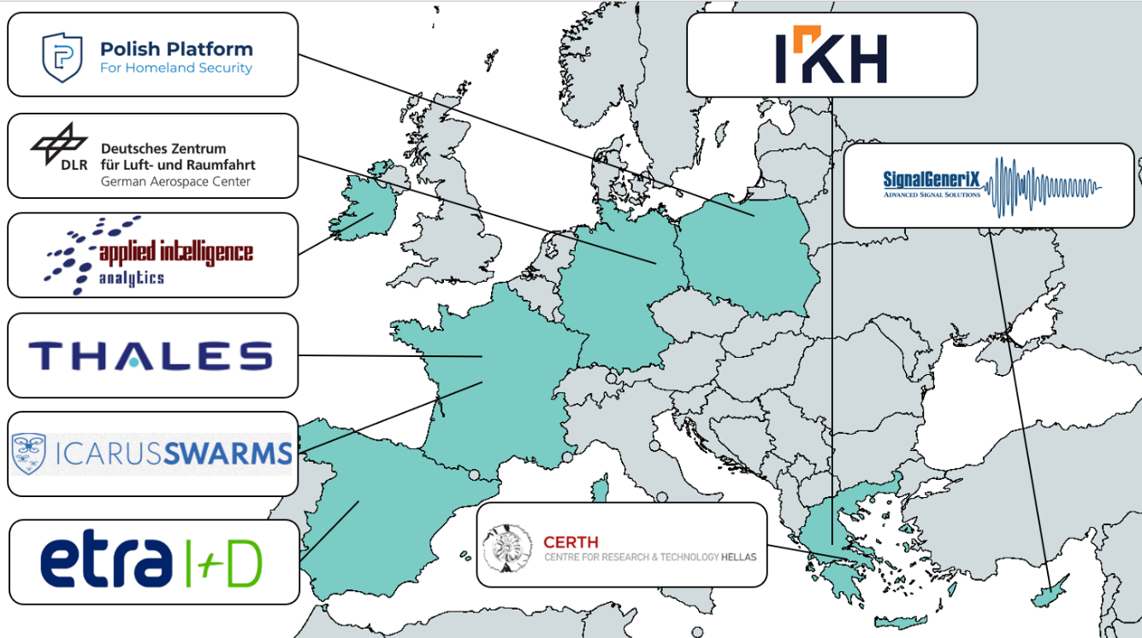
The SWARMER project brings together a diverse range of technologies and capabilities, with contributions from industry, SMEs and research institutions closely connected to the defence sector. The consortium is supported by Ministries of Defence (MoDs) and ex-military experts who bring invaluable domain experience, maximizing their added value in line with the project’s specific needs. The consortium includes nine partners from 7different EU Member States (Cyprus, Germany, Greece, Ireland, Poland, Spain and France), each demonstrating excellence in their respective fields. This expertise ensures the smooth implementation and successful completion of project activities. The involved SMEs, IKH (GR), SG (CY), ICARUS (FR) and AIA (IE) are actively engaged in the defence sector, contributing technological know-how and solutions through participation in national and European defence programs. Their work is supported by two industries i.e THALES (FR) and ETRA (ES) that bring profound knowledge in their domains. Their expertise directly supports SWARMER’s goals, providing advanced capabilities in autonomous navigation, swarming algorithms, sensor fusion, and system integration. The consortium is completed with the participation of three RTOs CERTH (GR), DLR (DE) and PPHS (PL) each leading research and innovation at their respective fields. The SWARMER project leverages cross-border expertise from seven EU countries to collaboratively design the SWARMER system. The following table outlines each partner's technical contributions, highlighting their specific areas of expertise and complementarity to ensure a robust, collaborative approach to meeting the challenges objectives. PPHS plays also an instrumental role to the project’s success by managing and overseeing the consortium’s participation to the challenge, engaging stakeholders to align SWARMER’s technologies with real-world defence needs while ensuring effective dissemination across defence networks.
Figure 45: SWARMER Cross Border Collaboration
Table 6: SWARMER's Technical Capabilities' Matrix
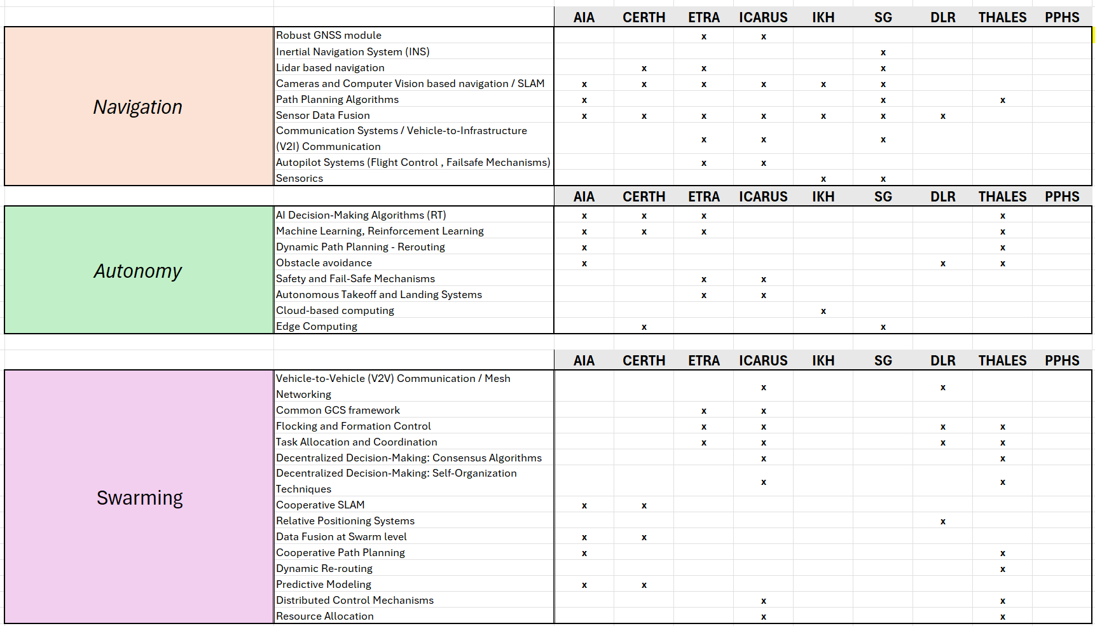

8.4 Consortium management and decision-making
Consortium management and decision-making
Explain the management structures and decision-making mechanisms within the consortium. Describe how decisions will be taken and how regular and effective communication will be ensured. Describe methods to ensure planning and control.
Note: The concept (including organisational structure and decision-making mechanisms) must be adapted to the complexity and scale of the project.
The SWARMER consortium includes seven partners from six different EU Member States. The governance structure is organized into the following key bodies:
General Assembly (GA): The GA serves as the highest governing body of the SWARMER project and consists of one senior management representative from each consortium partner. Led by the SWARMER Coordinator (IKH Managing Director), the GA is responsible for: ● Facilitating collaboration among consortium members and overseeing results and provisions as outlined in the Consortium Agreement ● Making formal decisions on the management and direction of the project ● Addressing major project decisions or changes, including modifications to the Consortium Agreement, project implementation issues, partner selection or exclusion, and activity adjustment ● Keeping the Project Management Team (PMT) informed of all decisions for execution.
Project Management Team (PMT): Chaired by the Project Manager (IKH), the PMT manages the day-to-day organization and operations of project activities. Key responsibilities include: ● Monitoring project progress, including objectives, risks, issues, schedule, and milestones; ● Proposing corrective actions as necessary (e.g., adjustments to the GA, CA, project plan, or budget).; ● Preparing for meetings with the European Commission and managing related data and deliverables; ● Defining technical roadmaps and reassigning work as needed; ● Implementing decisions made by the GA and supporting other project management bodies.
The PMT includes:
- Project Manager (IKH): Oversees the PMT, interfaces with the EC on behalf of the project, monitors project activities, ensures timely completion of milestones and deliverables, and reviews reports prepared by partners.
- Technical Manager (DLR): Leads the Technical Implementation Team, coordinating overall technical activities, consolidating technical reports, and supporting technical work across work packages.
- Technology Integrator (ETRA): Oversees the integration of all technical components into a cohesive system, ensuring seamless functionality and interoperability across the project's autonomous and swarming capabilities throughout the Challenge.
- Quality Assurance and Risk Registry Manager (IKH): Responsible for preparing the Quality Assurance and Risk Plan and updating the Risk Registry each semester with input received from all partners.
Work Package Leaders (WPLs): IKH, PPHS, DLR, SG, ETRA, CERTH, TRT are tasked with coordinating, planning, monitoring, and reporting the progress of their respective work packages to the Project Manager. They also review deliverables, milestones, risks, and contingency plans and are responsible for task leader role distribution, budget management, and performance monitoring within their work packages.
Project Support Office (PSo): Comprising Legal & IPR experts, financial and communication managers, a gender manager, and administrative staff (primarily from IKH), the PSo handles IPR and data management planning, sets communication procedures, coordinates project finances, and assists the PM and PMT in preparing meeting agendas and minutes. Additionally, the Security Advisory Board (SAB), chaired by the Security Manager and including a security-qualified representative from each partner, is part of the PSo. The SAB oversees security, classification issues, and reviews deliverables and shared information, as well as approves candidates for the SWARMER Advisory Board when needed. The project’s overall management structure and bodies are illustrated in the figure below.
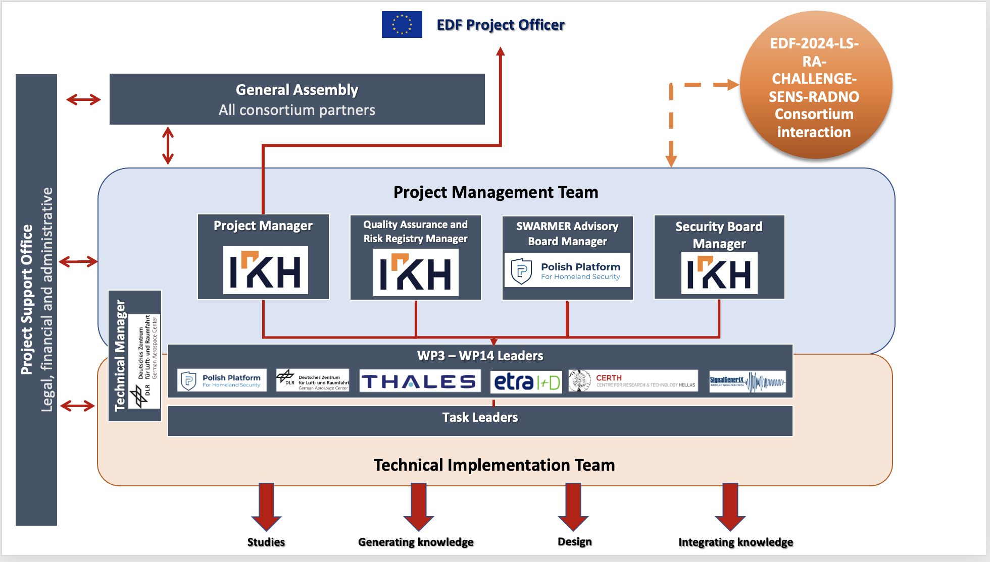
Figure 46: Management Structure
Decision-Making Mechanism
Given the consortium’s limited number of partners, the primary approach to decision-making will focus on reaching consensus through informal discussions, with formal methods (e.g., voting) applied only when necessary. All decisions, whether made through formal or informal means, will be documented throughout the project. Voting procedures and collaboration principles will be clearly defined in the SWARMER Consortium Agreement. The key mechanisms for decision-making are outlined in the table below.
Level | Decision mechanism | Escalation
Technical Implementation Team | Verbal consensus, frequent meetings depending on the activities | In case no consensus is reached or conflict, escalation to PMT.
Project Management Team | Verbal consensus, regular meetings – once per month | In case no consensus is reached (or one partner insists), voting procedure among PMT members. In case of deadlock escalation to GA.
General Assembly | Mandatory voting, meetings once per semester, mandatory presence (two-thirds (2/3) of its members are present or represented /quorum) Decisions shall be taken by a majority of two-thirds (2/3) of the votes cast. | Intervention by the EUC, or legal action, is the only escalation possible.
Communication
To ensure effective communication among SWARMER project partners as well as with external stakeholders, comprehensive intra and inter communication strategies will be established under T1.1 Project coordination, daily and periodic management and T1.5: Dissemination, Communication and Exploitation of Results respectively. These strategies will support partners in promoting their work by utilizing appropriate tools, methods, and communication channels and will include opportunities for disseminating portions of the project outcomes. Transparent communication channels will be created to ensure that project updates, milestones, and critical information are shared via centralized and accessible platforms. Regular consortium meetings will provide structured opportunities for open dialogue, allowing stakeholders to discuss progress, address challenges, and align efforts.
Collaborative online platforms, such as project management tools and shared document repositories, will enable real-time communication and seamless document sharing. Each partner organization will appoint a dedicated communication liaison to streamline information exchange and act as a point of contact. Task-specific communication protocols will address the unique requirements of technical developments, financial matters, and strategic decisions. The decision-making process will remain transparent, with thorough documentation of discussions and outcomes to foster a sense of ownership among partners. Feedback mechanisms will promote continuous improvement, while a crisis communication plan will be in place to handle any unforeseen challenges. Emphasis on language and cultural sensitivity will further enhance collaboration within this international consortium.
These strategies aim to cultivate an environment of seamless information flow, thriving collaboration, and collective decision-making for project success. Tools such as secure document repositories, collaborative platforms, and encryption software will be recommended by the Security Manager, a member of the Project Support Office, following EUC guidelines for handling confidential information. This approach will support the uptake and promotion of project results among relevant stakeholders, facilitating dialogue among consortium members and external parties—primarily SMEs. This will promote information exchange, raise awareness, and encourage multi-enterprise discussions focused on developing a plan for the commercialization of research outcomes.
#§CON-SOR-CS§# #@PRJ-MGT-PM@#

8.5 Project management, quality assurance and monitoring and evaluation strategy
Project management, quality assurance and monitoring and evaluation strategy
Describe the measures planned to ensure that the project implementation is of high quality and completed in time.
Describe the methods to ensure good quality, monitoring, planning and control.
Describe the evaluation methods and indicators (quantitative and qualitative) to monitor and verify the outreach and coverage of the activities and results (including unit of measurement, baseline and target values). The indicators proposed to measure progress should be relevant, realistic and measurable.
The SWARMER project is meticulously structured to ensure high-quality implementation within the planned timeframe. A series of measures have been established to guarantee project success:
Quality Assurance Measures: The project employs a robust Quality Management System (QMS) that adheres to the ISO 9001 standard. Each partner, certified to this standard, is responsible for upholding internal quality processes. A dedicated Quality Assurance and Risk Registry Manager (QARRM) oversees the quality framework, ensuring compliance with standards and advising on quality procedures. The QMS features structured processes, clear goals, realistic schedules, and adequate resources. Key components include: (1) Document Control: Both printed and electronic documents are managed according to predefined templates and formats, with clear protocols for dissemination and handling. (2) Reporting Procedures: Aligned with EC standards, the QMS gathers technical and financial information uniformly across all partners. (3) Deliverables Management: Instructions are provided for deliverable creation, with a structured review and acceptance process to ensure quality. (4) Communication Protocols: The QMS establishes effective communication channels among partners, supported by a collaborative project management platform for document handling and peer review.
Project Monitoring and Control: Effective monitoring and control are essential for the project's success. The QMS includes document control, reporting procedures aligned with EC standards, deliverables management, and clear communication protocols. An iterative process guides deliverable production, with multiple quality checkpoints: (1) Initial Draft created by the task leader, (2) Consolidation after partner input, (3) Peer Review by internal or external reviewers, (4) Final Editing by the task leader, (5) Final Approval by the PMT and Coordinator, and (6) Submission to the EC by the Project Coordinator.
Timely Planning and Control: Planning and control strategies are outlined in the project management handbook, which defines strategic goals, milestones, schedules, and resource allocation. Feedback mechanisms monitor the quality of processes and outputs, ensuring that the project stays on schedule and within budget. Key roles, such as the Quality Manager and Project Manager, are tasked with implementing corrective measures as necessary.
Evaluation Methods and Indicators: The project uses both qualitative and quantitative indicators for evaluation. Qualitatively, deliverables, workshops, training sessions, and feasibility studies are assessed based on ISO standards and participant satisfaction surveys. Training effectiveness and feasibility studies are evaluated using ISO 22398-compliant questionnaires. Quantitatively, indicators include the number of completed activities, average delay in deliverables, user involvement metrics (number of organizations/divisions consulted, attendees, and requirements gathered), and training/exercise statistics (number of organizations and trainees/users involved). These indicators offer a comprehensive framework for tracking and evaluating project progress, ensuring that project outcomes are relevant, realistic, and measurable. Target values are set based on realistic project objectives and initial baseline values established at the project's start.
#§PRJ-MGT-PM§# #@FIN-MGT-FM@#

8.6 Cost effectiveness and financial management
Cost effectiveness and financial management
Describe the measures adopted to ensure that the proposed results and objectives will be achieved in the most cost-effective way.
Indicate the arrangements adopted for the financial management of the project and, in particular, how the financial resources will be allocated and managed within the consortium.
Do NOT compare and justify the costs of each work package, but summarize briefly why your budget is cost effective.
The work outlined in the previous sections require a careful allocation of budget and resources to ensure their successful execution. The SWARMER consortium has estimated a total budget of € 4.997.006,48 € for the 48-month duration of the project, aligning with the project’s objectives and expected deliverables. The figures below present the budget distribution by activity type and beneficiary category, as well as by work package and organization. Resource allocation has been strategically tailored to support the proposed activities, ensuring high levels of effectiveness and efficiency in delivering the project outcomes.
Key aspects of budget and effort allocation for SWARMER include:
- 14% of the budget is allocated to Project Coordination and Management (WP1 & WP2), covering consortium meeting participation and partner involvement in project management and reporting activities.
- 23% is dedicated to the management of the Participation to the Challenge (WP3, WP6, WP9 and WP12), which includes all relevant work that will ensure a smooth participation to the Challenge and unobstructed communication and data exchange with the Organising consortium and the other participants. All partners contribute to this WP, ensuring a solid foundation for the project’s subsequent activities.
- 40% of the budget supports the design work for the various components of the SWARMER system (WP4, WP7, WP10 and WP13), with each technical partner contributing to the design of their specific components.
- 22% is allocated to the integration activities for the SWARMER components (WP5, WP8, WP11 and WP14), ensuring thorough testing prior to the Challenge’s field tests.
This structured budget allocation is designed to optimize resource use, ensuring that each work package is adequately funded to achieve the project’s goals.

#§FIN-MGT-FM§# #@RSK-MGT-RM@#

8.7 Risk management
Critical risks and risk management strategy
Describe critical risks, uncertainties or difficulties related to the implementation of your project, and your measures/strategy for addressing them.
Indicate for each risk (in the description) the impact and the likelihood that the risk will materialise (high, medium, low), even after taking into account the mitigating measures.
Note: Uncertainties and unexpected events occur in all organisations, even if very well-run. The risk analysis will help you to predict issues that could delay or hinder project activities. A good risk management strategy is essential for good project management.
Risk No | Description  (Likelihood=L, Impact=I, Risk=R) | Work package No | Proposed risk-mitigation measures
R1 | Lack of Communication among partners (All WPs). The lack of communication between partners can lead to incomprehension and reduce the performance of the consortium in delivering the foreseen developments to the stakeholders (L=LOW, I=HIGH). | WP1; WP2 | SWARMER has a rigorous governance model that enforces continuous and efficient communication between partners through regular coordination meetings, as well as team-building activities during plenary meetings to build trust between partners. When a communication issue is noticed, escalation is done to the project management team and general assembly.
R2 | Lack of commitment by one or more partners. One or more partners may not commit as expected to the work they are supposed to deliver in the project. The lack of commitment of partners can be very critical and impact the performance of the project. (L=MEDIUM, I=HIGH) | WP1; WP2 | The consortium agreement is proof that all partners should commit to be involved in the work and deliver what they have promised to the consortium. The coordinator will ensure total transparency on any lack of commitment of one or more partners to facilitate solutions
R3 | Conflicts between partners. One or more partners may have conflicts related to contradictory Personal or commercial interests. This can create blocking points in the project. (L=LOW, I=HIGH) | WP1; WP2 | The consortium is built based on trust relationships between partners already from the proposal phase. If such risk occurs, the project manager isolates the problem originating the conflict and proposes a way forward. If this fails, escalation is done to the coordinator and the GA.
R4 | One or more partners leave the consortium. This situation can impact the project performance in delivering the results with regards to the fixed schedule. (L=MEDIUM, I=MEDIUM) | WP1; WP2 | Escalation is made to the coordinator and GA. Then, the work is re-scoped in a way that doesn't affect the main objectives and results of the project or, when possible, the work is redistributed to interested partners with similar competences within the consortium or the procedure of onboarding a new partner will be started.
R5 | Consortium not working collaboratively risking poor delivery results and/or unavoidable delays. (L=LOW, I=HIGH) | WP1; WP2 | The work plan is realistic and allows for sufficient time for the optimal completion of tasks, attendance to meetings, coordination activities and the preparation of deliverables. In case a delay is detected, the schedule of the project will be adjusted on the decision of the GA. As a last resort, a project extension would be sought.
R6 | Financial risk – A partner may face financial difficulties and go bankrupt (L=LOW, I=HIGH) | WP1; WP2 | Partners are well-established in their markets and areas of expertise and are all financially strong organizations. However, if that happens other partners will assume their role, or a replacement will substitute them.
R7 | Delays in the submission of deliverables and in reaching milestones (L=MEDIUM, I=MEDIUM) | WP1; WP2 | Early identification of poor performance components will allow for modifications to the workplan. The WPs are defined with time margins so as to ensure that in case of delays, the rest WPs could run seamlessly.
R8 | Data handling: risk to disclose personal and sensitive data. Restricted or sensitive data are disclosed by a partner of a consortium that affect the work and privacy of other partners of the consortium (L=LOW, I=HIGH) | WP1; WP2 | Legal and ethical procedures will be prepared including security measures. A compliance framework with respect to legal, policy, social and ethical requirements will be integrated for all partners.
R9 | Poor match of requirement of the solution. The solution does not meet the Challenge’s needs. (L=LOW, I=MEDIUM) | WP5, WP8, WP11, WP14 | Early identification of poor performance components will allow for modifications during pre-evaluation phase. SWARMER experts will support in the elicitation of requirements and in assessing the implementation.
R10 | SWARMER designs are proven to be complex and not well understood by stakeholders outside the consortium limiting project’s impact. (L=LOW, I=MEDIUM) | WP4, WP7, WP10, WP13 | The consortium will monitor the design of the system in order to detect all interaction problems early. The expertise of all partners in this sector will minimize this risk.
R11 | Low quality feedback from stakeholders (end-users, challenge organisers, EC’s representatives, etc) leading to lack of inputs for the improvement of algorithms, specifications, architecture etc. (L=LOW, I=HIGH) | WP1; WP2; WP3; WP6; WP9; WP11 | Collaboration expected with majority of Member States involved based on the LoI signed during project preparation; Communicate regularly with MoDs/End-users to keep them engaged in discussions between MoDs and industries involved in the consortium, use of European forums (e.g. EDA)
R12 | Fusing different technologies, using iterative loops does not converge to integrated concept of SWARMER. (L=LOW, I=HIGH) | WP5; WP8; WP11; WP14 | Structured integration checkpoints, iterative alignment meetings, and a comprehensive system architecture document are inherent in the SWARMER workflow. Regular cross-functional meetings with the participation of the Technical Integrator and the Technical Manager.
R13 | Integrated system implementation is unsuccessful at the planned Challenge tests: Stakeholders may not approve the functionalities for different tasks. (L=MEDIUM, I=HIGH) | WP5, WP8, WP11, WP14 | Early validation cycles, stakeholder engagement, and adaptive testing protocols. Conducting initial tests in real-world conditions across multiple sites available from Consortium partners in Spain, France, Germany and Cyprus.
R14 | Poor or lack of communication between the SWARMER and the Challenge Organising consortium which may reduce the performance of the consortium in delivering the expected results fail to satisfy Challenge’s requirements (L=MEDIUM, I=HIGH) | WP3; WP6; WP9; WP11 | Dedicated WPs have been defined for handling the SWARMER Consortium’s participation to the Challenge each year. All required interactions (workshops, discussions, meetings) will be meticulously handled during the project to establish a regular communication stream between the consortium and the Organisers.
#§RSK-MGT-RM§# #@COM-DIS-VIS-CDV@#

8.8 Communication, dissemination and visibility
Communication, dissemination and visibility of funding
Describe any communication and dissemination activities that may occur in the context of the project.
Please be aware that; in EDF, all communication and dissemination activities are subject to specific security considerations and must therefore be discussed with and approved by the granting authority (prior written approval; see Annex 5 of the Grant Agreement).
In line with EDF guidelines, all SWARMER communication and dissemination activities will adhere to strict security considerations, with prior approval sought from the granting authority. Given the sensitive nature of the SWARMER defence project, our outreach will target defence-specific audiences, focusing on specialized stakeholders in the military and defence technology sectors. Dissemination and communication will ensure visibility of project achievements, demonstrate SWARMER’s added value to European defence capabilities, and reinforce project transparency with selected, secure, and controlled audiences.
Strategy for Communication and Dissemination activities
SWARMER’s communication and dissemination activities are structured across two strands:
Dissemination activities: SWARMER’s dissemination strategy is tailored to ensure that specific project outcomes are effectively shared with key stakeholders across the defence and security sectors. Dissemination efforts, such as participation in high-profile military and defence forums, are essential for knowledge transfer, allowing the project’s advancements to reach policymakers, Research and Technology Organizations (RTOs), defence industry stakeholders, and other critical players in the European defence ecosystem. By targeting these audiences, SWARMER ensures that its results align with EU strategic defence objectives, fostering an environment of continuous learning and application. Dissemination activities are planned to coincide with key project milestones, leveraging initial findings to generate interest, mid-term results to validate project progress, and final outcomes to showcase fully developed technologies. The dissemination framework is structured around active engagement in defence-specific forums and conferences, including NATO TechNet Europe and events organized by the European Defence Agency, where policymakers and industry stakeholders can witness firsthand how SWARMER’s technologies address pressing defence challenges. These forums will serve as critical avenues for demonstrating SWARMER’s AI-driven, autonomous capabilities for swarm coordination and navigation in GNSS-denied environments, as well as its resilient communication solutions, which can enhance real-time situational awareness in various defence contexts. By sharing practical insights and technical specifications through presentations, live demonstrations, and targeted discussions, SWARMER ensures that defence sector participants understand the unique value proposition it brings to European defence capabilities. Dissemination will be ongoing, with emphasis on secure, controlled channels to protect sensitive information, aligning with EDF requirements.
Communication activities: SWARMER’s communication efforts are designed to create awareness and visibility of its strategic contributions to defence and security within a highly targeted audience framework. Leveraging secure digital promotion channels, press releases, and attendance at selected defence events, SWARMER will highlight the project’s advancements to those directly involved in national and European defence strategies, including military leaders, technology policymakers, and other specialized stakeholders. This targeted approach to communication ensures that only relevant entities, particularly those tasked with implementing defence innovations, are kept informed about SWARMER’s progress. By focusing communication efforts on controlled channels, SWARMER not only safeguards sensitive information but also aligns with the security protocols required by EDF, ensuring that dissemination of knowledge is limited to those who can apply it within Europe’s defence ecosystem.The messaging strategy for SWARMER will concentrate on its technical achievements, such as the development of autonomous swarming capabilities, resilient navigation in GNSS-denied conditions, and advanced edge computing for real-time decision-making. These messages underscore the project’s strategic importance by linking SWARMER’s technological progress directly to the EU’s defence objectives, thus reinforcing the project’s relevance to stakeholders in European defence operations. Communication activities will also involve curated content, including progress updates and in-depth technical briefings on SWARMER’s unique solutions, distributed via secure online platforms and through participation in defence-centered conferences like EURONAVAL, DEFEA, and the European Defence Innovation Network (EDIN) meetings. These activities will ensure that SWARMER’s innovations are communicated to the right audience while maintaining compliance with all security and confidentiality standards.
An effective strategy necessitates identifying specific audiences for each result (e.g., technologies, methodologies, operational frameworks) to tailor messages effectively and deliver through appropriate defence and security-focused channels.
Target audiences
SWARMER will primarily target specialized stakeholders within the defence and security sectors, encompassing:
- Defence agencies and policymakers: enhance understanding and application of SWARMER’s contributions to hybrid defence capabilities within the EU.
- Military and defence technology experts: focus on integrating SWARMER’s autonomous and resilient navigation solutions across varied operational scenarios.
- EU military research institutions and universities: encourage knowledge-sharing and research collaboration on advanced swarm technologies and autonomous navigation.
- Strategic industry players in defence technology: collaborate with entities to potentially integrate SWARMER outcomes into broader defence systems.

Dissemination activities overview
SWARMER’s main objectives are to generate targeted awareness and secure, controlled communication of outcomes to stakeholders within European defence. The following table outlines the dissemination approach by audience type:

Target audiences (WHO) | Key assets  (WHAT) | Selected dissemination routes  (HOW)
Defence agencies and policymakers | SWARMER project findings and policy guidelines | Invitations to NATO TechNet Europe, European Defence Agency workshops, EU Commission Defence Workshops, policy briefings, secure websites, and published reports.
Military and defence technology experts | Technical results, methodologies, operational frameworks | Participation in EU Military Staff Forums, NATO Science & Technology events, and EURONAVAL (France), DEFEA (Greece), Defence & Security Equipment International (DSEI).
EU military research institutions and universities | Research methodologies and academic publications | Presentations at Research and Technology Symposium (RTO), Security Research Conference, collaborations with PESCO projects.
Strategic industry players in defence technology | Technology demonstrations and collaborative frameworks | Technology transfer workshops, participation in EURONAVAL, IDEX (UAE), Secure briefings with defence contractors, European Defence Industrial Development Program (EDIDP).
Time plan for dissemination and communication actions
The dissemination and communication actions will be structured into three distinct phases to optimize visibility, control, and impact across the project lifecycle:
- Launch Period (M1-M6): initial awareness-raising and strategy planning to secure interest from target audiences and outline SWARMER’s significance to defence stakeholders.
- Execution Period (M7-M36): focus on detailed dissemination of results, targeted knowledge transfer, and secure communications with relevant defence actors.
- Outcomes period (M36 and beyond): promote project results, demonstrate the system’s final outcomes, and solidify partnerships for continued impact and market opportunities in the defence sector.
Visibility of funding and compliance
All SWARMER communication and dissemination efforts will ensure clear visibility of EDF funding support, with disclaimers to acknowledge EDF’s role while adhering to strict security protocols. Dissemination materials will incorporate the EDF logo and relevant project funding references, ensuring compliance with Annex 5 of the Grant Agreement.
SWARMER’s approach to communication and dissemination prioritizes security, strategic alignment with defence needs, and targeted outreach, ensuring the project’s innovations strengthen European defence capabilities effectively and responsibly.

#§COM-DIS-VIS-CDV§# #§QUA-LIT-QL§# #@ETH-ICS-EI@#

9. OTHER

9.1 Ethics
Ethics
The ethics issues and measures you intend to take to solve/avoid them must be described in Part A.
See Application Form Part A.
#§ETH-ICS-EI§# #@SEC-URI-SU@#

9.2 Security
Security
Describe security issues that may arise during the project implementation.
If classified information is used as background information for the project implementation, please describe the nature of the classified information and its level of classification.
Note: Beneficiaries must ensure that their projects are not subject to third country/international organisation security requirements that could affect the implementation or put into question the award of the grant (e.g. technology restrictions, national security classification, etc).
Security Compliance: The SWARMER project’s security compliance is managed within WP1, covering essential areas such as security accreditations, sensitive information management, and export license handling. A Security Advisory Board (SAB), led by IKH and chaired by Dr. Pantelis Michalis (ISO 27001 & 9001 certified with ex-military experience), will oversee all security-related issues. Each partner designates a Security Officer who joins the SAB to address project security needs. Dedicated encryption software will be employed as necessary to secure information exchanges, applied at both the management and solution levels. In line with best practices, the SAB will conduct a risk assessment following ISO standards, establish a policy for data management, and ensure continuous adherence to security and ethical guidelines. Responsibilities of the SAB include forming an Incident Response Team, delivering a cyber and physical security approach, implementing a Crisis Management Plan, safeguarding sensitive information, and coordinating with the Project Coordinator on security issues as needed. Any security incidents will trigger a risk assessment, asset review, and mitigation measures.
Audit and Security Controls: SWARMER establishes a transparent framework for audit and security controls. Self-assessments will be regularly conducted throughout the project. The SWARMER Consortium also agrees to permit EU and EDF officials to perform security inspections, following prior coordination. In case of deviations or security breaches identified during an audit, a remediation plan will be implemented within an agreed timeframe, demonstrating the consortium’s commitment to robust security standards.
Environmental Safety and Security: The SWARMER project’s security compliance is managed within WP1, covering essential areas such as security accreditations, sensitive information management, and export license handling. A Security Advisory Board (SAB), led by IKH and chaired by Dr. Pantelis Michalis (ISO 27001 & 9001 certified with ex-military experience), will oversee all security-related issues. Each partner designates a Security Officer who joins the SAB to address project security needs. Dedicated encryption software will be employed as necessary to secure information exchanges, applied at both the management and solution levels. In line with best practices, the SAB will conduct a risk assessment following ISO standards, establish a policy for data management, and ensure continuous adherence to security and ethical guidelines. Responsibilities of the SAB include forming an Incident Response Team, delivering a cyber and physical security approach, implementing a Crisis Management Plan, safeguarding sensitive information, and coordinating with the Project Coordinator on security issues as needed. Any security incidents will trigger a risk assessment, asset review, and mitigation measures.
Audit and Security Controls: SWARMER establishes a transparent framework for audit and security controls. Self-assessments will be regularly conducted throughout the project. The SWARMER Consortium also agrees to permit EU and EDF officials to perform security inspections, following prior coordination. In case of deviations or security breaches identified during an audit, a remediation plan will be implemented within an agreed timeframe, demonstrating the consortium’s commitment to robust security standards.
Environmental Safety and Security: Environmental security is prioritized across the SWARMER project lifecycle. The consortium adheres to ISO 14001 standards for environmental management and OHSAS 18001 for personnel safety. Robust safety protocols, aligned with OSHA guidelines, and regular risk assessments (such as HAZOP) are employed to identify and mitigate environmental risks. Sustainable practices, including adherence to the Waste Electrical and Electronic Equipment (WEEE) Directive and seeking relevant certifications (e.g., EMAS), reinforce SWARMER’s dedication to environmental responsibility. All related considerations will be managed under WP1 and overseen by the PMT.
Legal Compliance: SWARMER commits to a comprehensive legal framework, particularly for defence applications. Compliance extends to GDPR, emphasizing data protection and user rights. The consortium will also adhere to the European Defence Agency Code of Conduct on Data Security and other regulations governing defence technology. Export control compliance, including ITAR where relevant, will be overseen by a dedicated legal team to ensure that all technology and information adhere to legal standards. Regular audits will monitor compliance, and transparent documentation will facilitate communication with authorities. This proactive approach ensures the project operates within ethical and legal bounds.
Data Security: Data security is paramount in SWARMER, where measures are implemented to safeguard information integrity and confidentiality. The consortium will follow GDPR principles and apply rigorous access controls and encryption to protect sensitive data. Adherence to ISO/IEC 27001 will establish a robust information security management system, encompassing risk management and continuous monitoring. Data governance policies will define ownership, access rights, and retention. Training programs will equip project personnel with the knowledge to uphold data security, fostering trust and ensuring responsible data use in defence applications.
Legal Compliance
SWARMER commits to a comprehensive legal framework, particularly for defence applications. Compliance extends to GDPR, emphasizing data protection and user rights. The consortium will also adhere to the European Defence Agency Code of Conduct on Data Security and other regulations governing defence technology. Export control compliance, including ITAR where relevant, will be overseen by a dedicated legal team to ensure that all technology and information adhere to legal standards. Regular audits will monitor compliance, and transparent documentation will facilitate communication with authorities. This proactive approach ensures the project operates within ethical and legal bounds.
Data Security
Data security is paramount in SWARMER, where measures are implemented to safeguard information integrity and confidentiality. The consortium will follow GDPR principles and apply rigorous access controls and encryption to protect sensitive data. Adherence to ISO/IEC 27001 will establish a robust information security management system, encompassing risk management and continuous monitoring. Data governance policies will define ownership, access rights, and retention. Training programs will equip project personnel with the knowledge to uphold data security, fostering trust and ensuring responsible data use in defence applications.
#§SEC-URI-SU§# #@DEC-LAR-DL@#

10. DECLARATIONS
Higher funding rate (n/a for Research Actions and Lump Sum Grants for Research Actions)
Indicate if you fulfil the conditions set out in the Call document for a higher funding rate.
PESCO bonus |  | YES/NO
Are you applying for PESCO bonus? |  | NO
If YES, please confirm that the project is developed in the context of a project of the permanent structured cooperation (PESCO).
If YES, explain and provide details (e.g. name of PESCO project, project details, etc).
Insert text

SME/Mid-cap bonuses |  | YES/NO
Are you applying for a SME/Mid-cap bonus? |  | NO
Which one? | [SME][Mid-cap][SME and Mid-cap]
If YES, please confirm that all the participants claiming the SME/Mid-cap status (beneficiaries, affiliated entities and subcontractors involved in the action) have a PIC registration in the Participant Register and a positive SME/Mid-cap self-assessment result (not older than 2 years).
Please note that only entities which fulfil these requirements can be counted for the SME/Mid-cap bonuses. The self-assessment is accessible through Funding & Tenders Portal account > My Organisations > Actions > Modify Organisation > SME tab > Start SME self-assessment (> Mid-cap self-declaration) (for more information, see IT How To).
If YES, explain and provide details.
Insert text

Project manager (if applicable) | YES/NO
Is the project linked to a procurement managed by a project manager appointed by Member States or EDF associated countries?  If YES, give details on the procurement (name, participating countries, name of project manager, etc).  Note: If the requirements under the EDF Regulation are fulfilled, the granting authority may make such procurements linked actions (for the purposes of the Grant Agreement) and manage them. | NO
Insert text

Galileo public regulated services (PRS) (if applicable)
If your project requires access to PRS, please fill out the questions below.
Note: Access to PRS is regulated by EU Decision 1104/2011. Compliance with the conditions must be confirmed by the competent PRS authority of your Member State (see Annex PRS Declaration).
PRS-related tasks |  | YES/NO
Does any of the participants need to conduct PRS-related tasks within the proposed project? |  | NO
If YES, please list the participants:
Are all these participants authorised by the Security Accreditation Board (SAB) within the meaning of Article 38 of EU Regulation 2021/696 in the PRS category required to execute the contract?
PRS Security Module Manufacturing |  | YES/NO
Does any of the participants need to be authorised for PRS Security Module Manufacturing? |  | NO
If YES, please list the participants:
Are these participants, authorised by the SAB for PRS security module manufacturing (SM), owned solely or through majority ownership by a Member State?
or
Have these participants, authorised by the SAB for PRS security module manufacturing (SM), appointed nationals of Member States holding a personnel security clearance granted by a Member State in its Board of Directors and delegated to these nationals the exclusive authority to take decisions related to the PRS?
PRS CRYPTO |  | YES/NO
Are activities requiring access to PRS CRYPTO included in your proposal? |  | NO
If YES, please list the participants:
Are these participants able to access such information? |  | NO

International law | YES/NO
Does the project cover the development of products and technologies, the use, development or production of which is prohibited by international law? | NO

Lethal autonomous weapons | YES/NO
Does the project cover the development of lethal autonomous weapons without the possibility for meaningful human control over selection and engagement decisions when carrying out strikes against humans? | NO
If YES, is it an early warning system or countermeasure for defensive purposes?
If YES to this question, explain and provide details.
Insert text

Background and results free from restrictions | YES/NO
Do you confirm that you will ensure that background needed to carry out the project will not be subject to control or other restrictions by a non-associated third country or non-associated third-country entity, directly or indirectly through one or more intermediary legal entities, in such a way that the action cannot be carried out? | YES
Do you confirm that you will ensure that the results of the project will not be subject to control or other restrictions by a non-associated third country or non-associated third country entity, directly or indirectly through one or more intermediate legal entities, including in terms of technology transfer? | YES

Spinning-in results from civil R&D (for Spin-in calls) |  | YES/NO
Do you confirm that this proposal builds on or integrates results that have been achieved in one (or several) projects funded under another EU programme call with a focus on civil applications? |  | NO
If YES, provide the related information: | [EU Programme short name] – [project acronym] – [project number]
If YES, provide the related information: | [EU Programme short name] – [insert acronym] – [project number]
If YES, provide the related information: | …
Do you confirm that you will have the necessary rights to the results that you will integrate (either because the consortium members are the owners or because they will obtain the necessary agreement from the owners or rightsholders)?

Previous activities
PADR/EDIDP funding |  | YES/NO
Does the background used for this action contain data, know-how or information generated in an action previously supported by the PADR or EDIDP Programme? |  | NO
If YES, please lease indicate the programme name and project number and acronym:
Research activities on defence applications
List the participants that have already carried out research activities targeting defence applications before 12 May 2021 (with or without public funding)?
Note: Activities targeting civil applications should not be counted, even if they had potential benefits for military applications (e.g. so-called ‘dual-use activities’).
IKH; AIA, SG; CERTH; DLR; TRT

Double funding
Information concerning other EU grants for this project  Please note that there is a strict prohibition of double funding from the EU budget (except under EU Synergies actions). | YES/NO
We confirm that to our best knowledge neither the project as a whole nor any parts of it have benefitted from any other EU grant (including EU funding managed by authorities in EU Member States or other funding bodies, e.g. EU Regional Funds, EU Agricultural Funds, etc). If NO, explain and provide details. | YES
We confirm that to our best knowledge neither the project as a whole nor any parts of it are (nor will be) submitted for any other EU grant (including EU funding managed by authorities in EU Member States or other funding bodies, e.g. EU Regional Funds, EU Agricultural Funds, etc). If NO, explain and provide details. | YES

Financial support to third parties (if applicable)
If in your project the maximum amount per third party will be more than the threshold amount set in the Call document, justify and explain why the higher amount is necessary in order to fulfil your project’s objectives.
N/A

Sovereignty Seal (if applicable)
If provided in the Call document, all eligible proposals that exceed the evaluation thresholds will be awarded a Sovereignty Seal. The Sovereignty Seal is a quality label which aims at facilitating access to additional public and/or private funding.
Do you agree that certain information about your proposal (i.e. acronym; title; abstract of the project; name, contact e-mail and address of the coordinator; requested EU contribution; and grant amount awarded, if any) will be published on the STEP online Portal (with open public access) to increase the visibility of your project? | YES
Do you agree that this information is shared with national managing authorities of EU funding that recognise and support Sovereignty Seal projects to facilitate funding for your project under other EU programmes and funds? | YES
#§DEC-LAR-DL§#

ANNEXES
LIST OF ANNEXES
Standard
ANNEX 1 - Detailed budget table/Calculator (annex 1 to Part B)
ANNEX 2 - Participant Information
ANNEX 3 - List of Infrastructure
ANNEX 4 - Ownership Control Declarations
ANNEX 5 – Letters of Support

Special
N/A

Single European Sky ATM Research 3 Joint Undertaking, European drones outlook study – Unlocking the value for Europe, Publications Office, 2017, https://data.europa.eu/doi/10.2829/085259
The case of Ukraine : Changing the paradigm; https://www.iris-france.org/wp-content/uploads/2024/06/ARES-97-Comment.pdf
https://eda.europa.eu/uas
https://www.bbc.com/news/articles/c6240qepyppo
https://www.reuters.com/graphics/UKRAINE-CRISIS/DRONES/dwpkeyjwkpm/
https://www.understandingwar.org/
WHAT IS THE PERCEPTION OF DEFENCE INDUSTRIAL PARTNERSHIPS WITH THE EDTIB BY NON-EU COUNTRIES? The case of Ukraine : Changing the paradigm; Mykhailo Samus / Director, New Geopolitics Research Network, Ukraine; June 2024
https://www.marketsandmarkets.com/Market-Reports/military-drone-market-221577711.html?gclid=CjwKCAjw7c2pBhAZEiwA88pOFw5_f-4GoLikMuKpQO4oNGBmwsvU34mVAWfrfwlaBaq4aLMXCDFHThoCuNsQAvD_BwE
Baran, P. (1964). On Distributed Communications, Memorandum RM-3420-PR.
Swarm Intelligence: From Natural to Artificial Systems by Eric Bonabeau, Marco Dorigo, and Guy Theraulaz.
Distributed Autonomous Robotic Systems (various conference proceedings).
IEEE Transactions on Robotics and Automation (for articles on decentralized and distributed control in robotic swarms).
Multi-Agent Systems: Algorithmic, Game-Theoretic, and Logical Foundations by Yoav Shoham and Kevin Leyton-Brown.
Iqbal, M. J., Iqbal, M. M., Ahmad, I., Alassafi, M. O., Alfakeeh, A. S., & Alhomoud, A. (2021). Real‐Time Surveillance Using Deep Learning. Security and Communication Networks, 2021(1), 6184756.
Zhang, H., Sun, M., Li, Q., Liu, L., Liu, M., & Ji, Y. (2021). An empirical study of multi-scale object detection in high resolution UAV images. Neurocomputing, 421, 173-182.
Zhao, H., Zhang, H., & Zhao, Y. (2023). Yolov7-sea: Object detection of maritime uav images based on improved yolov7. In Proceedings of the IEEE/CVF winter conference on applications of computer vision (pp. 233-238).
Zhang, J., Wan, G., Jiang, M., Lu, G., Tao, X., & Huang, Z. (2023). Small object detection in UAV image based on improved YOLOv5. Systems Science & Control Engineering, 11(1), 2247082.
Zhang, Y., Wu, C., Zhang, T., Liu, Y., & Zheng, Y. (2023). Self-attention guidance and multiscale feature fusion-based UAV image object detection. IEEE Geoscience and Remote Sensing Letters, 20, 1-5.
Liu, Y., Zhang, Y., Wang, Y., Hou, F., Yuan, J., Tian, J., ... & He, Z. (2023). A survey of visual transformers. IEEE Transactions on Neural Networks and Learning Systems.
Liang, T., & Zeng, G. (2024). FSH-DETR: An Efficient End-to-End Fire Smoke and Human Detection Based on a Deformable DEtection TRansformer (DETR). Sensors, 24(13), 4077.
Zou, D., Tan, P., & Yu, W. (2019). Collaborative visual SLAM for multiple agents: A brief survey. Virtual Reality & Intelligent Hardware, 1(5), 461-482.
Lajoie, P. Y., & Beltrame, G. (2023). Swarm-slam: Sparse decentralized collaborative simultaneous localization and mapping framework for multi-robot systems. IEEE Robotics and Automation Letters, 9(1), 475-482.
Zhong, S., Qi, Y., Chen, Z., Wu, J., Chen, H., & Liu, M. (2023). Dcl-slam: A distributed collaborative lidar slam framework for a robotic swarm. IEEE Sensors Journal.
Han, K., Wang, Y., Chen, H., Chen, X., Guo, J., Liu, Z., ... & Tao, D. (2022). A survey on vision transformer. IEEE transactions on pattern analysis and machine intelligence, 45(1), 87-110.
Amjoud, A. B., & Amrouch, M. (2023). Object detection using deep learning, CNNs and vision transformers: A review. IEEE Access, 11, 35479-35516.
Kim, D., Angelova, A., & Kuo, W. (2023). Region-aware pretraining for open-vocabulary object detection with vision transformers. In Proceedings of the IEEE/CVF conference on computer vision and pattern recognition (pp. 11144-11154).
Fang, Y., Yang, S., Wang, S., Ge, Y., Shan, Y., & Wang, X. (2023). Unleashing vanilla vision transformer with masked image modeling for object detection. In Proceedings of the IEEE/CVF International Conference on Computer Vision (pp. 6244-6253).
Vasu, P. K. A., Gabriel, J., Zhu, J., Tuzel, O., & Ranjan, A. (2023). FastViT: A fast hybrid vision transformer using structural reparameterization. In Proceedings of the IEEE/CVF International Conference on Computer Vision (pp. 5785-5795).
https://www.sciencedirect.com/science/article/pii/S0029801819300137?via%3Dihub
https://www.sciencedirect.com/org/science/article/pii/S2564493924000018
https://journals.sagepub.com/doi/full/10.1177/15501477211064758
https://www.mdpi.com/2504-446X/8/4/166
https://www.mdpi.com/1424-8220/21/16/5374
Michailidis, I.T., Michailidis, P., Kosmatopoulos, E., Bassiliades, N. (2024). Open-Source Online Mission-Planning in Emergent Environments with PDDL for Multi-robot Applications. AIAI 2024. IFIP Advances in Information and Communication Technology, vol 715. Springer, Cham. https://doi.org/10.1007/978-3-031-63227-3_31
Michailidis, I.T., Kapoutsis, A.C., Kosmatopoulos, E.B., Boutalis, Y. (2021). Dynamic Plume Tracking Utilizing Symbiotic Heterogeneous Remote Sensing Platforms. AIAI 2021. IFIP Advances in Information and Communication Technology, vol 627. Springer, Cham. https://doi.org/10.1007/978-3-030-79150-6_48
Sutton, R. S., & Barto, A. G. (2018). Reinforcement Learning: An Introduction. MIT Press, ISBN: 9780262039246
Missy Cummings (2017). Artificial Intelligence and the Future of Warfare. Chatham House for the Royal Institute of International Affairs, ISBN 1784131989, 9781784131982
Karatzinis, Georgios D. et al. (2022). Coordinating Heterogeneous Mobile Sensing Platforms for Effectively Monitoring a Dispersed Gas Plume. IOS Press, Integrated Computer-Aided Engineering, vol. 29, no. 4, pp. 411-429, 2022, DOI: 10.3233/ICA-220690
Jakub Konecn, H. B. McMahan, Daniel Ramage and Peter Richtrik (2016). Federated Optimization: Distributed Machine Learning for On-Device Intelligence, ArXiv, Vol. 1610.02527, url: https://api.semanticscholar.org/CorpusID:2549272
Papernot, Nicolas & McDaniel, Patrick & Jha, Somesh & Fredrikson, Matt & Celik, Z. Berkay & Swami, Ananthram. (2016). The Limitations of Deep Learning in Adversarial Settings. pp: 372-387, doi: 10.1109/EuroSP.2016.36.
Ziyang Zhen, Yan Chen, Liangdong Wen, Bing Han (2020). An intelligent cooperative mission planning scheme of UAV swarm in uncertain dynamic environment, Aerospace Science and Technology, Volume 100, 105826, ISSN 1270-9638, https://doi.org/10.1016/j.ast.2020.105826
X. B. Peng, M. Andrychowicz, W. Zaremba and P. Abbeel, "Sim-to-Real Transfer of Robotic Control with Dynamics Randomization," 2018 IEEE International Conference on Robotics and Automation (ICRA), Brisbane, QLD, Australia, 2018, pp. 3803-3810, doi: 10.1109/ICRA.2018.8460528
H. Huang, Y. Yang, H. Wang, Z. Ding, H. Sari and F. Adachi (2020). Deep Reinforcement Learning for UAV Navigation Through Massive MIMO Technique, in IEEE Transactions on Vehicular Technology, vol. 69, no. 1, pp. 1117-1121, doi: 10.1109/TVT.2019.2952549.
https://eda.europa.eu/publications-and-data/brochures/eda-action-plan-on-autonomous-systems
S. Grollius, M. Ligges, J. Ruskowski and A. Grabmaier, "Concept of an Automotive LiDAR Target Simulator for Direct Time-of-Flight LiDAR," in IEEE Transactions on Intelligent Vehicles, vol. 8, no. 1, pp. 825-835, Jan. 2023, doi: 10.1109/TIV.2021.3128808
https://journals.plos.org/plosone/article?id=10.1371/journal.pone.0287177
https://ieeexplore.ieee.org/abstract/document/7502633
https://www.tj.kyushu-u.ac.jp/evergreen/contents/EG2024-11_3_content/pdf/p2004-2010.pdf
https://labyrinth2020.eu/the-project/
https://www.sciencedirect.com/science/article/pii/S2405896323003580
https://onlinelibrary.wiley.com/doi/10.1155/2023/6568359
Wang, Y., Fang, Z., Zheng, Y. F., Yang, Z., Tong, W., & Cao, T. Y. (2023). Dual attribute adversarial camouflage toward camouflaged object detection. Defence Technology, 22, 166-175.
Lv, Y., Zhang, J., Dai, Y., Li, A., Barnes, N., & Fan, D. P. (2023). Toward Deeper Understanding of Camouflaged Object Detection. IEEE transactions on circuits and systems for video technology, 33(7), 3462-3476.
Liu, Y., Wang, C. Q., & Zhou, Y. J. (2023). Camouflaged people detection based on a semi-supervised search identification network. Defence Technology, 21, 176-183.
Gugan, G.; Haque, A. Path Planning for Autonomous Drones: Challenges and Future Directions. Drones 2023, 7, 169. https://doi.org/10.3390/drones7030169
Sethian, J. A. (1996). A Fast Marching Level Set Method for Monotonically Advancing Fronts. Proceedings of the National Academy of Sciences of the United States of America, 93(4), 1591–1595. http://www.jstor.org/stable/38628
Jean-Marie Mirebeau, Fast Marching methods for Curvature Penalized Shortest Paths, Journal of Mathematical Imaging and Vision, 2017
O. Khatib, "The Potential Field Approach and Operational Space Formulation in Robot Control" , Adaptive and Learning Systems: Theory and Applications, 367--377, Plenum Press, New York, NY, USA, K. S. Narendra, 1986
E. Falomir, S. Chaumette and G. Guerrini, Mobility Model Based on Improved Artificial Potential Fields for Swarms of UAVs, 2018 IEEE/RSJ International Conference on Intelligent Robots and Systems (IROS), Madrid (Spain), 01-05 October 2018
Dong, Z., Chen, Z., Zhou, R. et Zhang, R., 2011. A hybrid approach of virtual force and a search algorithm for UAV path re-planning. In 2011 6th IEEE Conference on Industrial Electronics and Applications, pages 1140–1145. doi :10:1109/ICIEA:2011:5975758.
Olfati‐Saber, R., Fax, J. A., and Murray, R. M. ﴾2007﴿. Consensus and cooperation in networked multi‐agent systems. Proceedings of the IEEE, 95﴾1﴿:215–233.
Seyboth, G. S., Dimarogonas, D. V., and Johansson, K. H. ﴾2011﴿. Control of multi‐agent systems via event‐based communication. IFAC Proceedings Volumes,44﴾1﴿:10086–10091
Ferdinando Fioretto, Enrico Pontelli, and William Yeoh. Distributed Constraint Op-timization Problems and Applications : A Survey.Journal of Artificial IntelligenceResearch, 61:623–698, March 2018
Yan Cao, Teng Long, Jingliang Sun, Zhu Wang, and Guangtong Xu. Comparisonof Distributed Task Allocation Algorithms Considering Non-ideal CommunicationFactors for Multi-UAV Collaborative Visit Missions.IEEE Robotics and AutomationLetters, pages 1–8, 2024
Petcu, Adrian, and Boi Faltings. "DPOP: A scalable method for multiagent constraint optimization." IJCAI 05. 2005.
Modi, Pragnesh Jay, et al. "ADOPT: Asynchronous distributed constraint optimization with quality guarantees." Artificial Intelligence 161.1-2 (2005): 149-180.
Han-Lim Choi, L. Brunet, and J.P. How. Consensus-Based Decentralized Auctionsfor Robust Task Allocation.IEEE Transactions on Robotics, 25(4):912–926, August2009
Shengli Wang, Youjiang Liu, Yongtao Qiu, and Jie Zhou. Consensus-Based De-centralized Task Allocation for Multi-Agent Systems and Simultaneous Multi-AgentTasks.IEEE Robotics and Automation Letters, 7(4):12593–12600, October 2022
https://www.emergenresearch.com/press-release/global-unmanned-aerial-vehicle-market
https://www.marketsandmarkets.com/Market-Reports/artificial-intelligence-military-market-41793495.html#:~:text=What%20is%20the%20Current%20Size,33.3%25%20from%202023%20to%202028.
https://www.emergenresearch.com/press-release/global-unmanned-aerial-vehicle-market
https://www.researchnester.com/reports/unmanned-aerial-vehicle-market/6364#:~:text=Unmanned%20Aerial%20Vehicle%20Market%20size,evaluated%20at%20USD%2026.03%20billion.
In this section, ‘cross-border SMEs’ and ‘mid-caps’ refer to SMEs and mid-caps which are established in Member States or EDF associated countries other than those where the legal entities cooperating within the consortium which are not SMEs or mid-caps are established.
Regulation (EU) 2021/696 of the European Parliament and of the Council of 28 April 2021 establishing the Union Space Programme and the European Union Agency for the Space Programme (OJ L 170, 12.5.2021, p. 69)

